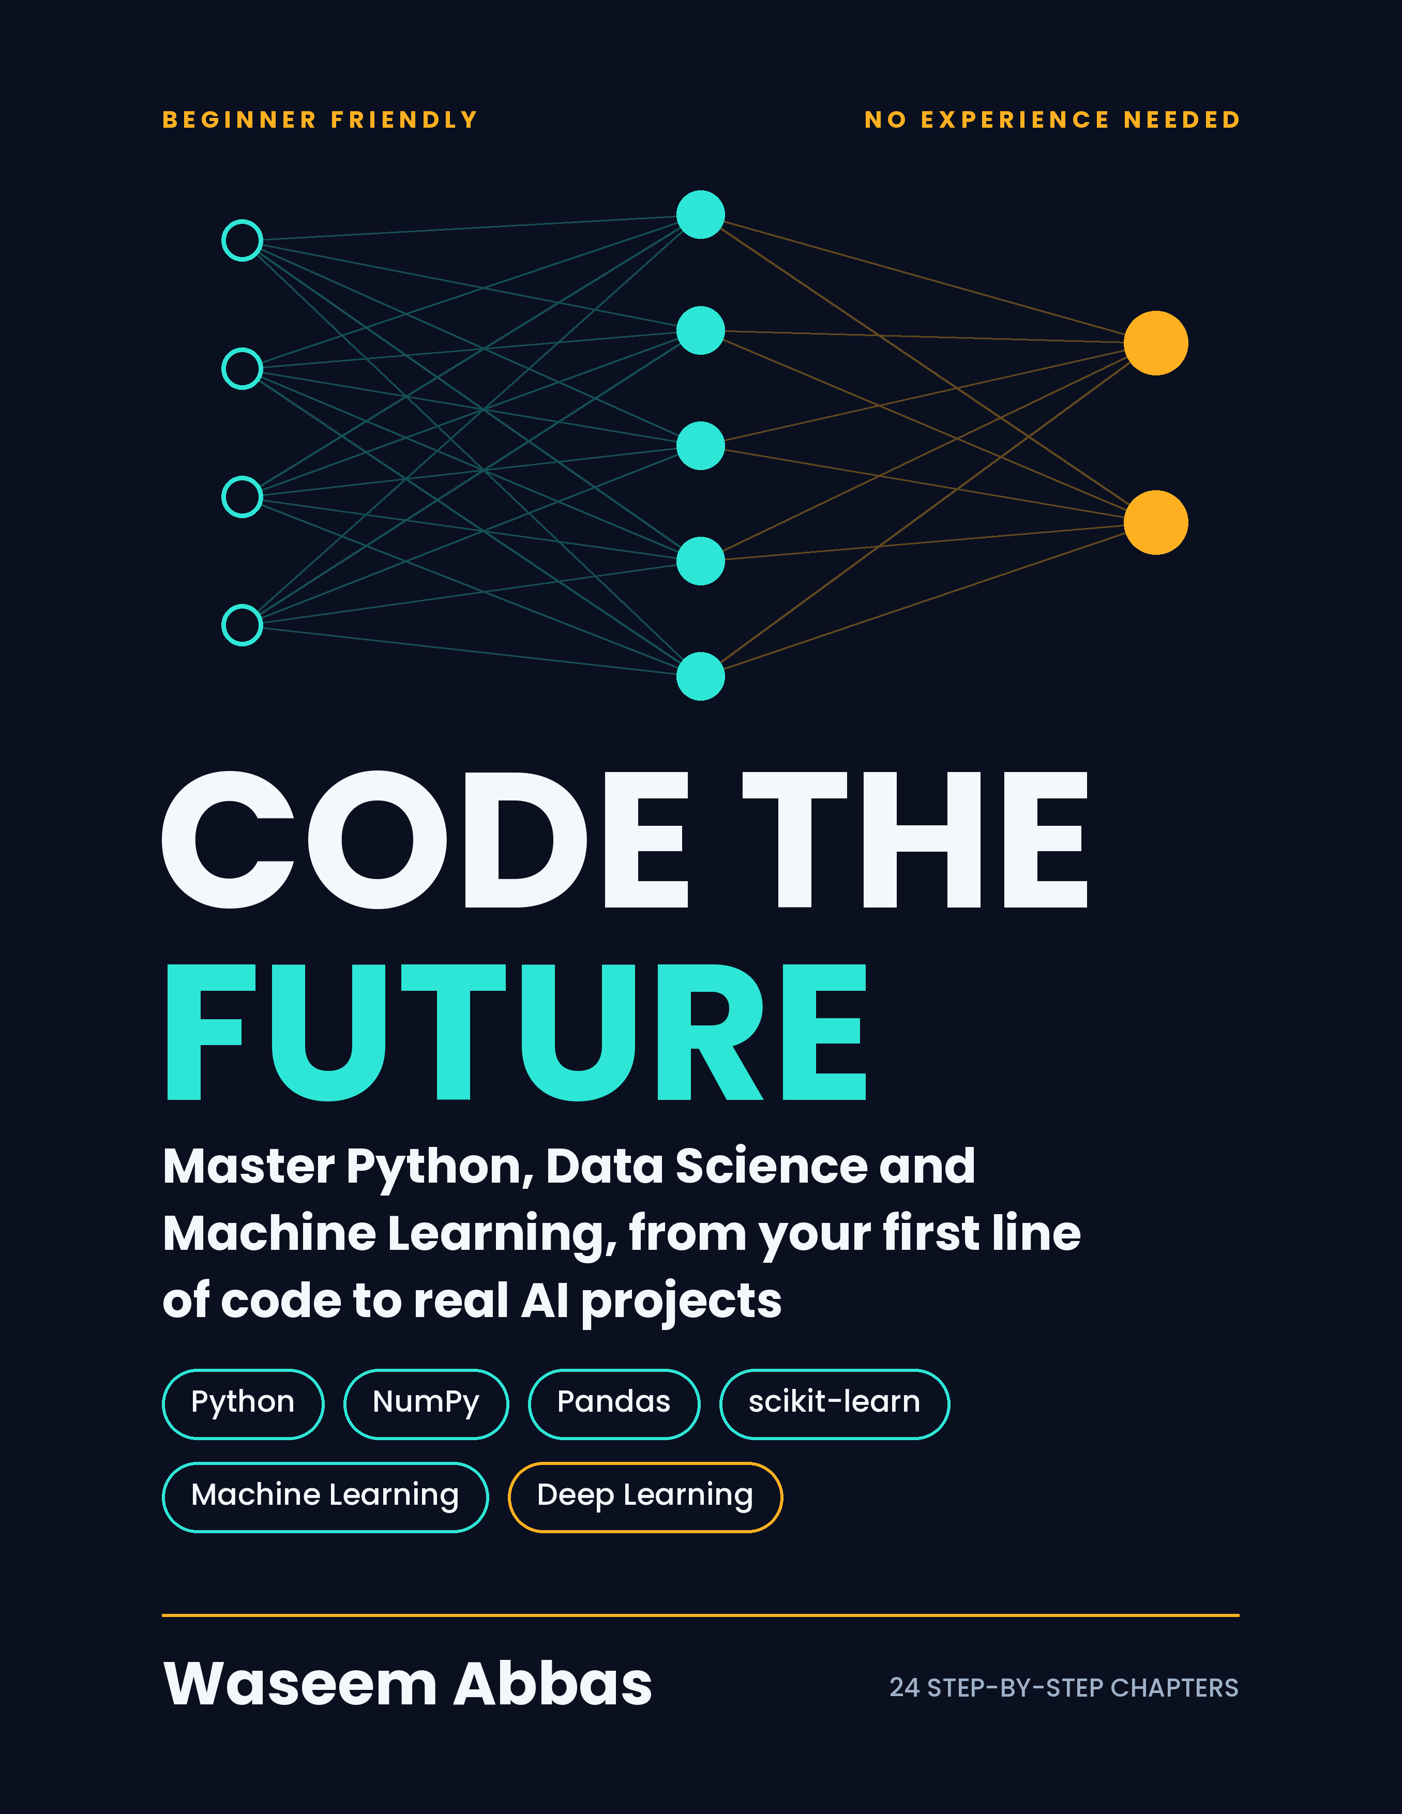
AI, Data Science & Machine Learning Made Easy
From Python Basics to Real Machine Learning Projects
A beginner-friendly, step-by-step guide with code, examples and exercises
By Waseem Abbas
Python • NumPy • Pandas • Matplotlib • scikit-learn • Machine Learning

Table of Contents
Introduction: How to Use This Book 1
Part 1: Python Foundations 2
Chapter 1: Getting Started with Python 2
Chapter 2: Variables and Data Types 4
Chapter 3: Strings and String Methods 8
Chapter 4: Lists 11
Chapter 5: Tuples 15
Chapter 6: Sets and Dictionaries 17
Chapter 7: Conditions and Loops 20
Chapter 8: Functions 34
Chapter 9: Object-Oriented Programming (OOP) 43
Chapter 10: Exception Handling and Files 55
Part 2: Data Science Tools 61
Chapter 11: NumPy: Fast Numerical Computing 61
Chapter 12: Pandas: Working with Data 66
Chapter 13: Matplotlib: Visualizing Data 76
Part 3: Machine Learning Foundations 87
Chapter 14: What Is Machine Learning? 88
Chapter 15: Data Preprocessing and EDA 92
Part 4: Supervised Learning 99
Chapter 16: Linear Regression 100
Chapter 17: Logistic Regression and Classification 106
Chapter 18: Decision Trees and Random Forests 111
Chapter 19: KNN, SVM and Naive Bayes 116
Part 5: Unsupervised Learning 120
Chapter 20: Clustering and PCA (Unsupervised Learning) 121
Part 6: Reinforcement Learning 126
Chapter 21: Reinforcement Learning 126
Part 7: Improving and Deploying Models 135
Chapter 22: Model Evaluation and Improvement 136
Chapter 23: Feature Engineering and Pipelines 142
Part 8: Deep Learning and Your Career 147
Chapter 24: A Gentle Introduction to Deep Learning 148
Chapter 25: Portfolio Projects and Career Roadmap 152
Appendix A: Python and ML Cheat Sheet 154
Appendix B: Glossary 155
Appendix C: More Important Libraries for AI, Data Science and Machine Learning 156

Introduction: How to Use This Book
Artificial Intelligence (AI) is everywhere: your phone's face unlock, YouTube recommendations, spam filters in your email, and chatbots. Behind most of these systems sits Machine Learning (ML), and behind ML sits Python and data.
This book takes you from zero to your first real ML projects. You do not need any previous programming knowledge. Every chapter follows the same pattern:
- Simple idea first: a plain-language explanation with a real-world example.
- Code: short, commented examples you can run.
- Practice: small exercises so you learn by doing.
Tips for success
- Type the code yourself. Do not only read it.
- When you get an error, read the message slowly. It is telling you what went wrong.
- Do every exercise before moving on.
- Build small projects early. A beginner who builds beats an expert who only watches.
What you need: a computer, an internet connection, and Python 3. We will use Google Colab or Jupyter Notebook, both free.

Part 1: Python Foundations

Chapter 1: Getting Started with Python
Definition: Python is a high-level programming language: a way of writing instructions in almost-English words that a computer can follow. A program is a list of such instructions, and programming (coding) is the work of writing them.

Why Python?
Python reads almost like English, has a huge community, and has the best libraries for AI and data science (NumPy, Pandas, scikit-learn, TensorFlow, PyTorch). That is why almost every AI/ML engineer uses it.

Setting up
The easiest way to start is Google Colab (colab.research.google.com). Open it, create a new notebook and you can run Python in your browser with nothing to install.
If you prefer your own computer, install Python from python.org and then install Jupyter:
pip install jupyter
jupyter notebook

Your first program
Definition: print() is a built-in function that displays values (text, numbers, results) on the screen. The word output means whatever a program shows.

Syntax
print(value1, value2, sep=" ", end="\n")
- Text goes inside quotes (single or double). Numbers and variables need no quotes.
- sep is what is placed between the values (default: one space).
- end is what is printed at the end (default: a new line).
Example: print("A", "B", sep="-") prints A-B.
# print() shows output on the screen
print("Hello, AI world!")
Output: Hello, AI world!

Comments
Definition: A comment is a note written for humans inside the code. It starts with #, and Python ignores it completely. Comments explain why the code does something.

Syntax
# a comment on its own line
x = 5 # a comment after code
"""
A longer note can be written
between triple quotes.
"""
Anything after # is ignored by Python. Comments are notes for humans.
# This is a comment
print(2 + 3) # This is also a comment
Output:
5

Getting input from the user
Definition: Input is data that goes into a program from outside, for example what the user types. The input() function pauses the program, waits for the user to type, and returns the typed text as a string.

Syntax
variable = input("message shown to the user")
number = int(input("Enter a number: ")) # convert text to a whole number
price = float(input("Enter price: ")) # convert text to a decimal
input() always gives you text (a string), even if the user types digits. Convert it with int() or float() when you need to calculate.
name = input("What is your name? ")
print("Welcome,", name)
Output (sample run, the user types Waseem):
What is your name? Waseem
Welcome, Waseem

Practice
- Print your name and your favorite subject on two separate lines.
- Ask the user for two numbers and print their sum. (Hint: input() gives text, so use int() to convert.)

Chapter 2: Variables and Data Types

What is a variable?
Definition: A variable is like a container, a labeled box in the computer's memory. You put a value inside it, and the label is its name, so you can open the box and use the value again whenever you need it. The value can change while the program runs (that is why it is called variable).
Think of a variable as a labeled box where you store a value. The label is the name, and the box holds the data.

Syntax
variable_name = value # create a variable
a, b, c = 1, 2, 3 # assign many at once
x = y = 0 # same value to many variables
x = x + 1 # update (can also write x += 1)
The single = means store. It does not mean "equal" as in maths.
age = 21 # a box named age holding 21
name = "Waseem" # a box named name holding text
print(name, age)
Output:
Waseem 21
Naming rules
- Use letters, digits and underscores. Do not start with a digit.
- No spaces. Use student_name, not student name.
- Names are case-sensitive: Age and age are different.
- Good names describe the data: total_price is better than x.

Main data types
Definition: A data type tells Python what kind of value something is and what you are allowed to do with it. For example, numbers can be added, and text can be joined. int is a whole number, float a decimal number, str (string) is text, bool is True or False, and list, tuple, set and dict are collections that hold many values.
Definition: Integer (int) is a whole number without a decimal point, such as 10, 0 or -5. Think of counting students in a class: you never count 2.5 students.
Definition: Float is a number with a decimal point, such as 3.14 or 72.5. Think of a weighing scale that shows 72.5 kg: it measures things that are not whole numbers.
Definition: String (str) is text written inside quotes, such as "hello". Think of a necklace: each letter is a bead, and the beads are threaded one after another.
Definition: Boolean (bool) is a value that can only be True or False. It works like a light switch: it is either on or off, yes or no.
Definition: None is a special value that means "nothing here yet". It is like an empty box: the box exists, but there is nothing inside it.

Syntax of each type
whole = 10 # int
decimal = 3.14 # float
text = "hello" # str (quotes)
flag = True # bool (True or False, capital first letter)
items = [1, 2, 3] # list (square brackets)
fixed = (1, 2, 3) # tuple (round brackets)
unique = {1, 2, 3} # set (curly brackets)
record = {"name": "Ali"} # dict (curly brackets with key: value)
type(value) # tells you the type of any value
Type | Meaning | Example
int | Whole number | 10, -5
float | Decimal number | 3.14
str | Text | "hello"
bool | True or False | True
list | Ordered, changeable collection | [1, 2, 3]
tuple | Ordered, unchangeable collection | (1, 2, 3)
set | Unordered unique items | {1, 2, 3}
dict | Key-value pairs | {"a": 1}
Use type() to check:
print(type(10)) # <class 'int'>
print(type(3.14)) # <class 'float'>
print(type("hi")) # <class 'str'>
print(type(True)) # <class 'bool'>
Output:
<class 'int'>
<class 'float'>
<class 'str'>
<class 'bool'>

Type conversion
Definition: Type conversion (also called type casting) means changing a value from one data type to another, for example turning the text "25" into the number 25 with int().

Syntax
int(value) # to whole number
float(value) # to decimal number
str(value) # to text
bool(value) # to True / False
list(value) # to list

x = "25" # this is text
y = int(x) # convert to integer
print(y + 5) # 30
print(float("2.5")) # 2.5
print(str(100)) # "100"
Output:
30
2.5
100
Common error: "5" + 5 gives a TypeError because you cannot add text and a number. Convert first: int("5") + 5.

Operators
Definition: An operator is a symbol that tells Python to perform an action on values, which are then called operands. In 3 + 4, the + is the operator and 3 and 4 are the operands. Arithmetic operators calculate, comparison operators compare and give True or False, logical operators (and, or, not) combine conditions, and assignment operators store values.

Syntax
result = operand1 operator operand2
Group | Operators
Arithmetic | + - * / // % **
Comparison | == != > < >= <=
Logical | and or not
Assignment | = += -= *= /=
a, b = 10, 3
print(a + b) # 13 addition
print(a - b) # 7 subtraction
print(a * b) # 30 multiplication
print(a / b) # 3.33 division (always float)
print(a // b) # 3 floor division
print(a % b) # 1 remainder (modulus)
print(a ** b) # 1000 power
Output:
13
7
30
3.3333333333333335
3
1
1000
Notice that 10 / 3 gives a long decimal. That is normal for computers, and you can round it with round(10 / 3, 2), which gives 3.33.
Comparison operators (==, !=, >, <, >=, <=) return True or False. Logical operators (and, or, not) combine them:
age = 20
print(age >= 18 and age < 60) # True
Output:
True

Practice
- Store your marks in three subjects and print the average.
- Convert the string "3.7" to a float and multiply it by 2.
- What is 17 % 5? What is 17 // 5? Predict first, then check.

Chapter 3: Strings and String Methods
Definition: A string (str) is a sequence of characters (letters, digits, spaces and symbols) written inside quotes. A string method is a built-in action that belongs to strings, such as .upper(), and is called with a dot.
A string is text inside quotes. It is one of the most used types in data work, because names, emails and reviews are all text.

Syntax
s1 = 'single quotes'
s2 = "double quotes"
s3 = """triple quotes
can span many lines"""
full = "Hello" + " " + "World" # join (concatenation)
line = "-" * 20 # repeat
n = len(full) # number of characters
print("Line1\nLine2\tTabbed") # \n = new line, \t = tab

s = "Machine Learning"

Indexing and slicing
Definition: An index is the position number of an item in a sequence, starting from 0. Slicing means taking a part of a sequence by giving a start and an end position.

Syntax
string[index] # one character
string[start:stop] # from start up to (not including) stop
string[start:stop:step] # with a step
string[::-1] # reversed
Index starts at 0. Negative index counts from the end (-1 is the last character).
Every character has a position, starting from 0.
M a c h i n e
0 1 2 3 4 5 6

s = "Machine Learning"
print(s[0]) # M
print(s[-1]) # g (last character)
print(s[0:7]) # Machine (start included, end excluded)
print(s[8:]) # Learning
print(s[::-1]) # reverses the string
Output:
M
g
Machine
Learning
gninraeL enihcaM

Useful string methods
Definition: A method is a function that belongs to an object (like a string) and works on it. You write the object, a dot, and the method name, for example text.upper().

Syntax
new_string = string.method(arguments)
text.upper() # no arguments
text.replace("old", "new") # two arguments
text.split(",") # returns a list
", ".join(list_of_words) # joins a list into one string
A method is written with a dot after the string. Because strings cannot be changed, the method returns a new string. Save it in a variable to keep it.
text = " Hello, Python World "
print(text.upper()) # " HELLO, PYTHON WORLD "
print(text.lower()) # " hello, python world "
print(text.strip()) # removes spaces from both ends
print(text.replace("World", "Data"))
print(text.split(",")) # [' Hello', ' Python World ']
print(text.count("o")) # counts a character
print(text.find("Python")) # position of the word, or -1
Output:
HELLO, PYTHON WORLD
hello, python world
Hello, Python World
Hello, Python Data
[' Hello', ' Python World ']
3
9
The 9 means the word "Python" starts at position 9 (counting from 0, and the two leading spaces and "Hello, " come first).
Other handy methods:
Method | What it does
title() | Capitalizes Each Word
capitalize() | Capitalizes first letter only
startswith("x") / endswith("x") | Checks the beginning or end
isdigit() | True if all characters are digits
isalpha() | True if all characters are letters
" ".join(list) | Joins a list into a string
Important: strings are immutable, meaning methods return a new string and do not change the original.
name = "ali"
name.upper() # result is thrown away!
name = name.upper() # save it to keep it

f-strings (the best way to format text)
Definition: An f-string (formatted string) is a string that starts with f and can contain variables and expressions inside curly brackets { }. Python replaces them with their values.

Syntax
f"text {variable} more text {expression}"
f"{number:.2f}" # 2 digits after the decimal point
f"{number:,}" # thousands separator: 1,000,000
Put the letter f before the opening quote and write variables inside { }.
name = "Sara"
score = 92.456
print(f"{name} scored {score:.1f}%") # Sara scored 92.5%
Output:
Sara scored 92.5%
:.1f rounded 92.456 to one digit after the decimal point.

Practice
- Take "python is fun" and print it in title case.
- Check whether a word is a palindrome (reads the same backward), for example "madam".
- Count how many vowels are in a sentence entered by the user.

Chapter 4: Lists
Definition: A list is an ordered, changeable (mutable) collection of items written in square brackets. It can hold any types and allows duplicates. An item or element is one value inside the list.
A list stores many items in one variable. Imagine a shopping list: ordered, and you can add or remove things.

Syntax
my_list = [item1, item2, item3] # create
empty = [] # empty list
another = list(range(5)) # from other data: [0, 1, 2, 3, 4]
Items are separated by commas and written inside square brackets.
fruits = ["apple", "banana", "mango"]
numbers = [10, 20, 30, 40]
mixed = [1, "hello", 3.5, True] # lists can mix types

Accessing items
Definition: Accessing means reading an item by its index. A negative index counts from the end of the list.

Syntax
my_list[index] # one item
my_list[start:stop] # a part of the list (slice)
my_list[-1] # last item

print(fruits[0]) # apple
print(fruits[-1]) # mango
print(fruits[0:2]) # ['apple', 'banana']
Output:
apple
mango
['apple', 'banana']

Changing a list
Definition: Mutable means changeable. A list is mutable, so you can add, remove and replace items after creating it.

Syntax
my_list.append(item) # add to the end
my_list.insert(index, item) # add at a position
my_list.remove(item) # remove by value
my_list.pop(index) # remove by position (last if no index)
my_list[index] = new_value # change an item
del my_list[index] # delete an item

fruits.append("orange") # add to the end
fruits.insert(1, "grape") # add at position 1
fruits.remove("banana") # remove by value
last = fruits.pop() # remove and return last item
fruits[0] = "kiwi" # change an item
print(fruits)
Output:
['kiwi', 'grape', 'mango']
To see how we got here, follow the list step by step: [apple, banana, mango], then append orange, then insert grape at position 1, then remove banana, then pop removes orange, then the first item becomes kiwi.

Common list operations
Definition: A list operation is a ready-made action that works on the whole list at once: len() counts the items, max() and min() find the biggest and smallest, sum() adds everything, and sort() puts the items in order. Think of a list as a shelf of books: these tools let you count the books, find the thickest one or arrange them all in a moment.

Syntax
len(my_list) max(my_list) min(my_list) sum(my_list)
my_list.sort() # sorts the list itself
sorted(my_list) # returns a new sorted list
my_list.reverse() # reverses the list itself
item in my_list # True or False

nums = [5, 2, 9, 1]
print(len(nums)) # 4
print(max(nums)) # 9
print(min(nums)) # 1
print(sum(nums)) # 17
nums.sort() # [1, 2, 5, 9] (changes the list)
nums.reverse() # [9, 5, 2, 1]
print(sorted(nums)) # returns a new sorted list
print(5 in nums) # True (membership check)
Output:
4
9
1
17
[1, 2, 5, 9]
True

List comprehension (a powerful shortcut)
Definition: A list comprehension is a short, one-line way to build a new list from an existing sequence, optionally filtering items with a condition.

Syntax
new_list = [expression for item in iterable]
new_list = [expression for item in iterable if condition]
Read it from left to right: "give me expression, for every item in iterable, (only if condition is True)."
Instead of a long loop, create a list in one line.
# Squares of numbers 1 to 5
squares = [n ** 2 for n in range(1, 6)]
print(squares) # [1, 4, 9, 16, 25]
# Only even numbers
evens = [n for n in range(10) if n % 2 == 0]
print(evens) # [0, 2, 4, 6, 8]
Output:
[1, 4, 9, 16, 25]
[0, 2, 4, 6, 8]
Read it as: "give me n squared, for every n in the range."

Nested lists
Definition: A nested list is a list that contains other lists as its items. A list of rows is the simplest way to represent a table or a matrix.

Syntax
matrix = [[1, 2], [3, 4]] # a list that contains lists
matrix[row][column] # first row number, then column number

matrix = [[1, 2], [3, 4], [5, 6]]
print(matrix[1][0]) # 3 (row 1, column 0)
Output:
3
Nested lists are the idea behind tables and matrices, which you will meet again in NumPy.

Practice
- Create a list of 5 numbers. Print the largest, the smallest and the average.
- Remove duplicates from [1, 2, 2, 3, 3, 3]. (Hint: next chapters will help.)
- Use a list comprehension to make a list of the lengths of words in ["AI", "data", "science"].

Chapter 5: Tuples
Definition: A tuple is an ordered collection of items written in round brackets that cannot be changed after it is created (it is immutable).
A tuple is like a list, but unchangeable (immutable). Use it for data that should never change, such as coordinates or days of the week.

Syntax
my_tuple = (item1, item2, item3) # create (round brackets)
single = (5,) # one item needs a comma
my_tuple[index] # access
my_tuple.count(item) # how many times an item appears
my_tuple.index(item) # position of an item
Tuples cannot be changed after creation.
point = (10, 20)
colors = ("red", "green", "blue")
single = (5,) # a one-item tuple needs a comma

print(colors[0]) # red
print(len(colors)) # 3
print(colors.count("red"))
print(colors.index("blue")) # 2
colors[0] = "pink" # TypeError! tuples cannot be changed
Output:
red
3
1
2
Traceback (most recent call last):
...
TypeError: 'tuple' object does not support item assignment
The last line is the error that appears when we try colors[0] = "pink". The first four lines run fine, and then Python stops with a TypeError, because tuples cannot be changed.

Unpacking
Definition: Unpacking means assigning the items of a tuple (or list) to separate variables in one line.

Syntax
variable1, variable2 = (value1, value2) # the number of variables must match the number of values
a, b = b, a # swap two variables
first, *rest = (1, 2, 3, 4) # first=1, rest=[2, 3, 4]

x, y = (10, 20)
print(x) # 10
print(y) # 20
Output:
10
20
Functions often return several values as a tuple, so unpacking is very common.

List or tuple?
Use a list when... | Use a tuple when...
Data will change | Data must stay fixed
You add/remove items | You want safety and slightly faster speed

Practice
- Store your birth date as a tuple (day, month, year) and unpack it into three variables.
- Swap two variables using tuples: a, b = b, a.

Chapter 6: Sets and Dictionaries

Sets
Definition: A set is an unordered collection of unique items written in curly brackets. Duplicates are removed automatically, and items have no index.
A set is an unordered collection of unique items. Think of a bag of different stickers: duplicates are not allowed.

Syntax
my_set = {item1, item2, item3} # create (curly brackets, no keys)
empty = set() # empty set (NOT {})
my_set.add(item) # add one
my_set.remove(item) # remove (error if missing)
my_set.discard(item) # remove (no error if missing)
A | B # union A & B # intersection A - B # difference

nums = {1, 2, 2, 3, 3, 3}
print(nums) # {1, 2, 3} duplicates removed
# Remove duplicates from a list quickly
unique = list(set([1, 2, 2, 3, 3, 3]))
s = {"a", "b"}
s.add("c") # add one item
s.remove("a") # remove (error if missing)
s.discard("z") # remove (no error if missing)
Output:
{1, 2, 3}
Sets support maths operations:
A = {1, 2, 3, 4}
B = {3, 4, 5, 6}
print(A | B) # union: {1, 2, 3, 4, 5, 6}
print(A & B) # intersection: {3, 4}
print(A - B) # difference: {1, 2}
Output:
{1, 2, 3, 4, 5, 6}
{3, 4}
{1, 2}
Note: {} creates an empty dictionary, not a set. Use set() for an empty set.

Dictionaries
Definition: A dictionary (dict) is a collection of key: value pairs. Each key is unique and is used to look up its value, like a word and its meaning in a real dictionary.
A dictionary stores data as key: value pairs, like a real dictionary (word, meaning) or a contact list (name, phone number).

Syntax
my_dict = {key1: value1, key2: value2} # create
my_dict[key] # get a value (error if missing)
my_dict.get(key, default) # get a value safely
my_dict[key] = new_value # add or update
del my_dict[key] # delete
my_dict.keys() my_dict.values() my_dict.items()
for key, value in my_dict.items(): # loop through a dictionary
print(key, value)

student = {
"name": "Ali",
"age": 20,
"course": "Computer Science"
}
print(student["name"]) # Ali
print(student.get("grade")) # None (safe, no error)
print(student.get("grade", "N/A"))# N/A (custom default)
student["age"] = 21 # update
student["city"] = "Lahore" # add new key
del student["course"] # delete
Output:
Ali
None
N/A

print(student.keys()) # all keys
print(student.values()) # all values
print(student.items()) # all (key, value) pairs
for key, value in student.items():
print(key, "->", value)
Output:
dict_keys(['name', 'age', 'city'])
dict_values(['Ali', 21, 'Lahore'])
dict_items([('name', 'Ali'), ('age', 21), ('city', 'Lahore')])
name -> Ali
age -> 21
city -> Lahore
Dictionaries are everywhere in data science. A single row of data (one customer, one house) is naturally a dictionary, and JSON data from APIs looks exactly like one.

Practice
- Find the common elements of two lists using sets.
- Create a dictionary of 3 friends and their ages. Print the oldest friend.
- Count how many times each word appears in a sentence using a dictionary.

Chapter 7: Conditions and Loops

Making decisions with if / elif / else
Definition: A conditional statement (if, elif, else) lets a program choose which code to run, depending on whether a condition (a question with a True or False answer) is true. Indentation means the spaces at the start of a line that show which lines belong inside the block.
Programs must make choices, just like you do: if it rains, take an umbrella; otherwise, wear sunglasses.

Syntax (the pattern)
Every decision in Python follows this pattern:
if condition_1:
# runs when condition_1 is True
elif condition_2:
# runs when condition_1 is False and condition_2 is True
else:
# runs when nothing above was True
Rules to remember (like grammar rules in English):
- A condition is a question whose answer is True or False, for example marks >= 50.
- After every if, elif and else we write a colon :.
- The lines inside are pushed to the right by 4 spaces. This is called indentation.
- elif and else are optional. You can use only an if.
- Python checks from top to bottom and runs only the first block whose condition is True.
Think of a traffic signal: if the light is green, go; elif it is yellow, slow down; else stop.

Example 1: Grade of a student
marks = 72
if marks >= 80:
print("Grade A")
elif marks >= 60:
print("Grade B")
else:
print("Keep trying!")
Output:
Grade B
Indentation matters. Python uses 4 spaces to know which lines belong inside the if. A missing indent causes an IndentationError.
Teacher's explanation of Example 1: Imagine you are the examiner. The student got 72 marks. First question: is 72 greater than or equal to 80? No, so we skip "Grade A". Second question: is 72 greater than or equal to 60? Yes, so Python prints "Grade B" and stops checking. It never reaches else. If the marks were 40, both questions would be No, and the else part would run.

Example 2: Can this person vote?
age = 17
if age >= 18:
print("You can vote.")
else:
print("Sorry, you must wait", 18 - age, "more year(s).")
Output:
Sorry, you must wait 1 more year(s).
Teacher's explanation: In our country, you can vote at 18. The computer asks one question: is age at least 18? Here age is 17, so the answer is False and the else block runs. The part 18 - age calculates how many years are left (18 minus 17 is 1). Change age to 20 and run it again. What do you see?

Example 3: Even or odd number
number = 14
if number % 2 == 0:
print(number, "is even")
else:
print(number, "is odd")
Output:
14 is even
Teacher's explanation: The symbol % gives the remainder after division. When we divide 14 by 2, nothing is left over, so the remainder is 0 and the number is even. When we divide 15 by 2, the remainder is 1, so it is odd. Notice we use two equal signs == to compare. A single = is used to store a value. Mixing them up is the most common beginner mistake.

Example 4: Shop discount using and / or
total_bill = 3500
is_member = True
if total_bill >= 5000 or is_member:
print("You get 10% discount")
elif total_bill >= 2000 and total_bill < 5000:
print("You get 5% discount")
else:
print("No discount")
Output:
You get 10% discount
Teacher's explanation: or means at least one condition must be True. and means both conditions must be True. Our customer's bill is 3500, which is less than 5000, but he is a member, so the first condition is True (because of or) and he gets 10 percent. If is_member were False, Python would test the elif: is the bill 2000 or more and less than 5000? Yes, so he would get 5 percent.
Try it yourself: Write a program that takes a temperature. If it is above 35 print "Very hot", if it is above 25 print "Warm", otherwise print "Cool".

The for loop
Definition: A loop repeats a block of code many times so that you do not have to write it again and again. A for loop repeats the code once for every item in a sequence (or a fixed number of times). Each repetition is called an iteration.
A loop repeats work so you do not write the same code again and again.

Syntax (the pattern)
for variable in sequence:
# this block runs once for every item in the sequence
- sequence can be a list, a string, a tuple, a dictionary or range().
- variable is a name you choose. It holds the current item, one at a time.
- The line ends with a colon : and the body is indented by 4 spaces.
range() has three forms:
Form | Meaning | Gives
range(5) | start at 0, stop before 5 | 0, 1, 2, 3, 4
range(2, 6) | start at 2, stop before 6 | 2, 3, 4, 5
range(1, 10, 2) | start 1, stop before 10, step 2 | 1, 3, 5, 7, 9
Remember: the stop number is never included.
Real-life picture: a teacher calls the attendance register. She reads the first name, then the second, then the third, until the list finishes. A for loop does exactly this.
for i in range(5): # 0, 1, 2, 3, 4
print("Step", i)
fruits = ["apple", "banana", "mango"]
for fruit in fruits:
print("I like", fruit)
Output:
Step 0
Step 1
Step 2
Step 3
Step 4
I like apple
I like banana
I like mango
range(start, stop, step) is useful:
for n in range(2, 11, 2): # 2, 4, 6, 8, 10
print(n)
Output:
2
4
6
8
10
Teacher's explanation of the examples above: In for i in range(5), the variable i becomes 0, then 1, then 2, 3 and 4. Each time, Python runs the print line. That is why it prints five times. In the fruits example, fruit first becomes "apple", then "banana", then "mango". When the list is finished, the loop stops by itself.

Example 3: Table of 5
for i in range(1, 11):
print("5 x", i, "=", 5 * i)
Output:
5 x 1 = 5
5 x 2 = 10
5 x 3 = 15
5 x 4 = 20
5 x 5 = 25
5 x 6 = 30
5 x 7 = 35
5 x 8 = 40
5 x 9 = 45
5 x 10 = 50
Teacher's explanation: We want the table from 1 to 10, so we write range(1, 11) (remember, 11 is not included). For each i, Python multiplies 5 by i and prints the line. The first line is 5 x 1 = 5 and the last is 5 x 10 = 50. Change the 5 to any number to get a different table.

Example 4: Total and average marks
marks = [78, 85, 62, 90, 70]
total = 0 # start with an empty purse
for m in marks:
total = total + m # put each mark into the purse
average = total / len(marks)
print("Total:", total)
print("Average:", average)
Output:
Total: 385
Average: 77.0
Teacher's explanation: Think of total as a purse that starts with zero rupees. The loop takes one mark at a time and adds it to the purse: 0 + 78 = 78, then 78 + 85 = 163, and so on until 385. Then we divide by the number of subjects (len(marks) is 5) to find the average, 77. Always set the starting value (total = 0) before the loop, not inside it.

Example 5: Counting vowels in a word
word = "education"
count = 0
for letter in word:
if letter in "aeiou":
count += 1
print("Vowels:", count) # 5
Output:
Vowels: 5
Teacher's explanation: A string is a row of letters, so a for loop can walk through it one letter at a time. For each letter we ask: is it one of a, e, i, o, u? If yes, we add 1 to count (count += 1 means "increase count by one"). In "education" the vowels are e, u, a, i, o, so the answer is 5. Here you can see a loop and an if working together. This is very common in real programs.
Try it yourself: Print all even numbers from 1 to 20 using a for loop with a step in range().

The while loop
Definition: A while loop repeats a block of code as long as a condition stays True. It is used when you do not know in advance how many repetitions are needed.
Runs as long as a condition is true.

Syntax (the pattern)
while condition:
# runs again and again while the condition is True
# change something here so the condition becomes False one day
- Python first checks the condition. If it is True, it runs the body, then goes back and checks again.
- When the condition becomes False, the loop ends and the program continues below it.
- If the condition never becomes False, you get an infinite loop (it never stops). Press the stop button or Ctrl + C to escape.
for or while? Use for when you know how many times to repeat (10 times, or once per item). Use while when you do not know how many times, and you repeat until something happens (until the password is correct, until the player loses).
Real-life picture: you keep adding sugar to tea while it is not sweet enough. You do not know in advance how many spoons it will need.

Example 1: Counting from 1 to 3
count = 1
while count <= 3:
print("Count is", count)
count += 1 # without this, the loop never ends!
Output:
Count is 1
Count is 2
Count is 3
Teacher's explanation of Example 1: count starts at 1. Is 1 <= 3? Yes, so print and add 1, making count equal to 2. Is 2 <= 3? Yes, print again, and count becomes 3. Is 3 <= 3? Yes, print, and count becomes 4. Is 4 <= 3? No, so the loop ends. The line count += 1 is very important. If we forget it, count stays 1 forever and the loop never stops.

Example 2: Countdown
seconds = 5
while seconds > 0:
print(seconds)
seconds -= 1 # reduce by one each time
print("Time is up!")
Output:
5
4
3
2
1
Time is up!
Teacher's explanation: This is like a rocket launch. It prints 5, 4, 3, 2, 1. Each time, seconds -= 1 makes the number smaller. When seconds reaches 0, the condition seconds > 0 is False, so the loop stops and "Time is up!" is printed. Notice that "Time is up!" is not indented, so it runs only once, after the loop.

Example 3: Keep asking until the password is correct
password = ""
while password != "python123":
password = input("Enter the password: ")
print("Access granted!")
Output (sample run: the user types abc, then python, then python123):
Enter the password: abc
Enter the password: python
Enter the password: python123
Access granted!
Teacher's explanation: The computer does not know how many wrong tries the user will make, so a for loop would not fit. != means "is not equal to". As long as the password is wrong, the loop asks again. The moment the user types python123, the condition becomes False and the loop ends. This is exactly how a login screen works.

Example 4: How many years to double your money?
money = 1000
years = 0
while money < 2000:
money = money * 1.10 # 10% profit every year
years += 1
print("It takes", years, "years") # 8 years
Output:
It takes 8 years
Teacher's explanation: Suppose you keep 1000 rupees in a bank that gives 10 percent profit each year. We do not know in advance how many years it will take, so we use while. Each round, the money grows by 10 percent and we count one more year. When the money reaches 2000 or more, the loop stops and we print the years. Try changing 1.10 to 1.05 (5 percent) and see how the answer changes.
Try it yourself: Use a while loop to print the sum of numbers 1 to 10, without using range().

break and continue
Definition: break stops a loop completely and jumps to the code after it. continue skips the rest of the current iteration and goes straight to the next one.
for n in range(1, 10):
if n == 3:
continue # skip 3
if n == 6:
break # stop the loop completely
print(n) # prints 1, 2, 4, 5
Output:
1
2
4
5
The number 3 is skipped by continue, and the loop stops completely at 6 because of break.

enumerate and zip
Definition: enumerate() gives both the position and the value of each item while looping. zip() pairs up items from two or more sequences so that you can loop through them together.
names = ["Ali", "Sara", "Omar"]
scores = [85, 92, 78]
for i, name in enumerate(names): # index + value
print(i, name)
for name, score in zip(names, scores): # loop two lists together
print(name, score)
Output:
0 Ali
1 Sara
2 Omar
Ali 85
Sara 92
Omar 78

Worked example: sum of numbers 1 to 100
Step 1: Make a variable total = 0. Step 2: Loop through 1 to 100. Step 3: Add each number to total.
total = 0
for n in range(1, 101):
total += n
print(total) # 5050
Output:
5050

Important programs using loops

Factorial of a number
Definition: The factorial of a number n (written n!) is the product of all whole numbers from 1 to n. For example 5! = 5 x 4 x 3 x 2 x 1 = 120. Think of arranging 5 different books on a shelf: there are 5! = 120 different orders.
Idea: Start with result = 1 and multiply it by every number from 1 to n inside a for loop.
n = 5
result = 1
for i in range(1, n + 1):
result *= i
print("Factorial of", n, "is", result)
Output:
Factorial of 5 is 120

Sum of the digits of a number
Definition: The sum of digits of a number is what you get when you add its digits one by one, for example 1 + 2 + 3 + 4 = 10 for 1234. Think of taking a number apart like a toy and adding the pieces.
Idea: n % 10 gives the last digit, and n // 10 removes the last digit. Repeat in a while loop until the number becomes 0.
n = 1234
total = 0
while n > 0:
digit = n % 10 # last digit
total += digit
n = n // 10 # remove last digit
print("Sum of digits:", total)
Output:
Sum of digits: 10

Reverse a number
Definition: To reverse a number means to write its digits in the opposite order, so 1234 becomes 4321. Think of reading a number in a mirror.
Idea: Take the last digit again and again, and build the reversed number with reverse = reverse * 10 + digit.
n = 1234
reverse = 0
while n > 0:
digit = n % 10
reverse = reverse * 10 + digit
n = n // 10
print("Reversed number:", reverse)
Output:
Reversed number: 4321

Palindrome number
Definition: A palindrome number is a number that reads the same forwards and backwards, such as 121 or 1331. It is like a word that looks the same in a mirror.
Idea: Reverse the number (as above) and compare it with the original. If both are equal, it is a palindrome.
def check(n):
original = n
reverse = 0
while n > 0:
reverse = reverse * 10 + n % 10
n = n // 10
if original == reverse:
print(original, "is a palindrome")
else:
print(original, "is NOT a palindrome")
check(121)
check(1331)
check(123)
Output:
121 is a palindrome
1331 is a palindrome
123 is NOT a palindrome

Palindrome string
Definition: A palindrome string is a word or sentence that reads the same from both sides, such as madam, level or racecar.
Idea: Compare the first letter with the last, the second with the second last, and so on. If any pair differs, it is not a palindrome.
word = "madam"
is_pal = True
for i in range(len(word) // 2):
if word[i] != word[len(word) - 1 - i]:
is_pal = False
break
print(word, "is a palindrome" if is_pal else "is not a palindrome")
# the short way: compare with the reversed string
print("python"[::-1] == "python")
Output:
madam is a palindrome
False

Fibonacci series
Definition: The Fibonacci series is a sequence in which every number is the sum of the two numbers before it: 0, 1, 1, 2, 3, 5, 8, ... It appears in nature, for example in the spirals of sunflowers and shells.
Idea: Keep two variables a and b (the last two numbers). In every round print a, then move forward: a becomes b and b becomes a + b.
n = 10
a, b = 0, 1
for _ in range(n):
print(a, end=" ")
a, b = b, a + b
print()
Output:
0 1 1 2 3 5 8 13 21 34

Prime number check
Definition: A prime number is a number greater than 1 that can be divided only by 1 and itself, such as 2, 3, 5, 7, 11. A prime is like a stubborn number that cannot be split into smaller equal groups.
Idea: Try to divide the number by every value from 2 up to its square root. If any value divides it exactly, it is not prime.
n = 29
is_prime = n > 1
for i in range(2, int(n ** 0.5) + 1):
if n % i == 0:
is_prime = False
break
print(n, "is prime" if is_prime else "is not prime")
# all primes from 1 to 30
primes = []
for num in range(2, 31):
for i in range(2, int(num ** 0.5) + 1):
if num % i == 0:
break
else: # runs only if the loop did not break
primes.append(num)
print(primes)
Output:
29 is prime
[2, 3, 5, 7, 11, 13, 17, 19, 23, 29]

Armstrong number
Definition: An Armstrong number is a number that equals the sum of its digits, each raised to the power of the number of digits. For example 153 = 1 cubed + 5 cubed + 3 cubed = 1 + 125 + 27.
Idea: Count the digits, then add each digit raised to that power, and compare the total with the original number.
n = 153
power = len(str(n))
total = 0
temp = n
while temp > 0:
digit = temp % 10
total += digit ** power
temp //= 10
print(n, "is an Armstrong number" if total == n else "is not an Armstrong number")
Output:
153 is an Armstrong number

GCD (greatest common divisor)
Definition: The GCD (also called HCF) of two numbers is the biggest number that divides both of them exactly. The GCD of 48 and 18 is 6. It is like finding the largest square tile that exactly covers a floor of both sizes.
Idea: Euclid's method: while b is not 0, replace (a, b) by (b, a % b). When the loop ends, a is the GCD.
a, b = 48, 18
while b != 0:
a, b = b, a % b
print("GCD is", a)
Output:
GCD is 6

Count vowels in a sentence
Definition: A vowel is one of the letters a, e, i, o, u. Counting vowels is a simple example of looping through text and counting only the letters that match a condition.
Idea: Loop over every character, convert it to lowercase and check whether it is in the string of vowels.
text = "Machine Learning is fun"
count = 0
for ch in text.lower():
if ch in "aeiou":
count += 1
print("Vowels:", count)
Output:
Vowels: 8

Largest and smallest number in a list
Definition: Finding the maximum and minimum means checking all the items to see which is the biggest and which is the smallest. It is like finding the tallest and shortest student by looking at everyone once.
Idea: Assume the first item is both the largest and the smallest, then compare every other item with these two.
nums = [45, 12, 89, 33, 7, 61]
largest = smallest = nums[0]
for n in nums:
if n > largest:
largest = n
if n < smallest:
smallest = n
print("Largest:", largest)
print("Smallest:", smallest)
Output:
Largest: 89
Smallest: 7

Star pattern (nested loops)
Definition: A nested loop is a loop inside another loop. The outer loop controls the rows and the inner loop controls what is printed in each row, like rows and seats in a cinema.
Idea: In row number i, print i stars. The outer loop goes through the rows and the inner part prints the stars.
rows = 5
for i in range(1, rows + 1):
print("*" * i)
print()
for i in range(1, rows + 1):
print(" " * (rows - i) + "*" * (2 * i - 1))
Output:
*
**
***
****
*****
*
***
*****
*******
*********

Practice
- Print the multiplication table of 7.
- Print all numbers from 1 to 50 that are divisible by 3.
- FizzBuzz: for 1 to 30 print "Fizz" if divisible by 3, "Buzz" if by 5, "FizzBuzz" if by both, else the number.

Chapter 8: Functions
Definition: A function is a named, reusable block of code that performs one task. You define it once with def, and then you call it as many times as you like. A parameter is a name in the definition, an argument is the real value you pass when calling, and the return value is the result the function sends back.
A function is a reusable block of code with a name, like a recipe you can cook any time. Functions keep code clean and avoid repetition (the DRY rule: Don't Repeat Yourself).

Syntax
def function_name(parameter1, parameter2):
"""Short description (docstring)."""
# body: indented by 4 spaces
result = parameter1 + parameter2
return result # optional: send a value back
answer = function_name(3, 4) # calling the function: use the name with brackets
- def means "I am defining a function". The line ends with a colon.
- Parameters are the names in the definition. Arguments are the real values you pass when calling.
- A function without return gives back None.
def greet(name):
"""Print a greeting for the given name.""" # docstring
print(f"Hello, {name}!")
greet("Waseem") # Hello, Waseem!
Output:
Hello, Waseem!

Return values
Definition: The return statement ends a function and sends a value back to the place where the function was called, so the result can be stored or used.
print shows something. return gives a value back so you can use it later.
def add(a, b):
return a + b
result = add(3, 4)
print(result * 2) # 14
Output:
14

Default and keyword arguments
Definition: A default argument is a parameter that already has a value, which is used when the caller does not give one. A keyword argument is passed by name (exponent=3), so the order does not matter.

Syntax
def function_name(required, optional=default_value):
...
function_name(5) # uses the default
function_name(5, 10) # overrides the default
function_name(optional=10, required=5) # keyword arguments: order does not matter
Parameters with defaults must come after the ones without.
def power(base, exponent=2):
return base ** exponent
print(power(5)) # 25
print(power(2, 3)) # 8
print(power(exponent=3, base=4)) # 64
Output:
25
8
64

*args and **kwargs
Definition: *args collects any number of extra positional arguments into a tuple. **kwargs collects any number of extra name=value arguments into a dictionary.

Syntax
def f(*args): # args is a tuple of all extra positional arguments
...
def g(**kwargs): # kwargs is a dictionary of all extra name=value arguments
...
f(1, 2, 3)
g(name="Ali", age=20)

def total(*numbers): # any number of arguments
return sum(numbers)
print(total(1, 2, 3, 4)) # 10
def show(**info): # any number of key=value arguments
print(info)
show(name="Ali", age=20)
Output:
10
{'name': 'Ali', 'age': 20}

Returning multiple values
Definition: Python functions can return several values at once. They are packed into a tuple, and you can unpack them into separate variables.
def stats(nums):
return min(nums), max(nums), sum(nums) / len(nums)
lowest, highest, average = stats([4, 8, 6])

Scope
Definition: Scope is the part of a program where a variable can be used. A variable created inside a function has local scope: it exists only inside that function. A variable created outside has global scope.
Variables created inside a function exist only inside it (local scope).
def test():
x = 10
test()
print(x) # NameError: x is not defined here
Output:
Traceback (most recent call last):
...
NameError: name 'x' is not defined
The variable x lives only inside test(), so the outside world cannot see it.

Lambda functions
Definition: A lambda function is a small, anonymous (nameless) function written in one line with the word lambda. It can contain only one expression.

Syntax
lambda parameters: expression
name = lambda x, y: x + y # store it in a variable
name(2, 3) # 5
A lambda has only one expression and returns its value automatically (no return word).
A tiny one-line function without a name.
square = lambda x: x ** 2
print(square(6)) # 36
words = ["banana", "kiwi", "apple"]
print(sorted(words, key=lambda w: len(w))) # sort by length
Output:
36
['kiwi', 'apple', 'banana']

map and filter
Definition: map() applies a function to every item of a sequence. filter() keeps only the items for which a function returns True. Both are examples of higher-order functions, which take other functions as input.

Syntax
map(function, iterable) # apply the function to every item
filter(function, iterable) # keep items for which the function gives True
list(map(...)) # wrap with list() to see the result

nums = [1, 2, 3, 4]
print(list(map(lambda x: x * 2, nums))) # [2, 4, 6, 8]
print(list(filter(lambda x: x % 2 == 0, nums)))# [2, 4]
Output:
[2, 4, 6, 8]
[2, 4]

Important programs using functions

Factorial: loop and recursion
Definition: Recursion is when a function calls itself to solve a smaller version of the same problem, until a simple case called the base case stops it. It is like opening a set of Russian dolls: each doll contains a smaller one, and you stop at the smallest.
Idea: factorial(n) = n x factorial(n - 1), and the base case is factorial(0) = 1. The loop version multiplies the numbers one by one.
def factorial_loop(n):
result = 1
for i in range(1, n + 1):
result *= i
return result
def factorial_rec(n):
if n == 0: # base case
return 1
return n * factorial_rec(n - 1)
print(factorial_loop(5))
print(factorial_rec(5))
Output:
120
120

Palindrome function
Definition: A palindrome reads the same forwards and backwards, like 121 or madam. A function that checks it should return True or False so that other code can use the answer.
Idea: Convert the value to a string, reverse it with slicing [::-1] and compare it with the original.
def is_palindrome(value):
text = str(value).lower()
return text == text[::-1]
print(is_palindrome(121)) # number
print(is_palindrome("Madam")) # word
print(is_palindrome(123))
Output:
True
True
False

Prime number function
Definition: A prime number has exactly two divisors: 1 and itself. A function is_prime(n) packs the check into a reusable tool, so you can test any number with one call.
Idea: Return False as soon as a divisor is found. If the loop finishes without finding one, return True.
def is_prime(n):
if n < 2:
return False
for i in range(2, int(n ** 0.5) + 1):
if n % i == 0:
return False
return True
print(is_prime(29))
print(is_prime(15))
print([n for n in range(1, 31) if is_prime(n)])
Output:
True
False
[2, 3, 5, 7, 11, 13, 17, 19, 23, 29]

Fibonacci: list and recursion
Definition: In the Fibonacci series every number is the sum of the two before it. A function can return the first n numbers as a list, or find the n-th number by calling itself.
Idea: The list version keeps the last two numbers. The recursive version uses fib(n) = fib(n - 1) + fib(n - 2) with base cases fib(0) = 0 and fib(1) = 1.
def fibonacci(n):
series = []
a, b = 0, 1
for _ in range(n):
series.append(a)
a, b = b, a + b
return series
def fib(n):
if n <= 1: # base cases
return n
return fib(n - 1) + fib(n - 2)
print(fibonacci(10))
print(fib(10))
Output:
[0, 1, 1, 2, 3, 5, 8, 13, 21, 34]
55

GCD using recursion
Definition: The GCD of two numbers is the largest number that divides both exactly. Euclid's idea is recursive: the GCD of a and b is the same as the GCD of b and the remainder a % b.
Idea: Base case: when b is 0, the answer is a. Otherwise call the function again with (b, a % b).
def gcd(a, b):
if b == 0:
return a
return gcd(b, a % b)
print(gcd(48, 18))
print(gcd(17, 5))
Output:
6
1

Sum of digits using recursion
Definition: The sum of digits of a number adds up its digits. Recursively, it is the last digit plus the sum of digits of the rest of the number.
Idea: n % 10 is the last digit and n // 10 is the rest. The base case is n == 0, which returns 0.
def sum_digits(n):
if n == 0:
return 0
return n % 10 + sum_digits(n // 10)
print(sum_digits(1234))
Output:
10

Power of a number
Definition: The power x n means multiplying x by itself n times, for example 2 5 = 32. Writing it as a function shows how recursion breaks a big task into smaller ones.
Idea: power(x, n) = x * power(x, n - 1), and any number to the power 0 is 1.
def power(x, n):
if n == 0:
return 1
return x * power(x, n - 1)
print(power(2, 5))
print(power(3, 4))
Output:
32
81

Reverse a string using recursion
Definition: To reverse a string means to write its characters in the opposite order. Recursively, the reverse of a text is the reverse of everything after the first letter, followed by that first letter.
Idea: Base case: an empty string is its own reverse. Otherwise reverse the rest and add the first character at the end.
def reverse_text(text):
if text == "":
return ""
return reverse_text(text[1:]) + text[0]
print(reverse_text("python"))
Output:
nohtyp

Leap year function
Definition: A leap year is a year with 366 days. A year is a leap year if it is divisible by 4, except century years, which must also be divisible by 400. So 2024 and 2000 are leap years, but 1900 is not.
Idea: Combine the rules with and / or and return True or False.
def is_leap_year(year):
return (year % 4 == 0 and year % 100 != 0) or (year % 400 == 0)
for y in [2024, 2023, 1900, 2000]:
print(y, is_leap_year(y))
Output:
2024 True
2023 False
1900 False
2000 True

Average of a list (with default argument)
Definition: An average (mean) is the sum of the values divided by how many values there are. Writing it as a function with a clear name, as in the good-practice rules, makes your code easy to read.
Idea: Add all the numbers with sum(), divide by len(), and round the result to the number of decimals given (default 2).
def calculate_average(numbers, decimals=2):
return round(sum(numbers) / len(numbers), decimals)
marks = [78, 85, 92, 66, 74, 81]
print(calculate_average(marks))
print(calculate_average(marks, 1))
Output:
79.33
79.3

Good practice
- One function should do one job.
- Choose clear names like calculate_average.
- Write a short docstring.

Practice
- Write is_even(n) that returns True or False.
- Write factorial(n) using a loop.
- Write count_vowels(text) and test it with three different sentences.

Chapter 9: Object-Oriented Programming (OOP)
Definition: Object-Oriented Programming (OOP) is a style of programming in which a program is built from objects that combine data (attributes) and actions (methods). Objects are created from blueprints called classes.

The big idea
A class is a blueprint, and an object is a real thing built from it. A blueprint of a car is the class. Your actual red Toyota is an object. Each object has:
- Attributes (data): colour, speed
- Methods (actions): start, brake
OOP matters for ML because scikit-learn, PyTorch and TensorFlow are all built with classes. When you write model = LinearRegression(), you create an object.

Your first class
Definition: A class is a blueprint for creating objects. An object (or instance) is one real thing made from a class. An attribute is a variable that belongs to an object, a method is a function that belongs to an object, and the constructor (__init__) is the special method that runs when an object is created. self refers to the current object.

Syntax of a class
class ClassName: # 1. keyword + name (start the name with a capital letter)
def __init__(self, value1, value2): # 2. constructor: runs when an object is created
self.attribute1 = value1 # 3. attributes store the data of the object
self.attribute2 = value2
def method_name(self): # 4. methods are actions the object can do
# use self.attribute1 here
pass
my_object = ClassName(10, 20) # 5. create an object
my_object.method_name() # 6. call a method
Part by part:
- class tells Python: "I am making a new blueprint."
- __init__ is the constructor. It runs automatically, once, when you create an object. Use it to give the object its starting data.
- self means "the object I am working on right now". self.name = name means "store this name inside this object".
- A method is simply a function that lives inside a class. Its first parameter is always self.
- To create an object, write the class name with brackets, like calling a function.
- To use a method, write object.method().
Real-life picture: an admission form is the class. It has empty fields: name, age, class. Each student who fills it creates one object, with their own name and age.

Example 1: Student class
class Student:
def __init__(self, name, marks): # constructor: runs when object is created
self.name = name # attribute
self.marks = marks
def is_pass(self): # method
return self.marks >= 50
def introduce(self):
print(f"I am {self.name} and I scored {self.marks}")
s1 = Student("Ali", 72)
s2 = Student("Sara", 45)
s1.introduce() # I am Ali and I scored 72
print(s2.is_pass()) # False
Output:
I am Ali and I scored 72
False
self simply means "this particular object".
Teacher's explanation of Example 1: Student("Ali", 72) makes one student object. Python automatically runs __init__, which stores "Ali" in self.name and 72 in self.marks. We then make a second student, Sara, with her own marks. Ali and Sara are two separate objects made from the same blueprint, and each has its own data. The method is_pass() checks self.marks >= 50. For Ali (72) it is True. For Sara (45) it is False.

Example 2: Car class
class Car:
def __init__(self, brand, speed=0):
self.brand = brand
self.speed = speed
def accelerate(self, amount):
self.speed = self.speed + amount
print(self.brand, "is now running at", self.speed, "km/h")
def brake(self):
self.speed = 0
print(self.brand, "has stopped")
my_car = Car("Toyota")
my_car.accelerate(40)
my_car.accelerate(30)
my_car.brake()
Output:
Toyota is now running at 40 km/h
Toyota is now running at 70 km/h
Toyota has stopped
Teacher's explanation: The car starts with speed 0 (a default value, because we did not give a speed). The first accelerate(40) changes self.speed from 0 to 40. The second call adds 30 more, so the speed becomes 70. Notice that the object remembers its speed between the calls. That is the big power of classes: data and actions live together. brake() sets the speed back to 0.

Example 3: Circle class
class Circle:
def __init__(self, radius):
self.radius = radius
def area(self):
return 3.14 * self.radius ** 2
def circumference(self):
return 2 * 3.14 * self.radius
c1 = Circle(5)
c2 = Circle(10)
print(c1.area()) # 78.5
print(c2.circumference()) # 62.8
Output:
78.5
62.800000000000004
The second number is not exactly 62.8 because computers store decimals in binary, so tiny rounding differences appear. This is normal. Use round(value, 2) to show 62.8.
Teacher's explanation: You know the formulas from maths class: area = πr² and circumference = 2πr. Here we wrap them inside a class. We make two circles with different radii, and each object calculates using its own radius. We write the formula only once, but we can use it for 100 circles. That is why programmers love classes.
Try it yourself: Make a Book class with title and pages. Add a method read(pages_read) that prints how many pages are left.

The four pillars of OOP
Definition: The four pillars of OOP are four core ideas that make object-oriented programs organized and reusable: encapsulation (keep data safe inside the object), inheritance (a child class reuses a parent class), polymorphism (one method name, many behaviours) and abstraction (hide the complex details and show only what is needed).
1. Encapsulation: keep data and the code that uses it together, and protect data from careless changes.
Syntax of encapsulation:
class ClassName:
def __init__(self, value):
self.__secret = value # two underscores: private attribute
def get_secret(self): # getter: lets outside code read it
return self.__secret
def set_secret(self, new_value): # setter: changes it safely
if new_value > 0: # we can add checks here
self.__secret = new_value
Example:
class BankAccount:
def __init__(self, balance):
self.__balance = balance # double underscore = private
def deposit(self, amount):
if amount > 0:
self.__balance += amount
def get_balance(self):
return self.__balance
2. Inheritance: a child class reuses a parent class.
Syntax of inheritance:
class Parent:
def __init__(self, name):
self.name = name
def show(self):
print("I am", self.name)
class Child(Parent): # put the parent's name in brackets
def __init__(self, name, extra):
super().__init__(name) # call the parent's constructor
self.extra = extra # add something new for the child
def new_method(self): # a new action only the child has
print("Extra is", self.extra)
- class Child(Parent) means: Child gets everything Parent has, without rewriting it.
- super() means "my parent". super().__init__(name) asks the parent to set up the name.
- The child can add new attributes and methods, or override (replace) a parent's method by writing a method with the same name.
Real-life picture: you inherit your surname and some habits from your father, and you also have your own talents. The parent is the base class, and you are the child class.
Example 1: Animal and Dog
class Animal:
def __init__(self, name):
self.name = name
def speak(self):
print("Some sound")
class Dog(Animal): # Dog inherits from Animal
def speak(self): # overrides the parent method
print(f"{self.name} says Woof!")
Dog("Bruno").speak() # Bruno says Woof!
Output:
Bruno says Woof!
Teacher's explanation of Example 1: Dog copies everything from Animal (the name attribute). But a dog speaks differently from a general animal, so we override speak(). When we call Dog("Bruno").speak(), Python finds speak inside Dog first, and prints "Bruno says Woof!".
Example 2: Vehicle and Bike (using super())
class Vehicle:
def __init__(self, brand, wheels):
self.brand = brand
self.wheels = wheels
def info(self):
print(self.brand, "has", self.wheels, "wheels")
class Bike(Vehicle):
def __init__(self, brand, has_gears):
super().__init__(brand, 2) # every bike has 2 wheels
self.has_gears = has_gears
def gear_info(self):
if self.has_gears:
print(self.brand, "has gears")
else:
print(self.brand, "has no gears")
b = Bike("Hero", True)
b.info() # method inherited from Vehicle
b.gear_info() # method of Bike
Output:
Hero has 2 wheels
Hero has gears
Teacher's explanation: Bike does not write the code for brand and wheels. It asks its parent using super().__init__(brand, 2), and we fix the wheels at 2 because every bike has two. Then Bike adds its own attribute, has_gears. The object b can use info() (from the parent) and gear_info() (its own). Less code, fewer mistakes.
Example 3: Person, Student and Teacher
class Person:
def __init__(self, name, age):
self.name = name
self.age = age
def introduce(self):
print(f"Hello, I am {self.name}, {self.age} years old.")
class Student(Person):
def __init__(self, name, age, roll_no):
super().__init__(name, age)
self.roll_no = roll_no
def introduce(self): # override
super().introduce() # first use the parent's version
print(f"My roll number is {self.roll_no}.")
class Teacher(Person):
def __init__(self, name, age, subject):
super().__init__(name, age)
self.subject = subject
Student("Ali", 15, 21).introduce()
Teacher("Miss Sana", 30, "Maths").introduce()
Output:
Hello, I am Ali, 15 years old.
My roll number is 21.
Hello, I am Miss Sana, 30 years old.
Teacher's explanation: Students and teachers are both people, so they share name, age and introduce(). We write those once in Person. Student overrides introduce() but still calls the parent's version first with super().introduce(), and then adds the roll number. Teacher does not override anything, so it simply uses the parent's introduce(). One parent can have many children.
3. Polymorphism: the same method name behaves differently for different objects.
Syntax of polymorphism: there is no new keyword. You just write the same method name in different classes, and call it in the same way:
class A:
def action(self):
print("A does it in its own way")
class B:
def action(self):
print("B does it in a different way")
for obj in [A(), B()]: # different objects in one list
obj.action() # same call, different behaviour
The word poly means many and morph means forms. One action, many forms.
Real-life picture: when the teacher says "Start writing!", one student writes in a notebook, another types on a laptop, and a third draws a diagram. The command is the same, but each one does it in his own way.
Example 1: Animals speaking
for animal in [Animal("Generic"), Dog("Bruno")]:
animal.speak()
Output:
Some sound
Bruno says Woof!
Teacher's explanation of Example 1: The loop does not care whether the object is a general Animal or a Dog. It just says speak(), and each object responds in its own way. We did not need any if statements to check the type.
Example 2: Shapes and their area
class Rectangle:
def __init__(self, width, height):
self.width = width
self.height = height
def area(self):
return self.width * self.height
class Square:
def __init__(self, side):
self.side = side
def area(self):
return self.side ** 2
class Triangle:
def __init__(self, base, height):
self.base = base
self.height = height
def area(self):
return 0.5 * self.base * self.height
shapes = [Rectangle(4, 5), Square(3), Triangle(6, 4)]
for shape in shapes:
print(shape.area()) # 20, 9, 12.0
Output:
20
9
12.0
Teacher's explanation: Every shape has an area() method, but the formula is different: width × height for a rectangle, side² for a square, and ½ × base × height for a triangle. When we write shape.area(), Python looks at the real object and runs the correct formula. If tomorrow you add a Circle, the loop does not need any change.
Example 3: Built-in polymorphism
print(len("hello")) # 5 letters in a string
print(len([10, 20, 30])) # 3 items in a list
print(len({"a": 1})) # 1 pairs in a dictionary
print(3 + 4) # 7 numbers are added
print("Py" + "thon") # Python strings are joined
print([1, 2] + [3]) # [1, 2, 3] lists are joined
Output:
5
3
1
7
Python
[1, 2, 3]
Teacher's explanation: You have already used polymorphism without knowing it. The function len() works on strings, lists and dictionaries, and the plus sign + adds numbers but joins strings and lists. Same name, different behaviour, depending on the object.
4. Abstraction: hide complex details and show only what is needed. You call model.fit(X, y) without knowing the maths inside.
Syntax of abstraction (using the abc module):
from abc import ABC, abstractmethod
class AbstractClass(ABC): # inherit from ABC
@abstractmethod # marks a method that children MUST write
def my_method(self):
pass # no body here, only the idea
class ConcreteClass(AbstractClass):
def my_method(self): # the child gives the real code
print("Real work done here")
obj = ConcreteClass() # allowed
# obj2 = AbstractClass() # ERROR: cannot create an object of an abstract class
- An abstract class is a rule-book. It says what must be done, but not how.
- An abstract method has no code. Every child class must provide it, otherwise Python will not allow you to create the object.
- You cannot create an object directly from an abstract class.
Real-life picture: a school rule says "every student must submit homework". It does not say how: one submits a notebook, another a printout. Or think of a car: you press the accelerator and the car moves, and you do not need to know how the engine works. The complicated part is hidden, and only the simple interface is shown.
Example 1: Shape rule-book
from abc import ABC, abstractmethod
class Shape(ABC):
@abstractmethod
def area(self):
pass
class Rectangle(Shape):
def __init__(self, w, h):
self.w = w
self.h = h
def area(self):
return self.w * self.h
r = Rectangle(4, 5)
print(r.area()) # 20
s = Shape() # TypeError: Can't instantiate abstract class Shape
Output:
20
Traceback (most recent call last):
...
TypeError: Can't instantiate abstract class Shape without an implementation for abstract method 'area'
The first line, 20, is the rectangle's area. The error appears on the last line of the code, s = Shape(), which is exactly what abstraction promises.
Teacher's explanation: Shape is only an idea. There is no such thing as just a "shape". There are rectangles and circles. So Shape declares: every shape must have an area(). Rectangle follows the rule and writes the real formula. When we try Shape(), Python says no, because you cannot make an object from an unfinished blueprint.
Example 2: Payment methods
from abc import ABC, abstractmethod
class Payment(ABC):
@abstractmethod
def pay(self, amount):
pass
class CashPayment(Payment):
def pay(self, amount):
print(f"Paid {amount} rupees in cash")
class CardPayment(Payment):
def pay(self, amount):
print(f"Paid {amount} rupees by card")
def checkout(method, amount):
method.pay(amount) # we do not care how it pays
checkout(CashPayment(), 500)
checkout(CardPayment(), 1200)
Output:
Paid 500 rupees in cash
Paid 1200 rupees by card
Teacher's explanation: The shop's checkout function only knows one thing: every payment method has a pay() method. It does not need to know whether it is cash or card, so the details are hidden (abstraction). Notice that this example also shows polymorphism: the same pay() call behaves differently. The two ideas often work together.
Example 3: Employees and salary
from abc import ABC, abstractmethod
class Employee(ABC):
def __init__(self, name):
self.name = name
@abstractmethod
def calculate_salary(self):
pass
def show(self): # a normal method is fine too
print(self.name, "earns", self.calculate_salary())
class FullTimeEmployee(Employee):
def calculate_salary(self):
return 60000
class PartTimeEmployee(Employee):
def __init__(self, name, hours):
super().__init__(name)
self.hours = hours
def calculate_salary(self):
return self.hours * 500
FullTimeEmployee("Ahmed").show() # Ahmed earns 60000
PartTimeEmployee("Zara", 40).show() # Zara earns 20000
Output:
Ahmed earns 60000
Zara earns 20000
Teacher's explanation: An abstract class can also have normal methods. show() is written once, and it uses calculate_salary(), which each child defines in its own way. A full-time employee gets a fixed salary, while a part-time employee is paid 500 rupees per hour. The parent guarantees the rule, and the children fill in the details.
Try it yourself: Create an abstract class Animal with an abstract method sound(). Make Cat and Cow classes that implement it, then call sound() on both.

Special (dunder) methods
Definition: Special methods (also called dunder methods, from "double underscore") are methods with names like __init__ or __str__ that Python calls automatically in certain situations, such as when printing an object.

Syntax
class ClassName:
def __str__(self): # what print(object) shows
return "text"
def __len__(self): # what len(object) returns
return 5
def __add__(self, other): # what object1 + object2 does
return ...
Methods with double underscores on both sides are called special or dunder methods. Python calls them automatically.
class Book:
def __init__(self, title):
self.title = title
def __str__(self): # controls what print() shows
return f"Book: {self.title}"
print(Book("Python 101")) # Book: Python 101
Output:
Book: Python 101

Practice
- Create a Rectangle class with width, height and methods area() and perimeter().
- Create a Car class and a child class ElectricCar with an extra attribute battery.
- Create a BankAccount that refuses withdrawals larger than the balance.

Chapter 10: Exception Handling and Files
Definition: An exception is an error that happens while the program is running and stops it. Exception handling is the technique of catching such errors with try and except so the program can react calmly instead of crashing.

What is an exception?
An exception is an error that happens while the program runs. Without handling, the program crashes. With handling, you can respond gracefully.
num = int(input("Enter a number: ")) # crashes if user types "abc"
Output (the user types abc, so the program crashes):
Enter a number: abc
Traceback (most recent call last):
...
ValueError: invalid literal for int() with base 10: 'abc'

try / except / else / finally
Definition: try marks the risky code. except holds the code that runs if a given error happens. else runs only if no error happened. finally runs always, whether there was an error or not.

Syntax (the pattern)
try:
# 1. put the risky code here (code that might cause an error)
except ErrorType:
# 2. what to do if THAT error happens
except AnotherErrorType:
# 3. you can have many except blocks for different errors
else:
# 4. runs only if NO error happened (optional)
finally:
# 5. runs always, whether there was an error or not (optional)
Rules to remember:
- try and at least one except are compulsory. else and finally are optional.
- Python runs the try block line by line. The moment an error happens, it jumps out of try and goes to the matching except. The remaining lines of try are skipped.
- Write the name of the error after except. Do not use a bare except:, because it hides every kind of mistake, even your own bugs.
- You can catch two errors in one line: except (ValueError, TypeError):.
- You can see the error message using except ValueError as e: and then print(e).
Real-life picture: a cyclist wears a helmet just in case he falls (try and except). If he does not fall, nothing happens (else). Whether he falls or not, he parks the cycle at the end of the ride (finally).

Example 1: A safe calculator
try:
num = int(input("Enter a number: "))
result = 10 / num
except ValueError:
print("Please enter digits only.")
except ZeroDivisionError:
print("You cannot divide by zero.")
else:
print("Result:", result) # runs only if no error happened
finally:
print("Done.") # always runs
Output (three separate runs):
Run 1, the user types abc:
Enter a number: abc
Please enter digits only.
Done.
Run 2, the user types 0:
Enter a number: 0
You cannot divide by zero.
Done.
Run 3, the user types 5:
Enter a number: 5
Result: 2.0
Done.
Teacher's explanation of Example 1: Suppose the user types abc. The line int(...) cannot turn "abc" into a number, so a ValueError happens. Python jumps to except ValueError and prints the message, instead of crashing with red error text. If the user types 0, then 10 / num is a division by zero, so Python jumps to except ZeroDivisionError. If the user types 5, nothing goes wrong, so the else block prints the result 2.0. In all three cases, finally prints "Done."

Example 2: Using the error message
try:
a = 10
b = 0
print(a / b)
except ZeroDivisionError as e:
print("Oops! Something went wrong:", e)
print("The program is still running.")
Output:
Oops! Something went wrong: division by zero
The program is still running.
Teacher's explanation: Dividing by zero is impossible in maths, and Python agrees. Instead of crashing, we catch the error and give it the nickname e. Printing e shows Python's own message: "division by zero". Most importantly, the last line still runs. Without try and except, the program would have died at line 4 and never reached it.

Example 3: Keep asking until the input is correct
while True:
try:
age = int(input("Enter your age: "))
break # correct input, so leave the loop
except ValueError:
print("Please type a number like 15, not letters!")
print("Your age is", age)
Output (sample run: the user types fifteen, then 15):
Enter your age: fifteen
Please type a number like 15, not letters!
Enter your age: 15
Your age is 15
Teacher's explanation: This is a very useful trick. while True repeats forever. Inside, we try to convert the input to a number. If the user types "fifteen", a ValueError happens, we print a friendly message, and the loop starts again. When the user finally types 15, there is no error, so break ends the loop. This is how real websites keep asking until your form is filled correctly.

Example 4: A file that may not exist
try:
with open("marks.txt", "r") as f:
print(f.read())
except FileNotFoundError:
print("Sorry, the file marks.txt was not found.")
finally:
print("Finished trying to read the file.")
Output (when marks.txt does not exist):
Sorry, the file marks.txt was not found.
Finished trying to read the file.
Teacher's explanation: Imagine you ask your friend to bring a notebook, but he does not have it. Programs have the same problem with files. If marks.txt does not exist, Python raises FileNotFoundError. We catch it and print a polite message. The finally block runs in both cases, so it is a good place for "clean-up" work like closing a connection.

Example 5: Wrong list index and wrong dictionary key
fruits = ["apple", "banana"]
student = {"name": "Ali"}
try:
print(fruits[5]) # IndexError: only positions 0 and 1 exist
except IndexError:
print("That position does not exist in the list.")
try:
print(student["age"]) # KeyError: no key called age
except KeyError:
print("That key is not in the dictionary.")
Output:
That position does not exist in the list.
That key is not in the dictionary.
Teacher's explanation: The list has only two items, at positions 0 and 1. Asking for position 5 is like opening locker number 5 when the school has only two lockers: IndexError. The dictionary has the key "name" but not "age", so asking for "age" gives KeyError. Each error has its own name, so we catch each one with its own except.
Try it yourself: Write a program that asks for two numbers and divides them. Handle both a wrong input (letters) and division by zero with two different messages.
Common exceptions
Exception | When it happens
ValueError | Right type, wrong value (int("abc"))
TypeError | Wrong type ("5" + 5)
ZeroDivisionError | Dividing by zero
IndexError | List index out of range
KeyError | Dictionary key not found
FileNotFoundError | File does not exist
Avoid a bare except: that catches everything. It hides real bugs. Catch specific errors.

Raising your own exceptions
Definition: To raise an exception means to create an error on purpose with the raise keyword, usually when a function receives a value that makes no sense.

Syntax
raise ErrorType("your message")
# custom exception class
class MyError(Exception):
pass
raise MyError("something specific went wrong")

def set_age(age):
if age < 0:
raise ValueError("Age cannot be negative")
return age

Working with files
Definition: File handling means reading data from files and writing data to files. A file mode tells Python what you want to do with the file (r read, w write, a append). The with statement opens a file and closes it automatically.

Syntax
with open("filename.txt", "mode") as file_variable:
file_variable.read() # whole file as one string
file_variable.readline() # one line
file_variable.readlines() # list of lines
file_variable.write("text") # write text
Mode | Meaning
"r" | read (default); error if the file does not exist
"w" | write; creates the file or erases the old content
"a" | append; adds to the end
"r+" | read and write
The with statement closes the file automatically.
# Writing
with open("notes.txt", "w") as f: # "w" overwrites, "a" appends
f.write("Learning Python\n")
# Reading
with open("notes.txt", "r") as f:
content = f.read()
print(content)
# Read line by line
with open("notes.txt") as f:
for line in f:
print(line.strip())
Output:
Learning Python
Learning Python
The blank line appears because the file text already ends with \n and print() adds one more new line. The .strip() in the last loop removes that extra line.
with automatically closes the file, even if an error occurs. Always use it.

Modules and packages
Definition: A module is a Python file that contains ready-made code (functions, classes, variables) which you can reuse with import. A package is a folder of modules, and a library is a collection of packages built for a purpose, such as NumPy or Pandas.

Syntax
import module_name # use as module_name.function()
import module_name as short # give it a nickname
from module_name import function_name # use function_name() directly
from module_name import * # import everything (avoid in real projects)
Install a third-party library in the terminal with pip install library_name.
import math
print(math.sqrt(16)) # 4.0
from random import randint
print(randint(1, 6)) # dice roll
import numpy as np # alias (a short nickname)
Output:
4.0
3
The 4.0 is the square root of 16. The dice roll in the second line is random, so you will see a number from 1 to 6 that changes every time you run the program.
Install third-party libraries with pip install library_name.

Practice
- Write a safe calculator that handles division by zero and invalid input.
- Save a list of 5 names to a file, then read it back.
- Write a function that returns a dictionary value and handles KeyError.

Part 2: Data Science Tools

Chapter 11: NumPy: Fast Numerical Computing
Definition: NumPy (Numerical Python) is a library for fast mathematical work. Its main object, the array (ndarray), is a grid of numbers of the same type that allows maths on all the values at once.

Why NumPy?
Python lists are flexible but slow for big numbers. NumPy stores numbers in compact arrays and does maths on all of them at once (vectorization). Almost every ML library is built on NumPy.
import numpy as np
a = np.array([1, 2, 3, 4])
print(a * 2) # [2 4 6 8] no loop needed
print(a + 10) # [11 12 13 14]
Output:
[2 4 6 8]
[11 12 13 14]
With a list, [1,2,3] * 2 would repeat the list. With NumPy, it multiplies each number. That is the magic.

Creating arrays
Definition: An array is an ordered grid of values, all of the same data type, stored in a compact way. A 1-D array is a row of numbers (a vector), a 2-D array is a table (a matrix).

Syntax
import numpy as np
np.array(list) # from a Python list
np.zeros(shape) # all zeros, e.g. np.zeros((2, 3))
np.ones(shape) # all ones
np.arange(start, stop, step) # like range() but gives an array
np.linspace(start, stop, num) # num evenly spaced numbers
np.random.rand(rows, cols) # random numbers between 0 and 1

np.zeros((2, 3)) # 2x3 of zeros
np.ones((3, 3)) # 3x3 of ones
np.arange(0, 10, 2) # [0 2 4 6 8]
np.linspace(0, 1, 5) # 5 evenly spaced numbers from 0 to 1
np.random.rand(3, 2) # random numbers 0 to 1
np.eye(3) # identity matrix
Output (each line wrapped in print() to display the result):
[[0. 0. 0.]
[0. 0. 0.]]
[[1. 1. 1.]
[1. 1. 1.]
[1. 1. 1.]]
[0 2 4 6 8]
[0. 0.25 0.5 0.75 1. ]
[[1. 0. 0.]
[0. 1. 0.]
[0. 0. 1.]]
np.random.rand(3, 2) gives a 3 by 2 array of random numbers between 0 and 1, so its values change every run.

Shape, dimensions and reshaping
Definition: The shape of an array is a tuple that gives its size in every direction, for example (2, 3) means 2 rows and 3 columns. Dimensions (ndim) is the number of directions. Reshaping changes the shape without changing the data.

Syntax
array.shape # (rows, columns)
array.ndim # number of dimensions
array.size # total number of items
array.dtype # data type
array.reshape(rows, cols) # new shape (same data)
array.flatten() # make it 1-D

m = np.array([[1, 2, 3],
[4, 5, 6]])
print(m.shape) # (2, 3) = 2 rows, 3 columns
print(m.ndim) # 2
print(m.size) # 6
print(m.dtype) # int64
print(m.reshape(3, 2))
print(m.flatten()) # [1 2 3 4 5 6]
Output:
(2, 3)
2
6
int64
[[1 2]
[3 4]
[5 6]]
[1 2 3 4 5 6]

Indexing, slicing and boolean masks
Definition: Indexing selects one element and slicing selects a part of an array. A boolean mask is a True/False array of the same shape that selects only the elements where the condition is True.

Syntax
array[row, column] # one element
array[start:stop] # slice of a 1-D array
array[row_slice, col_slice] # slice of a 2-D array, e.g. array[:, 0] = first column
array[condition] # boolean mask, e.g. array[array > 60]

print(m[0, 1]) # 2 (row 0, column 1)
print(m[:, 0]) # [1 4] first column
print(m[1, :]) # [4 5 6] second row
scores = np.array([55, 82, 91, 40, 67])
print(scores[scores > 60]) # [82 91 67]
Output:
2
[1 4]
[4 5 6]
[82 91 67]

Maths and statistics
Definition: Vectorization means doing an operation on a whole array at once, without writing a loop. An aggregation (like sum, mean, max) reduces many values to one. The axis says the direction: 0 goes down the rows (one result per column), and 1 goes across the columns (one result per row).

Syntax
array.mean() array.sum() array.max() array.min() array.std()
np.median(array)
array.sum(axis=0) # one result per column
array.sum(axis=1) # one result per row
array1 @ array2 # matrix multiplication

print(scores.mean()) # average
print(scores.median() if hasattr(scores, 'median') else np.median(scores))
print(scores.std()) # standard deviation
print(scores.max(), scores.min())
print(scores.sum())
m = np.array([[1, 2], [3, 4]])
print(m.sum(axis=0)) # column sums [4 6]
print(m.sum(axis=1)) # row sums [3 7]
print(m @ m) # matrix multiplication
Output:
67.0
67.0
18.297540818372287
91 40
335
[4 6]
[3 7]
[[ 7 10]
[15 22]]
The first two numbers are the mean and the median of the scores. The standard deviation, about 18.3, says that marks typically differ from the average by roughly 18 points.
axis=0 means "down the rows" (one result per column). axis=1 means "across the columns" (one result per row).

Broadcasting
Definition: Broadcasting is NumPy's rule for doing arithmetic between arrays of different shapes: the smaller array is automatically "stretched" to match the bigger one.

Syntax
bigger_array + smaller_array # the smaller one is stretched to match, if the shapes are compatible
Shapes are compatible when, comparing from the right, each pair of sizes is equal or one of them is 1.
NumPy can combine arrays of different shapes when it makes sense.
m = np.array([[1, 2, 3], [4, 5, 6]])
print(m + np.array([10, 20, 30])) # adds the row to every row
Output:
[[11 22 33]
[14 25 36]]

Practice
- Create an array of numbers 1 to 20 and select only the multiples of 4.
- Generate a 3x3 random matrix and find its mean for each row.
- Normalize an array: subtract the mean and divide by the standard deviation. (This is called standardization and you will use it in ML.)

Chapter 12: Pandas: Working with Data
Definition: Pandas is a library for working with tables of data. A DataFrame is a table with rows and labelled columns (like an Excel sheet), and a Series is a single column of a DataFrame.

Why Pandas?
Real data lives in tables: Excel sheets, CSV files, databases. Pandas is the Python library for loading, cleaning, exploring and analysing tables. If NumPy is the engine, Pandas is the dashboard.
Pandas has two main structures:
- Series: one column of data.
- DataFrame: a full table with rows and columns.

Syntax
import pandas as pd
s = pd.Series([10, 20, 30]) # one column
df = pd.DataFrame({"col1": [..], "col2": [..]}) # a table from a dictionary

import pandas as pd
data = {
"name": ["Ali", "Sara", "Omar", "Hina"],
"age": [20, 22, 21, 23],
"marks": [78, 91, 65, 88],
"city": ["Lahore", "Karachi", "Lahore", "Islamabad"]
}
df = pd.DataFrame(data)
print(df)
Output:
name age marks city
0 Ali 20 78 Lahore
1 Sara 22 91 Karachi
2 Omar 21 65 Lahore
3 Hina 23 88 Islamabad
The numbers 0 to 3 on the left are the index (the row labels). Pandas adds them automatically.

Loading and saving data
Definition: A CSV (comma-separated values) file is a plain-text table in which each line is a row and commas separate the columns. Loading data means reading a file into a DataFrame, and saving means writing a DataFrame back to a file.

Syntax
df = pd.read_csv("file.csv")
df = pd.read_excel("file.xlsx")
df.to_csv("new_file.csv", index=False) # index=False: do not save the row numbers

df = pd.read_csv("students.csv") # load CSV
df = pd.read_excel("students.xlsx") # load Excel
df.to_csv("clean_students.csv", index=False) # save

First look at your data (always do this!)
Definition: Data inspection is the first look at a dataset to learn its size, column names, data types and basic statistics before doing anything else.

Syntax
df.head(n) df.tail(n) # first / last n rows (default 5)
df.shape df.columns df.dtypes # these are attributes: no brackets
df.info() df.describe() # these are methods: with brackets

df.head() # first 5 rows
df.tail() # last 5 rows
df.shape # (rows, columns)
df.info() # column names, types, missing values
df.describe() # count, mean, std, min, max for numeric columns
df.columns # column names
df.dtypes # data type of each column
Output (each line wrapped in print(); our table has only 4 rows, so head() and tail() show the same rows):
(4, 4)
<class 'pandas.DataFrame'>
RangeIndex: 4 entries, 0 to 3
Data columns (total 4 columns):
# Column Non-Null Count Dtype
--- ------ -------------- -----
0 name 4 non-null str
1 age 4 non-null int64
2 marks 4 non-null int64
3 city 4 non-null str
dtypes: int64(2), str(2)

age marks
count 4.000000 4.000000
mean 21.500000 80.500000
std 1.290994 11.733144
min 20.000000 65.000000
25% 20.750000 74.750000
50% 21.500000 83.000000
75% 22.250000 88.750000
max 23.000000 91.000000
How to read it: (4, 4) means 4 rows and 4 columns. info() shows that no column has missing values (4 non-null out of 4). describe() gives the count, average (mean), spread (std), smallest and largest values and the quartiles of each number column. The average mark is 80.5.
Note: text columns show the type str in the newest Pandas (version 3). In older versions the same columns show object. Both mean text.

Selecting data
Definition: Selecting means picking certain columns or rows from a DataFrame. loc selects by label and iloc selects by integer position.

Syntax
df["column"] # one column (Series)
df[["col1", "col2"]] # several columns (DataFrame)
df.loc[row_label, "column"] # by label
df.iloc[row_pos, col_pos] # by integer position

df["name"] # one column (Series)
df[["name", "marks"]] # several columns (DataFrame)
df.loc[0] # row by label/index
df.loc[0, "marks"] # one cell
df.iloc[0:2, 0:3] # by position (rows 0-1, columns 0-2)
Output (each line wrapped in print()):
0 Ali
1 Sara
2 Omar
3 Hina
Name: name, dtype: str
name marks
0 Ali 78
1 Sara 91
2 Omar 65
3 Hina 88
name Ali
age 20
marks 78
city Lahore
Name: 0, dtype: object
78
name age marks
0 Ali 20 78
1 Sara 22 91
One column in single brackets gives a Series (a single column). Two brackets give a DataFrame (a small table). df.loc[0] gives the whole first row, and df.iloc[0:2, 0:3] gives rows 0 and 1 and columns 0, 1 and 2 (the end number is not included).
loc uses labels, iloc uses positions (integer locations). Remember: iloc = integer location.

Filtering rows
Definition: Filtering keeps only the rows that satisfy a condition. The condition produces a True/False value for every row, and only the True rows stay.

Syntax
df[df["column"] > value] # one condition
df[(condition1) & (condition2)] # AND: use &, wrap each in ( )
df[(condition1) | (condition2)] # OR: use |
df[df["column"].isin([value1, value2])] # value is in a list

df[df["marks"] > 80] # high scorers
df[(df["city"] == "Lahore") & (df["age"] > 20)] # use & (and), | (or)
df[df["city"].isin(["Lahore", "Karachi"])]
Output (each line wrapped in print()):
name age marks city
1 Sara 22 91 Karachi
3 Hina 23 88 Islamabad
name age marks city
2 Omar 21 65 Lahore
name age marks city
0 Ali 20 78 Lahore
1 Sara 22 91 Karachi
2 Omar 21 65 Lahore
The first result keeps only students above 80 marks. The second keeps students from Lahore and older than 20, and only Omar fits. The third keeps students from Lahore or Karachi.
Wrap each condition in brackets when combining. Using and instead of & causes an error.

Adding and changing columns
Definition: A column operation creates a new column from existing ones, renames a column, or removes one (drop).

Syntax
df["new_column"] = expression # add or replace a column
df = df.rename(columns={"old": "new"}) # rename
df = df.drop(columns=["col1", "col2"]) # delete columns

df["passed"] = df["marks"] >= 70
df["marks_percent"] = df["marks"] / 100 * 100
df = df.rename(columns={"marks": "score"})
df = df.drop(columns=["marks_percent"])
Output (after the code, print(df) shows the table):
name age score city passed
0 Ali 20 78 Lahore True
1 Sara 22 91 Karachi True
2 Omar 21 65 Lahore False
3 Hina 23 88 Islamabad True
The column marks is now called score, the new column passed is True when the score is 70 or more, and marks_percent was dropped. From here on, the table has a score column.

Sorting
Definition: Sorting arranges the rows in order (smallest to largest, or the reverse) according to the values of one or more columns.

Syntax
df.sort_values("column", ascending=True) # False for largest first
df.sort_values(["col1", "col2"]) # sort by two columns

df.sort_values("score", ascending=False)
Output:
name age score city passed
1 Sara 22 91 Karachi True
3 Hina 23 88 Islamabad True
0 Ali 20 78 Lahore True
2 Omar 21 65 Lahore False

Handling missing values
Definition: A missing value is a cell with no data, shown as NaN (Not a Number) or None. Imputation means filling missing values with a sensible replacement such as the mean, median or most common value.

Syntax
df.isnull().sum() # count missing values in each column
df.dropna() # remove rows with any missing value
df["column"] = df["column"].fillna(value) # fill missing values
Missing data is the most common problem in real datasets.
df.isnull().sum() # missing values per column
df.dropna() # remove rows with missing values
df["age"] = df["age"].fillna(df["age"].mean()) # fill with the mean
df["city"] = df["city"].fillna("Unknown")
Our student table has no missing values, so those commands would show zeros. Here is a demo table with real gaps so you can see them work:
df2 = pd.DataFrame({
"name": ["Ali", "Sara", "Omar", "Hina"],
"age": [20, None, 21, None],
"city": ["Lahore", "Karachi", None, "Islamabad"]
})
print(df2.isnull().sum())
print(df2.dropna())
df2["age"] = df2["age"].fillna(df2["age"].mean())
df2["city"] = df2["city"].fillna("Unknown")
print(df2)
Output:
name 0
age 2
city 1
dtype: int64
name age city
0 Ali 20.0 Lahore
name age city
0 Ali 20.0 Lahore
1 Sara 20.5 Karachi
2 Omar 21.0 Unknown
3 Hina 20.5 Islamabad
How to read it: isnull().sum() counts the gaps in each column: 2 missing ages and 1 missing city. dropna() throws away every row with a gap, and only Ali's row survives (we lost 75 percent of our data!). Filling is better here: the missing ages became 20.5, the average of 20 and 21, and the missing city became "Unknown".
Which is better: dropping or filling? Drop rows only if few are missing. Otherwise filling (imputation) keeps your data. Use the mean/median for numbers and the most common value (mode) for categories.

Removing duplicates
Definition: A duplicate is a row that is an exact copy of another row. Duplicates can count the same event twice and distort results, so we usually remove them.
df.duplicated().sum()
df = df.drop_duplicates()
Output:
0
(4, 5)
There are 0 duplicate rows, so nothing was removed. The table still has 4 rows and 5 columns.

Syntax
df.duplicated().sum() # how many duplicate rows
df = df.drop_duplicates() # remove them

GroupBy: the heart of data analysis
Definition: GroupBy splits a table into groups that share the same value in a column (for example, the same city), applies a calculation to each group (like the average), and puts the results together.

Syntax
df.groupby("group_column")["value_column"].function()
df.groupby("city")["score"].mean() # mean, sum, count, max, min
df.groupby("city").agg({"score": ["mean", "max"]}) # several functions
df["column"].value_counts() # how many rows for each value
Read it as: split the table into groups, choose a column, and calculate one number per group.
"What is the average score in each city?"
df.groupby("city")["score"].mean()
df.groupby("city").agg({"score": ["mean", "max"], "age": "mean"})
df["city"].value_counts() # how many rows per city
Output (each line wrapped in print()):
city
Islamabad 88.0
Karachi 91.0
Lahore 71.5
Name: score, dtype: float64
score age
mean max mean
city
Islamabad 88.0 88 23.0
Karachi 91.0 91 22.0
Lahore 71.5 78 20.5
city
Lahore 2
Karachi 1
Islamabad 1
Name: count, dtype: int64
How to read it: Lahore has two students (78 and 65), so its average score is 71.5. Karachi and Islamabad have one student each, so their average is just that student's score.

apply: use your own function on a column
Definition: apply() runs a function on every value of a column (or on every row) and returns the results.

Syntax
def my_function(value):
return ...
df["new_column"] = df["column"].apply(my_function)
df["new_column"] = df["column"].apply(lambda x: x * 2) # with a lambda

def grade(score):
if score >= 85:
return "A"
elif score >= 70:
return "B"
return "C"
df["grade"] = df["score"].apply(grade)
Output (after the code, print(df)):
name age score city passed grade
0 Ali 20 78 Lahore True B
1 Sara 22 91 Karachi True A
2 Omar 21 65 Lahore False C
3 Hina 23 88 Islamabad True A
The function grade ran once for every score: 91 and 88 became A, 78 became B and 65 became C.

Merging tables
Definition: Merging combines two tables side by side using a shared column (the key), like a database join. Concatenation stacks tables on top of each other.

Syntax
pd.merge(left_df, right_df, on="common_column", how="inner") # how: inner, left, right, outer
pd.concat([df1, df2]) # stack tables on top of each other

marks = pd.DataFrame({"id": [1, 2, 3], "marks": [80, 90, 70]})
names = pd.DataFrame({"id": [1, 2, 4], "name": ["Ali", "Sara", "Omar"]})
pd.merge(marks, names, on="id", how="inner") # only matching ids
pd.merge(marks, names, on="id", how="left") # keep all rows from marks
pd.concat([marks, marks]) # stack tables
Output (each line wrapped in print()):
id marks name
0 1 80 Ali
1 2 90 Sara
id marks name
0 1 80 Ali
1 2 90 Sara
2 3 70 NaN
id marks
0 1 80
1 2 90
2 3 70
0 1 80
1 2 90
2 3 70
How to read it: an inner merge keeps only ids found in both tables (1 and 2). A left merge keeps every row of the left table, so id 3 stays and gets NaN (missing) for the name. concat simply stacks one table under the other.

Mini case study: cleaning a dataset
- Load with read_csv.
- Check info() and isnull().sum().
- Fix data types (for example, convert dates with pd.to_datetime).
- Fill or drop missing values.
- Remove duplicates.
- Save the clean file.
Every ML project begins with these steps. Good data beats a fancy algorithm.

Practice
- Download any CSV (try the Titanic dataset). Show its shape, info and the number of missing values.
- Find the average age of passengers who survived and who did not.
- Create a new column family_size from two existing columns.

Chapter 13: Matplotlib: Visualizing Data
Definition: Data visualization is showing data as pictures (charts and graphs) so that patterns, trends and outliers are easy to see. Matplotlib is Python's main plotting library, and Seaborn is built on top of it for nicer statistical charts.

Why visualize?
Numbers hide patterns that pictures reveal. A chart can show a trend, an outlier or a relationship in seconds. Visualization is also how you explain results to other people.
import matplotlib.pyplot as plt

Line plot
Definition: A line plot connects points with a line. It is used to show how a value changes over time or order.

Syntax
import matplotlib.pyplot as plt
plt.plot(x_values, y_values, marker="o", color="green", linestyle="-")
plt.title("Title")
plt.xlabel("X label")
plt.ylabel("Y label")
plt.grid(True)
plt.show() # always the last line

months = ["Jan", "Feb", "Mar", "Apr"]
sales = [120, 150, 130, 180]
plt.plot(months, sales, marker="o", color="green")
plt.title("Monthly Sales")
plt.xlabel("Month")
plt.ylabel("Sales")
plt.grid(True)
plt.show()
Always add a title and axis labels. A chart without labels is a puzzle.

Bar chart
Definition: A bar chart uses bars whose heights show values, so you can compare categories.

Syntax
plt.bar(categories, heights, color="skyblue") # vertical bars
plt.barh(categories, widths) # horizontal bars
plt.show()

plt.bar(["Ali", "Sara", "Omar"], [78, 91, 65], color="skyblue")
plt.title("Marks")
plt.show()

Histogram: the distribution of one variable
Definition: A histogram splits the values of one numeric column into ranges called bins and shows how many values fall in each bin. It shows the distribution (shape) of the data.

Syntax
plt.hist(data, bins=20, edgecolor="black") # bins = number of groups (bars)
plt.show()

import numpy as np
ages = np.random.normal(30, 8, 500)
plt.hist(ages, bins=20, edgecolor="black")
plt.title("Age Distribution")
plt.show()

Scatter plot: the relationship between two variables
Definition: A scatter plot draws each row as a dot, using two numeric columns as the x and y positions. It shows the relationship between two variables.

Syntax
plt.scatter(x_values, y_values, color="red", s=50) # s = size of the dots
plt.show()

hours = [1, 2, 3, 4, 5, 6]
score = [35, 45, 55, 62, 75, 85]
plt.scatter(hours, score)
plt.xlabel("Study hours")
plt.ylabel("Exam score")
plt.show()
A rising pattern here tells us more study hours go with higher scores. This is exactly what regression will learn later.

Pie chart and box plot
Definition: A pie chart shows parts of a whole as slices of a circle. A box plot shows the middle value, the spread and the outliers (unusually far values) of a column.

Syntax
plt.pie(values, labels=names, autopct="%1.1f%%") # autopct shows percentages
plt.boxplot(data) # box plot of one or more lists
plt.show()

plt.pie([40, 35, 25], labels=["A", "B", "C"], autopct="%1.1f%%")
plt.show()
plt.boxplot([55, 60, 62, 70, 72, 75, 150]) # the 150 shows up as an outlier
plt.show()

Multiple plots in one figure
Definition: A subplot is one small chart inside a larger figure. Subplots let you put several charts side by side.

Syntax
fig, axes = plt.subplots(rows, cols, figsize=(width, height))
axes[0].plot(...) # draw on the first chart
axes[0].set_title("...") # on an axes object we write set_title, set_xlabel, set_ylabel
plt.tight_layout()
plt.show()

fig, axes = plt.subplots(1, 2, figsize=(10, 4))
axes[0].plot([1, 2, 3], [1, 4, 9])
axes[0].set_title("Line")
axes[1].bar(["a", "b"], [3, 5])
axes[1].set_title("Bar")
plt.tight_layout()
plt.show()

Plotting directly from Pandas
Definition: Pandas can draw charts directly from a DataFrame or Series with .plot(). It uses Matplotlib behind the scenes.

Syntax
df["column"].plot(kind="hist") # kind: line, bar, barh, hist, box, scatter, pie
df.plot(x="col1", y="col2", kind="scatter")
plt.show()

df["score"].plot(kind="hist")
df.groupby("city")["score"].mean().plot(kind="bar")
plt.show()

Seaborn: prettier statistical charts
Definition: A correlation measures how strongly two columns move together, from -1 to +1. A heatmap shows a table of numbers as colours. A correlation heatmap shows the correlation of every column pair at once.

Syntax
import seaborn as sns
sns.histplot(df["column"], kde=True)
sns.boxplot(x="category_column", y="number_column", data=df)
sns.countplot(x="column", hue="other_column", data=df)
sns.heatmap(df.corr(numeric_only=True), annot=True, cmap="coolwarm")
plt.show()

import seaborn as sns
sns.histplot(df["score"], kde=True)
sns.boxplot(x="city", y="score", data=df)
sns.heatmap(df.corr(numeric_only=True), annot=True, cmap="coolwarm")
plt.show()
The correlation heatmap is one of the most used EDA tools: it shows which features move together.

Which chart should I use?
Goal | Chart
Trend over time | Line
Compare categories | Bar
Distribution of a number | Histogram, box plot
Relationship of two numbers | Scatter
Parts of a whole | Pie (use sparingly)
Correlation of many features | Heatmap

Practice
- Plot a histogram of any numeric column in your dataset.
- Create a scatter plot of two columns and describe the relationship in one sentence.
- Build a 2x2 figure with four different charts.

Output: all the charts of this chapter (real run)
This is what the code in this chapter draws on your screen.
1. Matplotlib basics: line plot, bar chart, histogram, scatter plot, pie chart and box plot
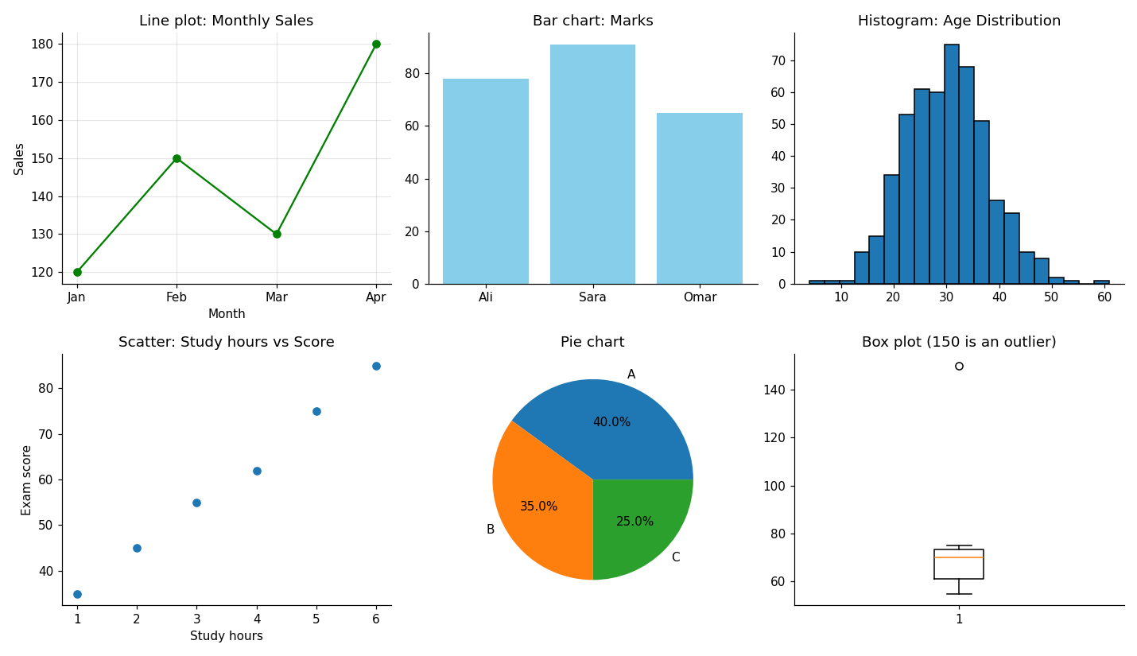
How to read it: the line plot shows sales rising in April. The histogram has a bell shape centred near 30 (ages). The scatter plot rises from left to right: more study hours, higher scores. In the box plot, the lonely circle at 150 is an outlier.
2. Plotting straight from Pandas
df.groupby("city")["score"].mean().plot(kind="bar")
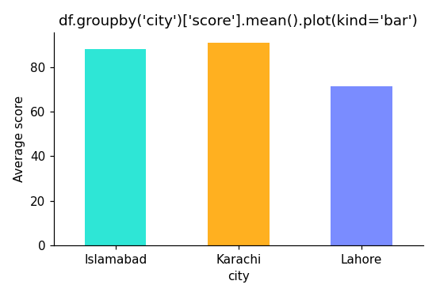
Lahore averages 71.5 (78 and 65), Karachi 91 and Islamabad 88.
3. Seaborn: histogram with KDE, box plot, count plot and correlation heatmap (Iris dataset)
import seaborn as sns
sns.histplot(data=df, x="sepal_length", hue="species", kde=True)
sns.boxplot(x="species", y="petal_length", data=df)
sns.countplot(x="species", hue="big_petal", data=df)
sns.heatmap(df.corr(numeric_only=True), annot=True, cmap="coolwarm")
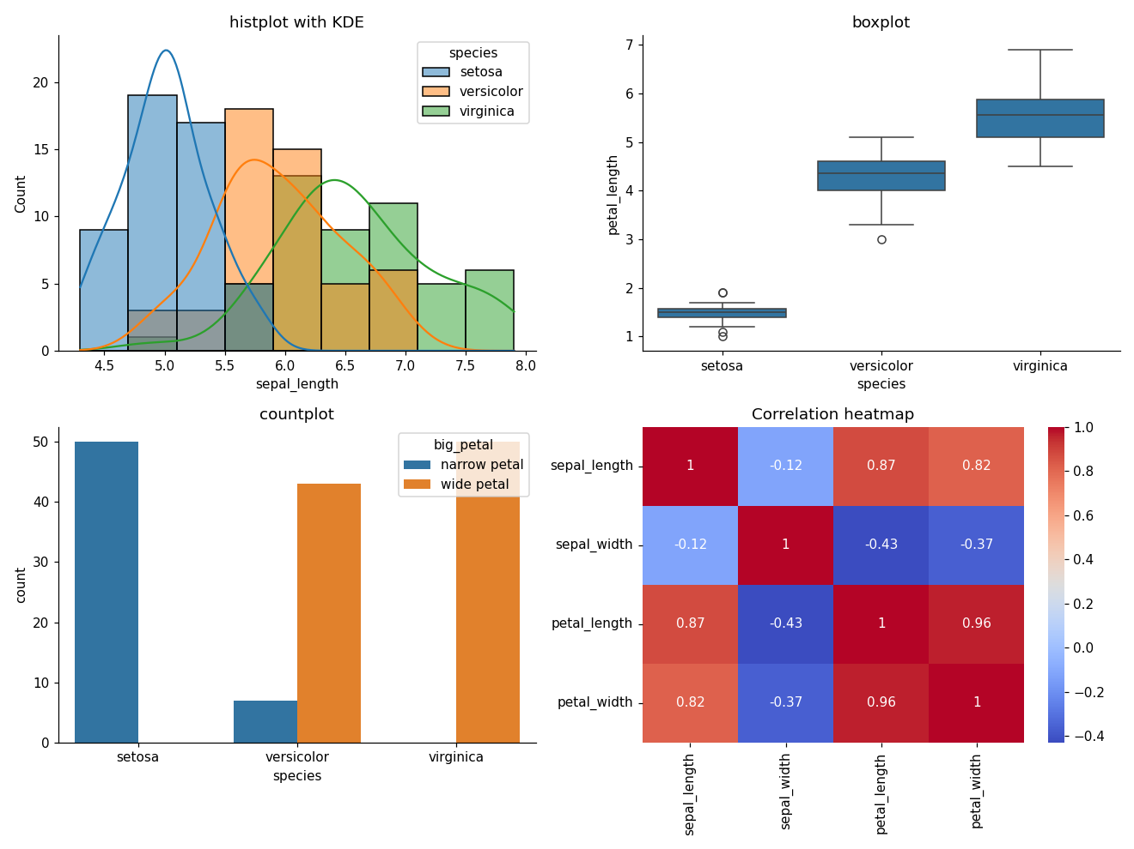
How to read it: in the box plot, the three species have clearly different petal lengths, so petal length is a very useful feature for a classifier. In the heatmap, a number close to 1 (dark red) means two features rise together. Petal length and petal width have a correlation of about 0.96, so they carry almost the same information.
4. Seaborn pairplot: the whole dataset in one picture
sns.pairplot(df, hue="species")
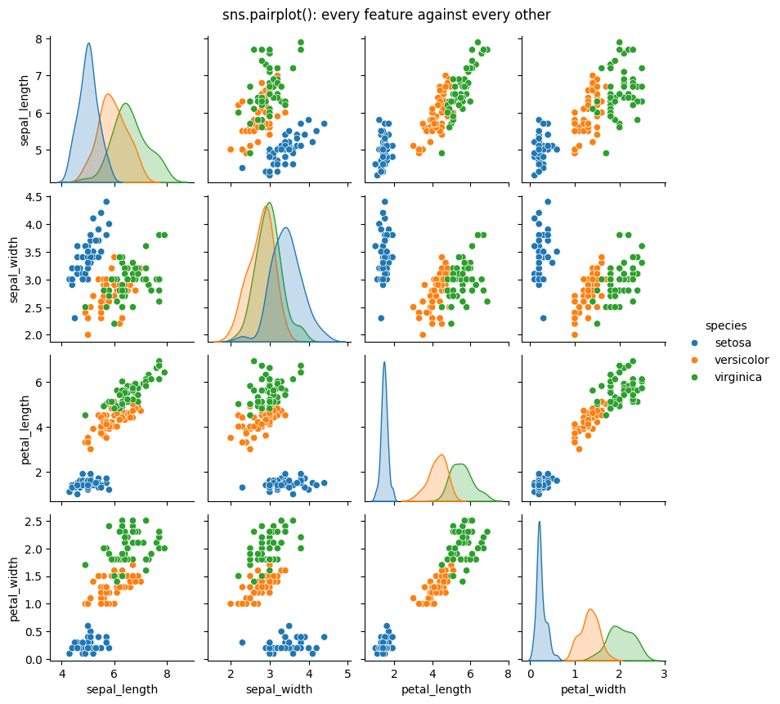
Every small chart compares two features, and the diagonal shows each feature's distribution. The three colours (species) form separate groups, which is why machine learning works so well on this dataset.

Part 3: Machine Learning Foundations
Machine learning is a big field. This book splits it into the three families that every engineer must know:
- Supervised learning (Part 4): learn from examples that have correct answers.
- Unsupervised learning (Part 5): find patterns in data without answers.
- Reinforcement learning (Part 6): learn by trial and error, using rewards.
This part gives you the foundations that all three families share: what machine learning is, and how to prepare data. Parts 7 and 8 then show how to improve models and how to move into deep learning.

Chapter 14: What Is Machine Learning?
Definition: Machine Learning (ML) is a part of artificial intelligence in which a computer learns patterns from data and uses them to make predictions or decisions, instead of being given fixed rules by a programmer. Artificial Intelligence (AI) is the wider goal of making machines behave intelligently, and Data Science is the field of getting useful knowledge out of data.

The simple idea
In normal programming, you write the rules, give data, and get answers.
In machine learning, you give data and answers, and the computer discovers the rules by itself.
Example: to detect spam, you could write rules by hand ("if the email contains 'free money' then spam"), but spammers change their words daily. Instead, you show a model 100,000 emails labeled spam or not spam, and it learns the patterns.

AI vs ML vs Deep Learning vs Data Science
Definition: Artificial Intelligence (AI) is the big goal of making machines do tasks that normally need human intelligence, such as understanding speech, recognizing faces or making decisions.
Definition: Machine Learning (ML) is the "learning" way of reaching AI: instead of a person writing every rule, the computer learns the rules from examples. Deep Learning (DL) is one special kind of ML that uses neural networks with many layers. Think of AI as a whole forest, ML as a large group of trees in it, and deep learning as one particular kind of tree.
Definition: Data Science is the work of using data, with statistics, programming, charts and ML, to answer questions and help people make decisions. A data scientist is like a detective who finds clues inside data.
- Artificial Intelligence (AI): the big goal, machines that act intelligently.
- Machine Learning (ML): a way to achieve AI by learning from data.
- Deep Learning (DL): ML using many-layered neural networks.
- Data Science: using data (statistics, programming, ML, visualization) to answer questions and make decisions.

Types of machine learning
Definition: Supervised learning is called learning with a teacher. The data comes with the correct answers (called labels), and the model learns to match each input to its answer, like a student who practises with solved exam questions.
Definition: Unsupervised learning is called learning without a teacher. The data has no answers, and the model finds groups and patterns by itself, like sorting a pile of mixed fruit into heaps without being told their names.
Definition: Reinforcement learning is called learning by trial and reward. An agent tries actions, gets a reward for good ones and a penalty for bad ones, and slowly learns what works, like training a dog with treats.
Definition: Regression is supervised learning that predicts a number, such as a price or a temperature. Classification is supervised learning that predicts a category, such as spam or not spam. Clustering is unsupervised learning that groups similar rows together. Dimensionality reduction is unsupervised learning that shrinks many columns into a few useful ones, like a short summary of a long book.
1. Supervised learning: learning from labeled examples (input and the correct answer).
- Regression: predict a number (house price, temperature).
- Classification: predict a category (spam or not, disease or healthy).
2. Unsupervised learning: finding hidden structure in unlabeled data.
- Clustering: grouping similar customers.
- Dimensionality reduction: simplifying data with many features.
3. Reinforcement learning: an agent learns by trial and reward, like training a dog or a game-playing AI.

Key vocabulary
Term | Meaning | Example (house prices)
Dataset | The whole table of data | 5,000 houses
Feature (X) | Input column | area, bedrooms, location
Target / Label (y) | What we predict | price
Sample / Row | One example | one house
Model | The learned rule | formula predicting price
Training | Model learns from data | model.fit()
Prediction | Model's answer for new data | model.predict()

The ML workflow
Definition: The ML workflow is the series of steps in a machine learning project: define the problem, collect data, clean it, build features, split it, train a model, evaluate it, improve it and deploy it.

Syntax: the scikit-learn pattern (used for almost every model)
from sklearn.model_selection import train_test_split
from sklearn.some_module import SomeModel # 1. import the model
X_train, X_test, y_train, y_test = train_test_split(X, y, test_size=0.2, random_state=42)
model = SomeModel(hyperparameter=value) # 2. create the model (an object)
model.fit(X_train, y_train) # 3. train: learn from the training data
predictions = model.predict(X_test) # 4. predict on new data
score = model.score(X_test, y_test) # 5. evaluate
X is the table of features (2-D) and y is the target column (1-D). Learn this five-step pattern once, and every algorithm in this book will feel familiar.
- Define the problem (regression? classification?).
- Collect data.
- Clean the data and do EDA (Exploratory Data Analysis).
- Engineer features.
- Split into training and test sets.
- Choose and train a model.
- Evaluate on the test set.
- Improve (tune, try other models, get more data).
- Deploy and monitor.

The most important concept: generalization
Definition: Generalization is a model's ability to perform well on new data it has never seen. Overfitting means the model memorized the training data (including its noise) and fails on new data. Underfitting means the model is too simple to learn the real pattern.
A good model performs well on new data it has never seen, not just on the data it studied. A student who memorizes last year's exam answers fails if the questions change. That student overfits.
- Overfitting: learns the training data too well (including noise). High training score, low test score.
- Underfitting: too simple to learn the pattern. Low scores everywhere.
- Good fit: captures the real pattern and generalizes.
This is why we always keep a test set hidden until the end.

Practice
For each problem, say whether it is regression, classification or clustering:
- Predicting tomorrow's temperature.
- Deciding whether a bank transaction is fraud.
- Grouping news articles by topic with no labels.
- Predicting a student's final marks.

Chapter 15: Data Preprocessing and EDA
Definition: Data preprocessing is the cleaning and preparing of raw data (fixing gaps, errors and formats) so that a model can learn from it. Garbage in, garbage out: a model is only as good as its data.
Beginners focus on algorithms. Professionals spend most of their time on data. Models are only as good as the data you feed them (garbage in, garbage out).

Step 1: Exploratory Data Analysis (EDA)
Definition: Exploratory Data Analysis (EDA) is the process of studying a dataset with statistics and charts to understand its shape, quality and patterns before building a model.

Syntax
df.head() df.info() df.describe() # first look
df.isnull().sum() # missing values
df["target"].value_counts() # class balance
df.corr(numeric_only=True) # correlation between numeric columns
sns.countplot(x="column", data=df) # count of each category

import pandas as pd, seaborn as sns, matplotlib.pyplot as plt
df = pd.read_csv("titanic.csv")
df.head()
df.info()
df.describe()
df.isnull().sum()
df["Survived"].value_counts()
Ask questions:
- How many rows and columns do I have?
- What are the data types?
- Which columns have missing values?
- Are the classes balanced (for classification)?
- Are there outliers?
- Which features are related to the target?
sns.countplot(x="Sex", hue="Survived", data=df)
sns.histplot(df["Age"].dropna(), kde=True)
sns.heatmap(df.corr(numeric_only=True), annot=True)
plt.show()

Step 2: Handling missing values
Definition: Imputation is the replacement of missing values by estimated ones (the mean, median or most frequent value). In scikit-learn the SimpleImputer does this and remembers the value it learned.

Syntax
from sklearn.impute import SimpleImputer
imputer = SimpleImputer(strategy="median") # "mean", "median", "most_frequent", "constant"
imputer.fit(X_train) # learn the fill value from training data
X_train = imputer.transform(X_train) # fill
X_test = imputer.transform(X_test) # fill test data with the SAME value
# shortcut for training data: imputer.fit_transform(X_train)
Use SimpleImputer so the same rule can be applied to new data later.
from sklearn.impute import SimpleImputer
imputer = SimpleImputer(strategy="median") # "mean", "most_frequent"
df[["Age"]] = imputer.fit_transform(df[["Age"]])

Step 3: Outliers
Definition: An outlier is a value that is unusually far from the others. The IQR rule calls a value an outlier if it is more than 1.5 times the interquartile range (Q3 minus Q1) below Q1 or above Q3.

Syntax
Q1 = df["col"].quantile(0.25)
Q3 = df["col"].quantile(0.75)
IQR = Q3 - Q1
lower = Q1 - 1.5 * IQR
upper = Q3 + 1.5 * IQR
df = df[(df["col"] >= lower) & (df["col"] <= upper)] # keep values inside the limits
Outliers are extreme values. Use a box plot to spot them, and the IQR rule to filter them:
Q1 = df["Fare"].quantile(0.25)
Q3 = df["Fare"].quantile(0.75)
IQR = Q3 - Q1
lower, upper = Q1 - 1.5 * IQR, Q3 + 1.5 * IQR
df_clean = df[(df["Fare"] >= lower) & (df["Fare"] <= upper)]
Do not blindly delete outliers. A billionaire's income is a real value. Ask whether it is an error or a genuine rare case.

Step 4: Encoding categorical data
Definition: Encoding converts text categories into numbers. Label encoding gives each category a number (good for ordered categories). One-hot encoding creates a separate 0/1 column for each category (good for unordered ones).

Syntax
df["col"] = df["col"].map({"Low": 0, "Medium": 1, "High": 2}) # label encoding
df = pd.get_dummies(df, columns=["col"], drop_first=True) # one-hot encoding
Models need numbers, not text.
# Label encoding: for ordered categories (Low < Medium < High)
df["size"] = df["size"].map({"Small": 0, "Medium": 1, "Large": 2})
# One-hot encoding: for unordered categories (city, colour)
df = pd.get_dummies(df, columns=["Embarked"], drop_first=True)
One-hot encoding turns the column city into separate 0/1 columns such as city_Lahore, city_Karachi.

Step 5: Feature scaling
Definition: Feature scaling puts all numeric features on a similar scale. Standardization makes the mean 0 and the standard deviation 1. Min-max scaling squeezes values into the range 0 to 1.

Syntax
from sklearn.preprocessing import StandardScaler, MinMaxScaler
scaler = StandardScaler() # or MinMaxScaler()
X_train_scaled = scaler.fit_transform(X_train) # learn from train AND apply
X_test_scaled = scaler.transform(X_test) # only apply to test
If one feature is in thousands (salary) and another is 0 to 10 (rating), distance-based models get confused. Scaling puts features on a similar scale.
from sklearn.preprocessing import StandardScaler, MinMaxScaler
scaler = StandardScaler() # mean 0, std 1
X_scaled = scaler.fit_transform(X)
minmax = MinMaxScaler() # squeezes values into 0 to 1
Standardization formula: z = (x - mean) / std. Each value becomes "how many standard deviations from average."
Models needing scaling: KNN, SVM, Logistic/Linear Regression (with regularization), Neural Networks, PCA. Tree-based models do not need it.

Step 6: Train/test split (and avoiding data leakage)
Definition: The train/test split divides data into a training set (the model learns from it) and a test set (kept hidden to check performance). Data leakage happens when information from the test set sneaks into training, which makes the results falsely good.

Syntax
from sklearn.model_selection import train_test_split
X_train, X_test, y_train, y_test = train_test_split(
X, y,
test_size=0.2, # fraction used for testing
random_state=42, # makes the split repeatable
stratify=y # keep class proportions (classification only)
)

from sklearn.model_selection import train_test_split
X = df.drop("Survived", axis=1) # features
y = df["Survived"] # target
X_train, X_test, y_train, y_test = train_test_split(
X, y, test_size=0.2, random_state=42, stratify=y
)
- test_size=0.2 keeps 20% for testing.
- random_state=42 makes results repeatable.
- stratify=y keeps the class proportions equal in both sets.
Data leakage warning: fit the scaler/imputer only on the training data, then apply it to the test data.
scaler = StandardScaler()
X_train_s = scaler.fit_transform(X_train) # learn from train
X_test_s = scaler.transform(X_test) # only apply to test
If you fit on all data, information from the test set leaks into training and your score becomes falsely optimistic.

Practice
- Do a full EDA on the Titanic dataset and write 5 findings.
- One-hot encode the Embarked and Sex columns.
- Split the data and scale it correctly without leakage.

Run it yourself: the whole preprocessing workflow, with output
The Titanic file is not bundled with Python, so this runnable example uses a small Titanic-style table that you can type in directly.
import pandas as pd, numpy as np
from sklearn.impute import SimpleImputer
from sklearn.preprocessing import StandardScaler
from sklearn.model_selection import train_test_split
df = pd.DataFrame({
"Age": [22, 38, 26, 35, np.nan, 54, 2, 27, 14, 58],
"Fare": [7.25, 71.28, 7.92, 53.1, 8.05, 51.86, 21.07, 11.13, 30.07, 512.33],
"Sex": ["male", "female", "female", "female", "male", "male", "male", "female", "female", "male"],
"Survived": [0, 1, 1, 1, 0, 0, 0, 1, 1, 1],
})
df.info()
print(df.isnull().sum())
print(df["Survived"].value_counts())
# Step 2: fill the missing age with the median
imputer = SimpleImputer(strategy="median")
df[["Age"]] = imputer.fit_transform(df[["Age"]])
print("Median age used:", imputer.statistics_[0])
# Step 3: IQR rule for Fare
Q1, Q3 = df["Fare"].quantile(0.25), df["Fare"].quantile(0.75)
IQR = Q3 - Q1
lower, upper = Q1 - 1.5 * IQR, Q3 + 1.5 * IQR
print("Q1:", Q1, "Q3:", Q3, "IQR:", IQR)
print("Allowed range:", round(lower, 2), "to", round(upper, 2))
print("Outliers:", df[(df["Fare"] < lower) | (df["Fare"] > upper)]["Fare"].tolist())
# Step 4: one-hot encoding
df = pd.get_dummies(df, columns=["Sex"], drop_first=True)
print(df.head(3))
# Step 5 and 6: split first, then scale (no leakage)
X = df.drop("Survived", axis=1)
y = df["Survived"]
X_train, X_test, y_train, y_test = train_test_split(X, y, test_size=0.2, random_state=42, stratify=y)
print("Train shape:", X_train.shape, "Test shape:", X_test.shape)
scaler = StandardScaler()
X_train_s = scaler.fit_transform(X_train)
X_test_s = scaler.transform(X_test)
print("Train mean after scaling:", X_train_s.mean(axis=0).round(2))
print("Train std after scaling :", X_train_s.std(axis=0).round(2))
Output:
<class 'pandas.DataFrame'>
RangeIndex: 10 entries, 0 to 9
Data columns (total 4 columns):
# Column Non-Null Count Dtype
--- ------ -------------- -----
0 Age 9 non-null float64
1 Fare 10 non-null float64
2 Sex 10 non-null str
3 Survived 10 non-null int64
dtypes: float64(2), int64(1), str(1)
Age 1
Fare 0
Sex 0
Survived 0
dtype: int64
Survived
1 6
0 4
Name: count, dtype: int64
Median age used: 27.0
Q1: 8.82 Q3: 52.79 IQR: 43.97
Allowed range: -57.14 to 118.74
Outliers: [512.33]
Age Fare Survived Sex_male
0 22.0 7.25 0 True
1 38.0 71.28 1 False
2 26.0 7.92 1 False
Train shape: (8, 3) Test shape: (2, 3)
Train mean after scaling: [-0. 0. 0.]
Train std after scaling : [1. 1. 1.]
How to read it, step by step:
- EDA: Age has 9 of 10 values, so one is missing. 6 passengers survived and 4 did not (the classes are fairly balanced).
- Imputation: the missing age was filled with the median, 27.0.
- Outliers: the fare 512.33 is far outside the allowed range of -57 to 118.74, so it is flagged as an outlier. In the real Titanic data, a few first-class tickets really cost that much, so you would keep it or transform it instead of deleting it.
- Encoding: Sex became one column, Sex_male (True means male). In older Pandas versions you will see 1 and 0 instead of True and False.
- Split: 8 rows for training and 2 for testing.
- Scaling: after standardization, each training column has a mean of 0 and a standard deviation of 1. The scaler learned these numbers from the training data only, which avoids data leakage.

Part 4: Supervised Learning
In supervised learning every training example comes with the correct answer (the label), like a student who practises with an answer key. The model studies thousands of solved examples and learns the rule that connects the features (X) to the answer (y). Afterwards, it predicts answers for new, unseen data.
There are two kinds of supervised problems:
- Regression: the answer is a number (house price, exam score, temperature).
- Classification: the answer is a category (spam or not spam, disease or healthy, species of a flower).
Chapter | Algorithm | Type
16 | Linear Regression, Ridge and Lasso | Regression
17 | Logistic Regression | Classification
18 | Decision Trees, Random Forests, Boosting | Both
19 | KNN, SVM, Naive Bayes | Mostly classification
Every algorithm in this part follows the same five steps you met in Chapter 14: import, create, fit, predict and evaluate.

Chapter 16: Linear Regression
Definition: Linear regression is a supervised learning algorithm that predicts a number by fitting the best straight line (or flat plane) through the data. Regression means predicting a number. The slope is how much the answer changes when a feature increases by one, and the intercept is the answer when all features are zero.

The idea
Imagine you want to predict a student's exam score from the hours they studied. You plot the data and see the points roughly form a line going upward. Linear regression finds the best straight line through the points.
The line's equation is the one you learned in school:
y = m x + b
- x is the input (hours studied)
- y is the prediction (exam score)
- m is the slope (how much the score rises per extra hour)
- b is the intercept (the score with zero hours)
With many features, it becomes: y = w1 x1 + w2 x2 + ... + b, where each w is a weight showing how important that feature is.

How does the model find the best line?
Definition: A residual (prediction error) is the gap between the real value and the predicted value, like the distance between where a dart landed and the bullseye. A loss function adds up all these gaps into one score that tells the model how wrong it is; a lower loss means a better line, like fewer marks lost in an exam.
Definition: Gradient descent is the method of improving the model step by step, always moving in the direction that lowers the loss, like walking downhill in fog until you reach the valley. The learning rate is the size of each step.
It tries a line, measures how wrong it is, and adjusts.
- Prediction error (residual): actual minus predicted.
- Loss function: Mean Squared Error (MSE) = the average of the squared errors. Squaring makes all errors positive and punishes big mistakes more.
- Gradient descent: imagine standing on a foggy hill and wanting to reach the valley. You feel the slope under your feet and take a small step downhill, again and again. Each step changes the weights to reduce the loss. The step size is the learning rate.
Too large a learning rate and you overshoot the valley. Too small and learning takes forever.

Code: predicting exam scores

Syntax
from sklearn.linear_model import LinearRegression
model = LinearRegression()
model.fit(X_train, y_train)
model.coef_ # the slopes (weights)
model.intercept_ # the intercept (b)
y_pred = model.predict(X_test)

import numpy as np
import pandas as pd
from sklearn.linear_model import LinearRegression
from sklearn.model_selection import train_test_split
from sklearn.metrics import mean_squared_error, r2_score, mean_absolute_error
import matplotlib.pyplot as plt
# 1. Create a simple dataset
data = pd.DataFrame({
"hours": [1, 2, 3, 4, 5, 6, 7, 8, 9, 10],
"score": [35, 42, 50, 55, 62, 68, 74, 80, 85, 93]
})
X = data[["hours"]] # double brackets: X must be 2D (a DataFrame)
y = data["score"] # y is 1D (a Series)
# 2. Split
X_train, X_test, y_train, y_test = train_test_split(
X, y, test_size=0.2, random_state=42
)
# 3. Create and train the model
model = LinearRegression()
model.fit(X_train, y_train)
print("Slope (m):", model.coef_[0])
print("Intercept (b):", model.intercept_)
# 4. Predict
y_pred = model.predict(X_test)
print(model.predict(pd.DataFrame({"hours": [7.5]})))
# 5. Evaluate
print("MAE :", mean_absolute_error(y_test, y_pred))
print("RMSE:", np.sqrt(mean_squared_error(y_test, y_pred)))
print("R2 :", r2_score(y_test, y_pred))
# 6. Visualize
plt.scatter(X, y, label="Actual")
plt.plot(X, model.predict(X), color="red", label="Model")
plt.xlabel("Hours studied")
plt.ylabel("Score")
plt.legend()
plt.show()
Common error: ValueError: Expected 2D array, got 1D array. It happens when you pass X as a Series (data["hours"]). Fix: use double brackets data[["hours"]], because scikit-learn expects features as a table with rows and columns.

Regression metrics explained
Definition: A metric is a number that measures how good a model is. MAE is the average size of the errors, MSE is the average of the squared errors, RMSE is the square root of MSE (in the units of the target), and R-squared is the share of the variation that the model explains.

Syntax
from sklearn.metrics import mean_absolute_error, mean_squared_error, r2_score
mean_absolute_error(y_true, y_pred)
mean_squared_error(y_true, y_pred) # take np.sqrt() of it for RMSE
r2_score(y_true, y_pred)
The actual values always come first, then the predictions.
Metric | Meaning | Good value
MAE | Average absolute error, in the same units as the target | Lower is better
MSE | Average squared error | Lower is better
RMSE | Square root of MSE, in the target's units | Lower is better
R-squared | Share of variation the model explains (1 = perfect, 0 = no better than guessing the mean) | Closer to 1

Multiple linear regression and assumptions
Definition: Multiple linear regression is linear regression that uses more than one input feature at the same time, such as area, bedrooms and age together to predict a price. Multicollinearity means that two features carry almost the same information, like a temperature given in both Celsius and Fahrenheit. An assumption is a condition that should be roughly true for the model to be trustworthy.
Using several features (area, bedrooms, age) is just X = df[["area", "bedrooms", "age"]]. Linear regression works best when:
- The relationship is roughly linear.
- Features are not too strongly correlated with each other (multicollinearity).
- Errors are roughly evenly spread.
- Outliers are limited.

Polynomial regression, Ridge and Lasso
Definition: Polynomial regression fits a curve by adding powers of the features (x squared, x cubed). Regularization adds a penalty on large weights to keep the model simple. Ridge shrinks all weights, and Lasso can shrink some of them to exactly zero.

Syntax
from sklearn.preprocessing import PolynomialFeatures
from sklearn.pipeline import make_pipeline
from sklearn.linear_model import Ridge, Lasso
make_pipeline(PolynomialFeatures(degree=2), LinearRegression())
Ridge(alpha=1.0) # alpha = strength of the penalty (bigger = simpler model)
Lasso(alpha=0.1)
If data curves, add polynomial features:
from sklearn.preprocessing import PolynomialFeatures
from sklearn.pipeline import make_pipeline
poly_model = make_pipeline(PolynomialFeatures(degree=2), LinearRegression())
poly_model.fit(X_train, y_train)
If the model overfits, add regularization, a penalty on large weights:
from sklearn.linear_model import Ridge, Lasso
ridge = Ridge(alpha=1.0).fit(X_train, y_train) # shrinks weights
lasso = Lasso(alpha=0.1).fit(X_train, y_train) # can set weights to exactly 0 (feature selection)

Practice
- Use a house price dataset (for example, the California housing dataset from sklearn.datasets). Train a linear regression model and report RMSE and R-squared.
- Compare the plain model with Ridge. Which is better on the test set?
- Try adding polynomial features. Did the training score go up but the test score go down? That is overfitting.

Output of the code above (real run)
Slope (m): 6.336206896551724
Intercept (b): 29.775862068965516
[77.29741379]
MAE : 1.125
RMSE: 1.3128520704399633
R2 : 0.9962713238315662
How to read the output, like a teacher:
- Slope 6.34: every extra study hour adds about 6.3 marks.
- Intercept 29.8: with zero hours of study, the line starts at about 30 marks.
- [77.29]: the model predicts about 77 marks for a student who studies 7.5 hours.
- MAE 1.125: on average the prediction is wrong by about 1 mark.
- R2 0.996: the line explains 99.6 percent of the changes in the marks. Our data is tiny and almost perfectly straight, so real-world data will give a lower R2. The test set has only 2 rows here, so treat the metrics as a demonstration.

Visualization: the best-fit line and its residuals
fig, ax = plt.subplots(1, 2, figsize=(11, 4))
ax[0].scatter(X, y, label="Actual")
ax[0].plot(X, model.predict(X), color="red", label="Model")
residuals = y - model.predict(X)
ax[1].bar(X["hours"], residuals)
plt.show()
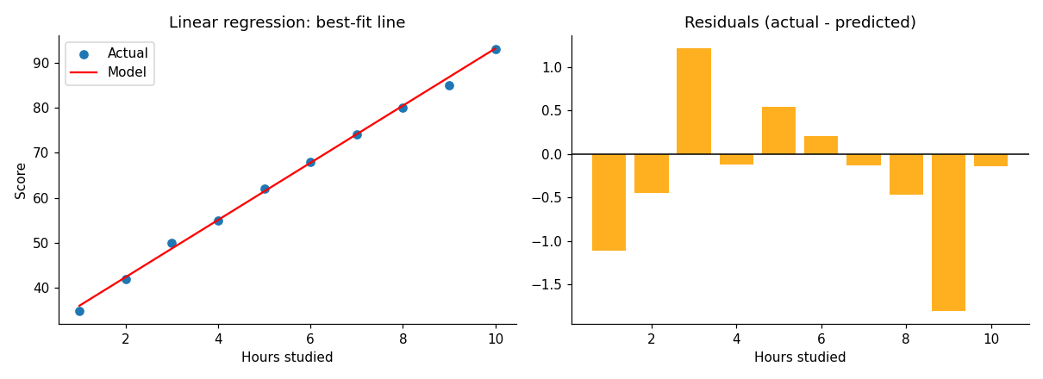
Left: the red line is the model. Right: each bar is the error (actual minus predicted). Bars near zero mean good predictions.

Visualization: underfitting, good fit and overfitting
for degree in [1, 4, 15]:
m = make_pipeline(PolynomialFeatures(degree), StandardScaler(), LinearRegression())
m.fit(x_train.reshape(-1, 1), y_train) # then plot m.predict(...) as a red curve
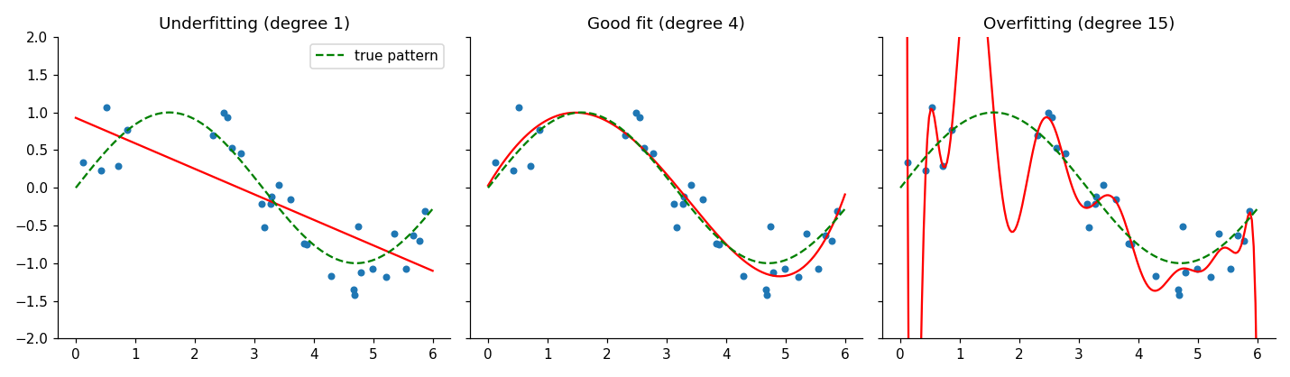
Degree 1 is a straight line that is too simple (underfitting). Degree 4 follows the real pattern (the green dashed curve). Degree 15 wiggles through every noisy point (overfitting): it will fail on new data.

Chapter 17: Logistic Regression and Classification
Definition: Classification means predicting a category. Logistic regression is a classification algorithm that turns a weighted sum of the features into a probability between 0 and 1 using the sigmoid function. If the probability is above the threshold (usually 0.5), it predicts class 1.

From numbers to categories
Sometimes we want a category, not a number: will this customer leave (yes/no)? Is this tumor harmful or harmless? That is classification.
Logistic regression, despite its name, is a classification algorithm. It calculates a score like linear regression, then squeezes it into a probability between 0 and 1 using the sigmoid function:
probability = 1 / (1 + e^(-z)), where z = w1 x1 + w2 x2 + ... + b
The sigmoid draws an S-shaped curve: big negative scores become close to 0, big positive scores become close to 1.
If the probability is above a threshold (usually 0.5), the model predicts class 1, otherwise class 0.

Code: predicting Titanic survival

Syntax
from sklearn.linear_model import LogisticRegression
model = LogisticRegression()
model.fit(X_train, y_train)
model.predict(X_test) # predicted class (0 or 1)
model.predict_proba(X_test) # probabilities for each class

import pandas as pd
from sklearn.model_selection import train_test_split
from sklearn.linear_model import LogisticRegression
from sklearn.preprocessing import StandardScaler
from sklearn.metrics import accuracy_score, classification_report, confusion_matrix
df = pd.read_csv("titanic.csv")
# Simple preprocessing
df["Age"] = df["Age"].fillna(df["Age"].median())
df["Sex"] = df["Sex"].map({"male": 0, "female": 1})
features = ["Pclass", "Sex", "Age", "Fare"]
X = df[features]
y = df["Survived"]
X_train, X_test, y_train, y_test = train_test_split(
X, y, test_size=0.2, random_state=42, stratify=y
)
scaler = StandardScaler()
X_train = scaler.fit_transform(X_train)
X_test = scaler.transform(X_test)
model = LogisticRegression()
model.fit(X_train, y_train)
y_pred = model.predict(X_test)
probs = model.predict_proba(X_test)[:, 1] # probability of class 1
print("Accuracy:", accuracy_score(y_test, y_pred))
print(confusion_matrix(y_test, y_pred))
print(classification_report(y_test, y_pred))

Understanding the confusion matrix
Definition: The confusion matrix is a table that counts correct and wrong predictions for each class. Accuracy is the share of all predictions that were right. Precision is the share of predicted positives that were truly positive. Recall is the share of real positives that were found. F1-score balances precision and recall.

Syntax
from sklearn.metrics import accuracy_score, precision_score, recall_score, f1_score
from sklearn.metrics import confusion_matrix, classification_report
accuracy_score(y_true, y_pred)
confusion_matrix(y_true, y_pred)
classification_report(y_true, y_pred) # precision, recall and F1 for every class
For a medical test predicting disease:
 | Predicted: No | Predicted: Yes
Actual: No | True Negative (TN) | False Positive (FP)
Actual: Yes | False Negative (FN) | True Positive (TP)
- Accuracy = (TP + TN) / total. How often the model is right overall.
- Precision = TP / (TP + FP). Of those predicted positive, how many really are? Important when false alarms are costly (spam filter).
- Recall = TP / (TP + FN). Of all real positives, how many did we catch? Important when missing a case is dangerous (cancer detection).
- F1-score: the balance between precision and recall.
Why accuracy can mislead: if 99% of transactions are not fraud, a model that always says "not fraud" gets 99% accuracy but catches nothing. Always check precision, recall and F1 on imbalanced data.

ROC curve and AUC
Definition: The ROC curve plots the true positive rate against the false positive rate for every possible threshold. AUC is the area under that curve: 1.0 is perfect and 0.5 is no better than guessing.

Syntax
from sklearn.metrics import roc_auc_score
probabilities = model.predict_proba(X_test)[:, 1] # probability of class 1
roc_auc_score(y_test, probabilities)
The ROC curve shows the trade-off between catching positives and raising false alarms across all thresholds. AUC (area under the curve) summarizes it: 0.5 is random guessing, 1.0 is perfect.
from sklearn.metrics import roc_auc_score
print("AUC:", roc_auc_score(y_test, probs))

Practice
- Change the threshold from 0.5 to 0.3 using probs > 0.3. What happens to recall and precision?
- Add the SibSp and Parch columns as features. Does accuracy improve?
- Explain, in your own words, when you would prefer recall over precision.

Run it yourself: output on a built-in dataset
The Titanic file is not bundled with Python, so here is the same workflow on scikit-learn's built-in breast cancer dataset (diagnose a tumour as malignant or benign). You can run it without downloading anything.
from sklearn.datasets import load_breast_cancer
from sklearn.model_selection import train_test_split
from sklearn.preprocessing import StandardScaler
from sklearn.linear_model import LogisticRegression
from sklearn.metrics import accuracy_score, confusion_matrix, classification_report, roc_auc_score
data = load_breast_cancer()
X_train, X_test, y_train, y_test = train_test_split(
data.data, data.target, test_size=0.2, random_state=42, stratify=data.target)
scaler = StandardScaler()
X_train = scaler.fit_transform(X_train)
X_test = scaler.transform(X_test)
model = LogisticRegression(max_iter=1000).fit(X_train, y_train)
pred = model.predict(X_test)
probs = model.predict_proba(X_test)[:, 1]
print("Accuracy:", accuracy_score(y_test, pred))
print(confusion_matrix(y_test, pred))
print(classification_report(y_test, pred, target_names=data.target_names))
print("AUC:", roc_auc_score(y_test, probs))
Output:
Accuracy: 0.9824561403508771
[[41 1]
[ 1 71]]
precision recall f1-score support
malignant 0.98 0.98 0.98 42
benign 0.99 0.99 0.99 72
accuracy 0.98 114
macro avg 0.98 0.98 0.98 114
weighted avg 0.98 0.98 0.98 114
AUC: 0.9953703703703703
How to read it:
- Accuracy 0.98: the model is right for 112 of the 114 test patients.
- Confusion matrix: 41 malignant tumours were found correctly and 71 benign ones were correct. There was 1 mistake of each kind.
- AUC 0.995: the model separates the two classes almost perfectly (1.0 is perfect, 0.5 is guessing).

Effect of the threshold
threshold 0.5: precision=0.986 recall=0.986
threshold 0.9: precision=0.984 recall=0.847
When we demand 90 percent confidence before saying "benign", recall falls from 0.986 to 0.847. The model becomes more careful, but it misses more real cases. Choosing the threshold is a business decision.

Visualization: sigmoid, confusion matrix and ROC curve
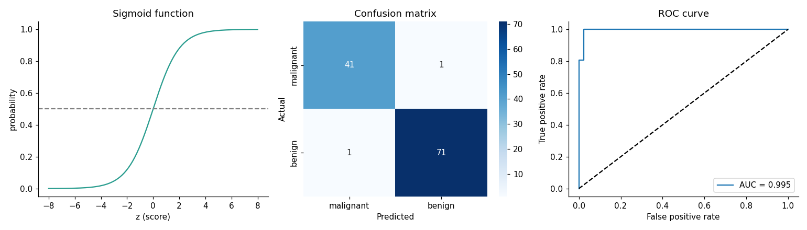
Left: the sigmoid squeezes any score into a probability between 0 and 1. Middle: the confusion matrix, where the dark diagonal holds the correct predictions. Right: the ROC curve hugs the top-left corner, which means an excellent model.

Chapter 18: Decision Trees and Random Forests
Definition: A decision tree is a model that predicts by asking a series of yes/no questions about the features, like a flowchart. It can be used for classification and regression. Gini impurity and entropy measure how mixed the classes in a group are, and the tree picks the questions that make the groups purer.

Decision trees: twenty questions
A decision tree makes predictions by asking a series of yes/no questions, like the game of twenty questions.

Syntax
from sklearn.tree import DecisionTreeClassifier, DecisionTreeRegressor
tree = DecisionTreeClassifier(
max_depth=3, # how many questions deep the tree may go
min_samples_leaf=5, # minimum rows in a final group
random_state=42
)
tree.fit(X_train, y_train)
tree.predict(X_test)
Use DecisionTreeRegressor when the target is a number.
Is the passenger female?
Yes -> Is class 1 or 2? -> Yes: Survived
No -> Is age < 10? -> Yes: Survived
How does the tree choose its questions? At each step it picks the question that best separates the classes, measured by Gini impurity or entropy. A pure group (all one class) has impurity 0. The tree splits to make the groups purer.
from sklearn.tree import DecisionTreeClassifier, plot_tree
import matplotlib.pyplot as plt
tree = DecisionTreeClassifier(max_depth=3, random_state=42)
tree.fit(X_train, y_train)
print("Train:", tree.score(X_train, y_train))
print("Test :", tree.score(X_test, y_test))
plt.figure(figsize=(14, 6))
plot_tree(tree, feature_names=features, filled=True)
plt.show()
Pros: easy to understand, no scaling needed, handles numbers and categories. Cons: a deep tree overfits easily by memorizing the training data.
Control overfitting using max_depth, min_samples_split and min_samples_leaf.

Random forests: wisdom of the crowd
Definition: A random forest is an ensemble (a team) of many decision trees, each trained on a random sample of rows and features. The trees vote, and the majority wins. This technique is called bagging, and it reduces overfitting.

Syntax
from sklearn.ensemble import RandomForestClassifier, RandomForestRegressor
forest = RandomForestClassifier(n_estimators=200, max_depth=6, random_state=42)
forest.fit(X_train, y_train)
forest.predict(X_test)
forest.feature_importances_ # importance of every feature
n_estimators is the number of trees.
Ask one person to guess the number of candies in a jar and they may be far off. Ask 100 people and average the answers, and you will be surprisingly close. A random forest builds many different trees and lets them vote.
Each tree is trained on a random sample of rows (bootstrap) and a random subset of features, so the trees make different mistakes, and the mistakes cancel out. This idea is called bagging (bootstrap aggregating).
from sklearn.ensemble import RandomForestClassifier
rf = RandomForestClassifier(n_estimators=200, max_depth=6, random_state=42)
rf.fit(X_train, y_train)
print("Test accuracy:", rf.score(X_test, y_test))
# Which features matter most?
importance = pd.Series(rf.feature_importances_, index=features)
print(importance.sort_values(ascending=False))
For regression, use DecisionTreeRegressor and RandomForestRegressor.

Boosting (next level)
Definition: Boosting is an ensemble method that builds models one after another, each one trying to fix the mistakes of the previous ones. Gradient Boosting, XGBoost and LightGBM are popular boosting libraries.

Syntax
from sklearn.ensemble import GradientBoostingClassifier, GradientBoostingRegressor
booster = GradientBoostingClassifier(n_estimators=100, learning_rate=0.1, max_depth=3)
booster.fit(X_train, y_train)
booster.predict(X_test)
Instead of building trees independently, boosting builds them one after another, each fixing the mistakes of the previous one. Gradient Boosting, XGBoost and LightGBM often win competitions on table data.
from sklearn.ensemble import GradientBoostingClassifier
gb = GradientBoostingClassifier().fit(X_train, y_train)

Which is better?
Start with a random forest as a strong baseline. It works well with little tuning. Move to boosting when you need extra accuracy and are willing to tune.

Practice
- Train trees with max_depth from 1 to 15. Plot training and test accuracy. Where does overfitting start?
- Compare a single tree, a random forest and gradient boosting on the same data.
- Show the top 3 most important features and explain whether they make sense.

Output (real run on the built-in Iris dataset)
from sklearn.datasets import load_iris
from sklearn.tree import DecisionTreeClassifier, plot_tree
from sklearn.ensemble import RandomForestClassifier, GradientBoostingClassifier
iris = load_iris()
X_train, X_test, y_train, y_test = train_test_split(
iris.data, iris.target, test_size=0.3, random_state=42, stratify=iris.target)
tree = DecisionTreeClassifier(max_depth=3, random_state=42).fit(X_train, y_train)
print("Tree Train:", round(tree.score(X_train, y_train), 3))
print("Tree Test :", round(tree.score(X_test, y_test), 3))
forest = RandomForestClassifier(n_estimators=200, max_depth=6, random_state=42).fit(X_train, y_train)
print("Forest Test accuracy:", round(forest.score(X_test, y_test), 3))
print(pd.Series(forest.feature_importances_, index=iris.feature_names).sort_values(ascending=False).round(3))
boost = GradientBoostingClassifier(random_state=42).fit(X_train, y_train)
print("Boosting Test accuracy:", round(boost.score(X_test, y_test), 3))

Tree Train: 0.981
Tree Test : 0.978
Forest Test accuracy: 0.911
petal length (cm) 0.431
petal width (cm) 0.427
sepal length (cm) 0.115
sepal width (cm) 0.027
Boosting Test accuracy: 0.933
How to read it: the tree gets 98 percent on both training and test data, so it is not overfitting at depth 3. The forest and boosting scores (91 percent and 93 percent) are close, and with only 45 test flowers, one flower changes the score by about 2 percent. Do not read too much into small differences. The importance table says that petal length and petal width do almost all the work in deciding the flower type.

Visualization: the decision tree and feature importance
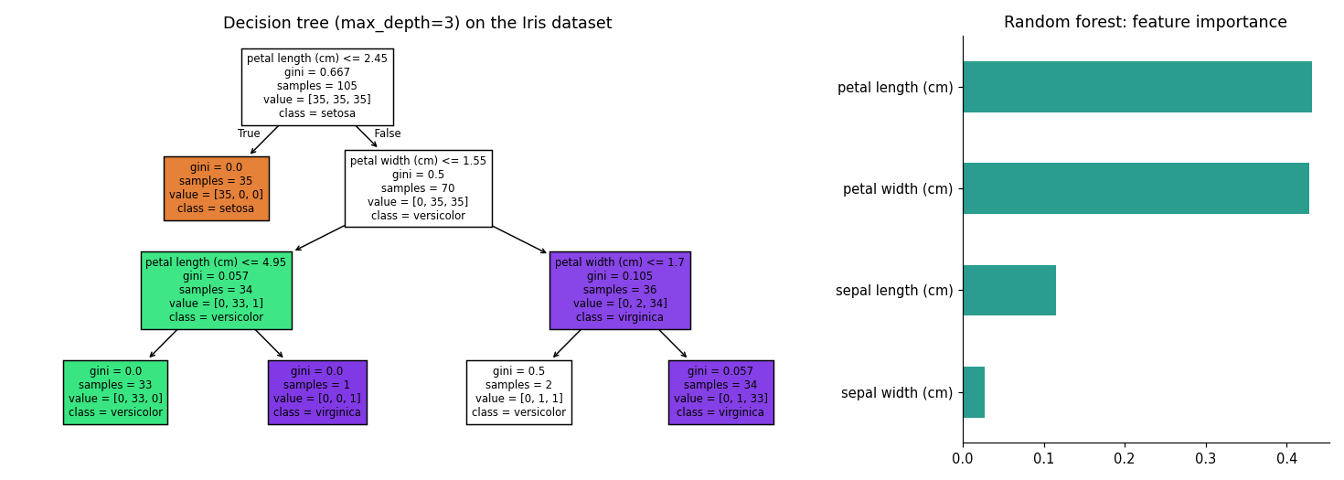
Read the tree from the top: the first question is "petal length <= 2.45?". If yes, the flower is setosa straight away (the orange box, gini = 0 means perfectly pure). Otherwise the tree asks about petal width, and so on. The darker the colour, the purer the group.

Visualization: when does a tree start to overfit?
This experiment uses the breast cancer data and changes max_depth from 1 to 15.
depth train test
1 0.927 0.912
3 0.980 0.924
5 0.995 0.930
10 1.000 0.918
15 1.000 0.918
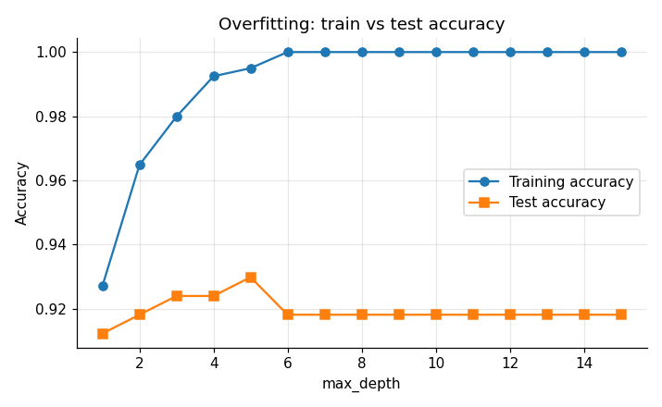
The training accuracy climbs to 100 percent (the tree memorizes the data), but the test accuracy stops improving after depth 5 and then drops slightly. The gap between the two lines is the sign of overfitting.

Chapter 19: KNN, SVM and Naive Bayes

K-Nearest Neighbors (KNN)
Definition: K-Nearest Neighbors (KNN) classifies a new point by finding the K closest training points and taking a majority vote. It needs scaled features because it works with distances.

Syntax
from sklearn.neighbors import KNeighborsClassifier, KNeighborsRegressor
knn = KNeighborsClassifier(n_neighbors=5) # K = 5
knn.fit(X_train_scaled, y_train) # scale the features first
knn.predict(X_test_scaled)
"Tell me who your friends are and I will tell you who you are." To classify a new point, KNN looks at its K closest neighbors and takes a majority vote.
How it works: (1) pick K, (2) measure the distance to every training point (usually Euclidean distance), (3) take the K nearest, (4) vote.
from sklearn.neighbors import KNeighborsClassifier
knn = KNeighborsClassifier(n_neighbors=5)
knn.fit(X_train, y_train) # data must be scaled!
print(knn.score(X_test, y_test))
- Small K: sensitive to noise (overfits). Large K: too smooth (underfits).
- Always scale features, because distance depends on size.
- It is slow on huge datasets because it compares with every point at prediction time.

Support Vector Machine (SVM)
Definition: A Support Vector Machine (SVM) finds the boundary that separates the classes with the widest margin. The points closest to the boundary are the support vectors. A kernel lets it draw curved boundaries.

Syntax
from sklearn.svm import SVC, SVR
svm = SVC(kernel="rbf", C=1.0, gamma="scale") # kernel: "linear", "rbf", "poly"
svm.fit(X_train_scaled, y_train)
svm.predict(X_test_scaled)
SVM finds the best dividing boundary between two classes, the one with the widest possible margin (empty street) between them. The points touching the margin are called support vectors.
For data that cannot be separated by a straight line, the kernel trick lifts the data into a higher dimension where a line works.
from sklearn.svm import SVC
svm = SVC(kernel="rbf", C=1.0, gamma="scale")
svm.fit(X_train, y_train)
print(svm.score(X_test, y_test))
- C controls strictness: large C allows fewer mistakes but may overfit.
- Needs scaling. Works well on small and medium datasets.

Naive Bayes
Definition: Naive Bayes is a classifier based on Bayes' theorem. It calculates the probability of each class given the features, and it naively assumes that the features are independent. It is fast and works very well for text.

Syntax
from sklearn.naive_bayes import MultinomialNB, GaussianNB
from sklearn.feature_extraction.text import CountVectorizer
vectorizer = CountVectorizer() # turns text into word counts
X = vectorizer.fit_transform(texts)
nb = MultinomialNB() # for counts (text); GaussianNB for normal numbers
nb.fit(X, labels)
nb.predict(vectorizer.transform(["new text"]))
Based on Bayes' theorem, it calculates the probability of each class given the features. It is called "naive" because it assumes features are independent of each other. This is rarely true, yet the algorithm still works well, especially for text classification like spam detection.
from sklearn.feature_extraction.text import CountVectorizer
from sklearn.naive_bayes import MultinomialNB
emails = ["win free money now", "meeting at 10 am", "free prize claim now", "project report attached"]
labels = [1, 0, 1, 0] # 1 = spam
vec = CountVectorizer()
X = vec.fit_transform(emails)
nb = MultinomialNB().fit(X, labels)
print(nb.predict(vec.transform(["claim your free money"]))) # [1]

Quick comparison
Algorithm | Strength | Weakness | Needs scaling?
Logistic Regression | Simple, fast, interpretable | Only linear boundaries | Yes
Decision Tree | Very interpretable | Overfits | No
Random Forest | Accurate, robust | Less interpretable | No
KNN | Easy idea | Slow on big data | Yes
SVM | Strong on small data | Slow on huge data | Yes
Naive Bayes | Great for text, very fast | Independence assumption | No

Practice
- Find the best K for KNN by testing K from 1 to 30 and plotting test accuracy.
- Train SVM with linear and rbf kernels. Compare.
- Build a small spam classifier with at least 10 messages of your own.

Output (real run on the breast cancer data, scaled)
scaler = StandardScaler().fit(X_train)
A, B = scaler.transform(X_train), scaler.transform(X_test)
accuracies = [KNeighborsClassifier(k).fit(A, y_train).score(B, y_test) for k in range(1, 31)]
print("Best K:", accuracies.index(max(accuracies)) + 1, "accuracy:", round(max(accuracies), 3))
print("SVM rbf:", round(SVC().fit(A, y_train).score(B, y_test), 3),
"| SVM linear:", round(SVC(kernel="linear").fit(A, y_train).score(B, y_test), 3))

Best K: 12 accuracy: 0.977
SVM rbf: 0.977 | SVM linear: 0.982
The spam example from the Naive Bayes section prints:
NB prediction: [1]
The value 1 means spam: the words "claim" and "free" appeared only in spam messages while training.
How to read it: KNN, SVM and logistic regression all reach about 98 percent on this dataset. When several models give similar results, prefer the simplest and easiest one to explain.

Visualization: choosing K for KNN
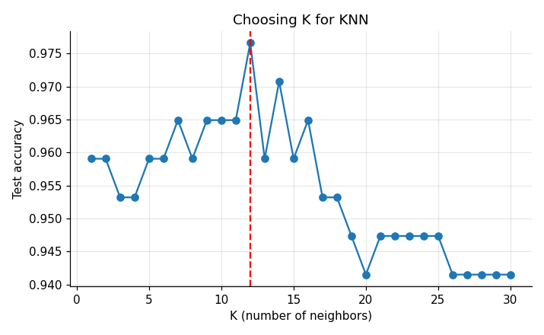
With K = 1 the model is too sensitive to single points. Accuracy improves as K grows and peaks around K = 12 (the red dashed line). Very large K would make the model too smooth and accuracy would fall again.

Part 5: Unsupervised Learning
In unsupervised learning the data has no target column, so there are no correct answers to learn from. The algorithm studies the data by itself and looks for structure: groups of similar rows (clustering) or a simpler way to describe the data (dimensionality reduction).
- Chapter 20 covers clustering with K-Means and dimensionality reduction with PCA.
Typical uses: grouping customers into types, finding unusual transactions, compressing data with hundreds of features, and exploring a new dataset. Because there is no right answer to compare with, you judge the result with scores such as inertia and the silhouette score, and with your own common sense about the business.

Chapter 20: Clustering and PCA (Unsupervised Learning)
Definition: Unsupervised learning finds patterns in data without labels. Clustering groups similar rows together, and dimensionality reduction reduces the number of features while keeping the important information.
In unsupervised learning there is no target column. We ask the data: "What natural groups or patterns do you contain?"

K-Means clustering
Definition: K-Means is a clustering algorithm that splits data into K groups. Each group has a centre point called a centroid, and each row belongs to the nearest centroid.

Syntax
from sklearn.cluster import KMeans
kmeans = KMeans(n_clusters=3, random_state=42, n_init=10)
labels = kmeans.fit_predict(X_scaled) # one cluster number per row
kmeans.cluster_centers_ # the centroids
kmeans.inertia_ # how tight the clusters are
There is no y here, because this is unsupervised learning.
Imagine a shop wants to group customers into types (big spenders, bargain hunters, occasional visitors) without anyone labeling them first.
How K-Means works:
- Choose the number of groups, K.
- Place K random centers (centroids).
- Assign every point to its nearest centroid.
- Move each centroid to the average of its points.
- Repeat steps 3 and 4 until nothing changes.
import pandas as pd
from sklearn.cluster import KMeans
from sklearn.preprocessing import StandardScaler
import matplotlib.pyplot as plt
customers = pd.DataFrame({
"income": [15, 16, 17, 60, 62, 65, 30, 32, 28, 90, 95, 88],
"spending": [80, 75, 85, 20, 25, 18, 50, 55, 48, 10, 12, 15]
})
X = StandardScaler().fit_transform(customers)
kmeans = KMeans(n_clusters=3, random_state=42, n_init=10)
customers["cluster"] = kmeans.fit_predict(X)
plt.scatter(customers["income"], customers["spending"], c=customers["cluster"])
plt.xlabel("Income")
plt.ylabel("Spending score")
plt.show()

How to choose K?
Definition: Inertia is the total squared distance between each point and its centroid (smaller means tighter clusters). The elbow method plots inertia for different K and picks the K where the curve bends. The silhouette score measures how well separated the clusters are (closer to 1 is better).

Syntax
inertias = []
for k in range(1, 11):
inertias.append(KMeans(n_clusters=k, n_init=10).fit(X).inertia_)
plt.plot(range(1, 11), inertias, marker="o") # look for the "elbow"
from sklearn.metrics import silhouette_score
silhouette_score(X, labels) # closer to 1 is better
Elbow method: run K-Means for K = 1 to 10 and plot the inertia (how tight the clusters are). Choose the K where the curve bends like an elbow.
inertias = []
for k in range(1, 8):
inertias.append(KMeans(n_clusters=k, random_state=42, n_init=10).fit(X).inertia_)
plt.plot(range(1, 8), inertias, marker="o")
plt.xlabel("K")
plt.ylabel("Inertia")
plt.show()
The silhouette score (sklearn.metrics.silhouette_score) is another check: closer to 1 means well-separated clusters.
Other clustering methods: Hierarchical clustering (builds a tree of groups) and DBSCAN (finds groups of any shape and marks outliers).

PCA: Principal Component Analysis
Definition: Principal Component Analysis (PCA) reduces many features to a few new ones, called principal components, that keep as much of the data's variation (information) as possible.

Syntax
from sklearn.decomposition import PCA
pca = PCA(n_components=2) # or a fraction, e.g. 0.95 = keep 95% of the information
X_reduced = pca.fit_transform(X_scaled)
pca.explained_variance_ratio_ # information kept by each component
When data has dozens or hundreds of features, it is hard to visualize and slow to train. PCA compresses many features into a few new ones (principal components) while keeping as much information (variance) as possible.
Think of photographing a 3D object. You pick the angle that shows the most detail in a 2D picture. PCA finds that best angle.
from sklearn.decomposition import PCA
from sklearn.datasets import load_iris
iris = load_iris()
X = StandardScaler().fit_transform(iris.data) # 4 features
pca = PCA(n_components=2)
X_2d = pca.fit_transform(X) # reduced to 2 features
print("Variance kept:", pca.explained_variance_ratio_.sum())
plt.scatter(X_2d[:, 0], X_2d[:, 1], c=iris.target)
plt.xlabel("PC1")
plt.ylabel("PC2")
plt.show()
Always scale before PCA.

Practice
- Cluster the Iris dataset (ignore the labels) into 3 groups and compare with the real species.
- Use the elbow method on a dataset of your own.
- Apply PCA to a dataset with 10+ features and find how many components keep 95% of the variance.

Output (real run)
customers = pd.DataFrame({
"income": [15, 16, 17, 60, 62, 65, 30, 32, 28, 90, 95, 88],
"spending": [80, 75, 85, 20, 25, 18, 50, 55, 48, 10, 12, 15]
})
X = StandardScaler().fit_transform(customers)
customers["cluster"] = KMeans(n_clusters=3, random_state=42, n_init=10).fit_predict(X)
print(customers)
print("silhouette:", round(silhouette_score(X, customers["cluster"]), 3))

income spending cluster
0 15 80 2
1 16 75 2
2 17 85 2
3 60 20 0
4 62 25 0
5 65 18 0
6 30 50 1
7 32 55 1
8 28 48 1
9 90 10 0
10 95 12 0
11 88 15 0
silhouette: 0.72
How to read it: the cluster numbers (0, 1, 2) are only labels, not ranks. Cluster 2 is the low income, high spending group, cluster 1 is the middle group, and cluster 0 is the high income, low spending group. A silhouette of 0.72 means the groups are well separated (above 0.5 is good).
Inertia for K = 1 to 7 (for the elbow method):
[24.0, 3.92, 1.82, 0.22, 0.16, 0.12, 0.09]
The inertia falls steeply until K = 4 and then flattens. That tells us this small dataset really has about 4 natural groups (the high-income customers split into two sub-groups). Choosing K is a judgement, so always combine the elbow plot with the silhouette score and common sense about your business.
PCA on the Iris dataset (4 features reduced to 2):
Variance kept: 0.9581
Per component: [0.73 0.229]
Two components keep 95.8 percent of the information in the four original features. The first one alone holds 73 percent.

Visualization: clusters, elbow plot and PCA
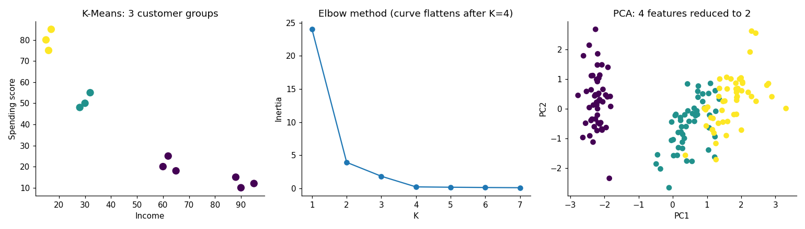
Left: the three customer groups in different colours. Middle: the elbow plot. Right: Iris flowers projected on two principal components. The three species are visibly separated even though PCA never saw the labels.

Part 6: Reinforcement Learning

Chapter 21: Reinforcement Learning

The idea
Definition: Reinforcement learning (RL) is a type of machine learning in which an agent learns to make good decisions by interacting with an environment. Good actions earn a reward and bad actions earn a penalty, and the goal is to collect the highest total reward over time. Think of a child learning to ride a bicycle: nobody gives a list of correct moves, the child falls, adjusts and tries again.
Definition: In short: supervised learning is learning with a teacher who gives the answers, unsupervised learning is learning without a teacher by finding patterns, and reinforcement learning is learning from experience through rewards.
In supervised learning a teacher gives you the right answer for every example. In unsupervised learning there is no teacher, and you look for patterns. In reinforcement learning (RL) there is no list of correct answers either. Instead, an agent tries actions, and the world gives it a reward (a score) or a penalty. Over time, the agent learns which actions lead to the most reward.
Think of how you train a puppy. You do not show the puppy a table of correct actions. When the puppy sits, you give a treat (reward). When it chews your shoes, it hears "No!" (penalty). After many tries, the puppy learns what to do. A game-playing AI, a robot vacuum learning the layout of a house, and a self-driving car learning to stay in its lane all learn in this way.
 | Supervised | Unsupervised | Reinforcement
Data | Examples with correct answers | Examples without answers | No dataset: the agent creates its own experience
Feedback | The correct answer | None | A reward, often delayed
Goal | Predict the answer | Find structure | Maximize the total reward
Example | Predict a house price | Group customers | Learn to play a game

Key vocabulary
Term | Meaning | Example: a robot in a maze
Agent | The learner that makes decisions | The robot
Environment | The world the agent lives in | The maze
State (s) | What the agent can see right now | The square the robot is standing on
Action (a) | A choice the agent can make | Move left, down, right or up
Reward (r) | The score after an action | +1 for reaching the exit, 0 otherwise
Policy | The agent's strategy: which action in which state | "In square 4, go down"
Episode | One complete try, from start to finish | One run through the maze

The learning loop
Definition: The RL loop is the repeating cycle of state, action, reward and new state. It is like a video game: you look at the screen (state), press a button (action), score or lose points (reward), and then see a new screen.
Every RL program repeats the same loop:
- The agent looks at the state.
- It chooses an action.
- The environment returns a new state and a reward.
- The agent learns from this and goes back to step 1.

Two important ideas
Definition: Exploration means trying new actions to discover something better, and exploitation means using the best action you already know. Trying a new restaurant is exploration; going to your favourite one is exploitation.
Definition: The discount factor (gamma) is a number between 0 and 1 that tells how much future rewards count compared with rewards now. It is like preferring 100 rupees today to 100 rupees a year later.
1. Explore or exploit? Suppose you always eat at the same restaurant because it is good. You are exploiting what you know. But a much better restaurant may exist on the next street, and you will never find it unless you explore. An RL agent must balance both. The simplest method is epsilon-greedy: with a small probability epsilon try a random action (explore), otherwise take the best known action (exploit).
2. Future rewards matter, but a little less. A reward you get now is worth more than the same reward later. The discount factor gamma (between 0 and 1, often 0.95 or 0.99) makes later rewards count slightly less. It also makes the agent prefer short paths to the goal.

Q-learning: the classic algorithm
Definition: Q-learning is a reinforcement learning algorithm that learns a score, called the Q-value, for every action in every state and keeps all the scores in a table called the Q-table. It is like a cheat sheet that says: in this situation, this move is worth this many points. The agent picks the move with the best score and updates the score after every experience.
Q-learning keeps a table called the Q-table. It has one row per state and one column per action, and each cell holds a score: "how good is this action in this state?" At the start, the table is full of zeros. After every step, the agent improves one cell using this rule:
Q(s, a) = Q(s, a) + alpha x ( reward + gamma x max Q(next state) - Q(s, a) )
- alpha is the learning rate: how big a step to take (0 to 1).
- reward + gamma x max Q(next state) is what we now think the action is really worth: the reward we just got, plus the best value we can expect from the next state.
- The part in brackets is the surprise: the gap between what we expected and what happened. We move the Q value a little in that direction.
A tiny worked example. Suppose Q(s, a) = 0, the reward is 0, the best Q value of the next state is 0.774, alpha = 0.8 and gamma = 0.95. Then the new value is 0 + 0.8 x (0 + 0.95 x 0.774 - 0) = 0.588. The agent has learned that this action leads towards something good, even though it got no reward yet. In this way, the value of the goal slowly flows backward, one step at a time, through the whole Q-table.

Syntax
import numpy as np
import gymnasium as gym # pip install gymnasium
env = gym.make("EnvironmentName") # create the environment
state, info = env.reset() # start a new episode
next_state, reward, terminated, truncated, info = env.step(action) # take one action
Q = np.zeros((n_states, n_actions)) # the Q-table
# epsilon-greedy choice
if np.random.random() < epsilon:
action = env.action_space.sample() # explore
else:
action = np.argmax(Q[state]) # exploit
# Q-learning update
Q[state, action] += alpha * (reward + gamma * np.max(Q[next_state]) - Q[state, action])
terminated is True when the episode ended naturally (goal or hole). truncated is True when it was cut off, for example by a time limit.

Example 1: The slot-machine problem (explore vs exploit)
Definition: The multi-armed bandit problem is the task of choosing among several slot machines ("one-armed bandits") with unknown winning chances so that you earn as much as possible. The epsilon-greedy strategy solves it: most of the time play the best machine known so far, but with a small chance (epsilon) try a random machine to keep exploring.
A casino has three slot machines. The machines win with probabilities 20 percent, 50 percent and 70 percent, but we do not know which is which. We have 1000 pulls. Which machine should we pull?
import numpy as np
true_p = np.array([0.2, 0.5, 0.7]) # the hidden win probabilities
def play(epsilon, steps=1000, seed=0):
rng = np.random.default_rng(seed)
Q = np.zeros(3) # estimated value of each machine
N = np.zeros(3) # how many times we pulled each machine
rewards = []
for t in range(steps):
if rng.random() < epsilon:
a = rng.integers(3) # explore: random machine
else:
a = int(np.argmax(Q)) # exploit: best machine so far
r = float(rng.random() < true_p[a]) # 1 if we win, else 0
N[a] += 1
Q[a] += (r - Q[a]) / N[a] # update the running average
rewards.append(r)
return Q, N, np.array(rewards)
for epsilon in (0.0, 0.1, 0.5):
Q, N, r = play(epsilon, seed=1)
print(f"epsilon={epsilon}: estimates={Q.round(2)} pulls={N.astype(int)} total reward={int(r.sum())}")
Output:
epsilon=0.0: estimates=[0.2 0. 0. ] pulls=[1000 0 0] total reward=199
epsilon=0.1: estimates=[0.15 0.44 0.7 ] pulls=[ 54 32 914] total reward=660
epsilon=0.5: estimates=[0.18 0.54 0.68] pulls=[157 179 664] total reward=577
Averaged over 200 repeated games, the average reward per pull was 0.201 for epsilon = 0, 0.653 for epsilon = 0.1 and 0.580 for epsilon = 0.5. The best possible average is 0.7.
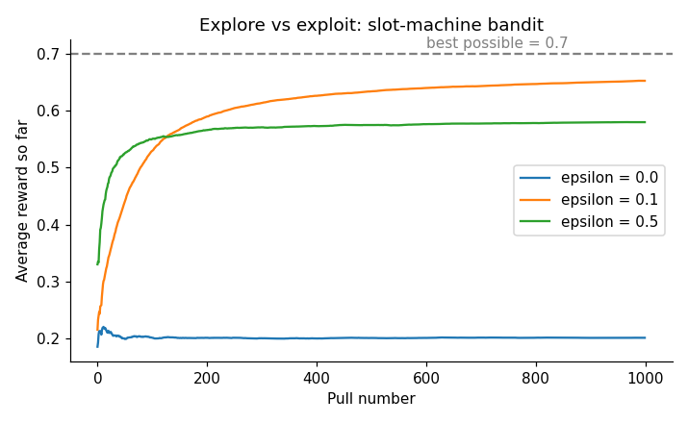
Teacher's explanation:
- epsilon = 0 (never explore) got stuck. The agent pulled the first machine once, saw a result, and then pulled machine 0 all 1000 times. It never tried the other two machines, so it never found out they were better. Its total reward was only 199.
- epsilon = 0.1 (explore 10 percent of the time) tried every machine a few times, discovered that machine 2 is the best (its estimate, 0.70, is almost exactly the true 0.7), and then used it 914 times. Reward: 660.
- epsilon = 0.5 (explore half the time) also found the best machine, but wasted too many pulls on random choices, so the reward (577) is lower.
The lesson is that a little exploration is essential, and too much exploration wastes time. Practitioners often start with a high epsilon and slowly reduce it.

Example 2: Q-learning in a frozen lake
Definition: The frozen lake is a small grid game used to test RL algorithms: the agent must walk from the start square to the goal without falling into a hole. An episode is one complete game from the start until it ends, and the agent plays many episodes to learn.
In this classic game, the agent stands on a 4 by 4 frozen lake. It must walk from the start square (S) to the goal (G) without falling into a hole (H). It gets a reward of +1 only when it reaches the goal, and 0 otherwise. This is hard because the reward is delayed: the agent only learns whether a path was good at the very end.
S F F F S = start F = frozen (safe)
F H F H H = hole (the episode ends)
F F F H G = goal (reward +1)
H F F G
The agent has 4 actions: 0 = left, 1 = down, 2 = right, 3 = up. This gives 16 states and 4 actions, so the Q-table has 16 x 4 = 64 numbers.
import numpy as np
import gymnasium as gym
env = gym.make("FrozenLake-v1", map_name="4x4", is_slippery=False)
n_states, n_actions = env.observation_space.n, env.action_space.n
Q = np.zeros((n_states, n_actions))
alpha, gamma, episodes = 0.8, 0.95, 2000
rng = np.random.default_rng(42)
rewards = []
for episode in range(episodes):
epsilon = max(0.05, 1.0 - episode / 1000) # explore a lot at first, then less
state, _ = env.reset(seed=int(rng.integers(1e9)))
done, total = False, 0
while not done:
if rng.random() < epsilon:
action = int(rng.integers(n_actions)) # explore
else:
action = int(np.argmax(Q[state])) # exploit
next_state, reward, terminated, truncated, _ = env.step(action)
done = terminated or truncated
Q[state, action] += alpha * (reward + gamma * np.max(Q[next_state]) * (not terminated) - Q[state, action])
state = next_state
total += reward
rewards.append(total)
print("Q-table shape:", Q.shape)
print("Success rate, first 200 episodes:", np.mean(rewards[:200]))
print("Success rate, last 200 episodes :", np.mean(rewards[-200:]))
Output:
Q-table shape: (16, 4)
Success rate, first 200 episodes: 0.06
Success rate, last 200 episodes : 0.95
Now test the trained agent by always choosing the best action (no exploring):
Learned policy (best action in each square):
v > v <
v H v H
> v v H
H > > G
Greedy agent reaches the goal in 100 of 100 test games
Path of squares: [0, 4, 8, 9, 13, 14, 15]
Q-values of start square: [0.735 0.774 0.774 0.735]
Random agent success rate over 1000 games: 0.019
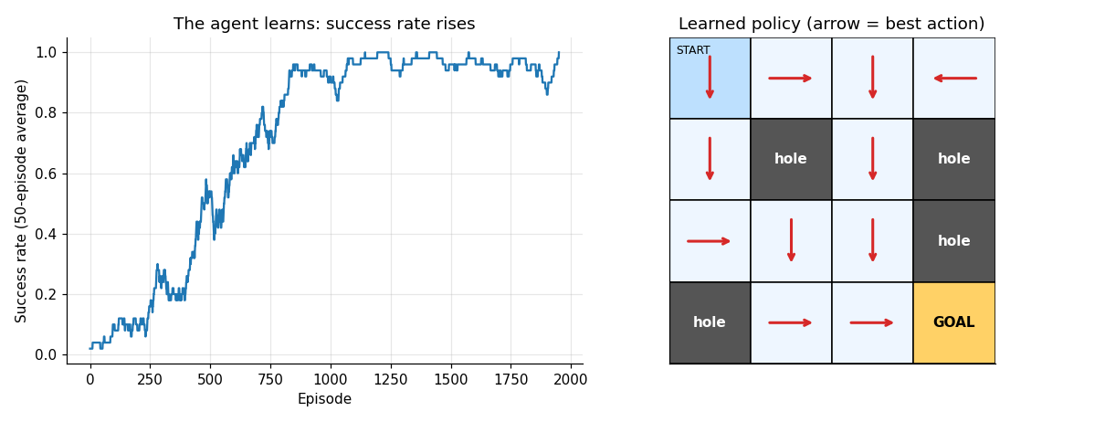
Teacher's explanation:
- At the beginning the agent is clueless. In the first 200 episodes it reached the goal only 6 percent of the time, because it was mostly moving at random. (A purely random agent succeeds only 1.9 percent of the time.)
- Learning is slow, then fast. The graph is flat at first, because nothing has been learned yet. Once the agent stumbles on the goal a few times, the reward "flows backward" through the Q-table, and the success rate climbs sharply between episodes 300 and 900.
- After training, the agent is almost perfect. In the last 200 episodes, it succeeded 95 percent of the time (the remaining failures came from the 5 percent random exploration). When we switch off exploration, it wins 100 out of 100 test games.
- The policy makes sense. Follow the arrows from the start: down, down, right (square 8, then 9), down, right, right, which is the path 0, 4, 8, 9, 13, 14, 15 that avoids all holes. It takes 6 steps, the shortest possible route.
- The Q-values of the start square are 0.774 for "down" and for "right", and 0.735 for "left" and "up". Moving left or up from the start square bumps into the wall and wastes a step, so those actions are worth a little less (0.735 = 0.774 x 0.95). That small gap is gamma at work: the agent prefers the shorter path.
What if the ice is slippery? In the real FrozenLake game, the agent slips and sometimes moves in a different direction than it chose. The environment is then random. Using the same method with more episodes (20,000), a trained agent succeeded in about 76 percent of 1000 test games. It can never reach 100 percent because of the random slips. Real-world problems are often like this.

Where is reinforcement learning used?
- Games: Chess, Go and video games (AlphaGo, Atari agents).
- Robotics: Walking, grasping and balancing robots.
- Self-driving and drones: Lane keeping, parking, flight control.
- Recommendation and advertising: Choosing which item to show next (these are bandit problems like Example 1).
- Chatbots: Large language models are improved with reinforcement learning from human feedback (RLHF), where human ratings act as the reward.
- Industry: Energy saving in data centres, traffic light control, inventory management.

Going further (code only)
Q-tables work only when the number of states is small. For games with millions of states (such as images from a screen), the Q-table is replaced by a neural network. This is Deep Reinforcement Learning (for example DQN or PPO). The Stable-Baselines3 library lets you train such agents in a few lines. The code below was not run here, because it needs a large installation:
# pip install stable-baselines3 gymnasium
from stable_baselines3 import PPO
model = PPO("MlpPolicy", "CartPole-v1", verbose=1)
model.learn(total_timesteps=20_000) # the agent learns to balance a pole on a cart

Practice
- In Example 1, change the win probabilities to [0.4, 0.45, 0.5]. Is it now harder or easier to find the best machine? Compare epsilon values.
- In Example 2, change gamma to 0.5. Does the agent still find the goal? Why might it have more trouble?
- Use epsilon = 0.05 from the very start (no decay) in Example 2. Compare the success rate in the first 200 episodes.
- Write the policy and the path of the slippery game, and explain why the path is different from the non-slippery game.

Part 7: Improving and Deploying Models
The next two chapters work with every kind of model in this book, supervised or unsupervised. Chapter 22 shows how to measure whether a model is good and how to improve it. Chapter 23 shows how to build better features and how to package everything into a professional pipeline.

Chapter 22: Model Evaluation and Improvement
Training a model is easy. Knowing whether it is good and making it better is the real skill.

Bias and variance
Definition: Bias is the error that comes from a model being too simple to see the real pattern (underfitting), like drawing a straight line through a curve. Variance is the error that comes from a model being too sensitive to its training data (overfitting), like a student who memorizes the answers but fails when the questions change. The bias-variance trade-off is the balancing act of keeping both low.
- High bias (underfitting): the model is too simple and misses the pattern. Both training and test scores are low.
- High variance (overfitting): the model is too complex and memorizes noise. Training score is high, test score is much lower.
The goal is the sweet spot in between.
Symptom | Likely problem | What to try
Low train, low test | Underfitting | More features, more complex model, less regularization
High train, low test | Overfitting | More data, simpler model, regularization, fewer features
Great on test, bad in real life | Data leakage or data drift | Re-check your pipeline and data source

Cross-validation
Definition: Cross-validation estimates how well a model will perform on new data by splitting the training data into K parts (folds), training K times and testing on a different fold each time, then averaging the scores.

Syntax
from sklearn.model_selection import cross_val_score
scores = cross_val_score(model, X, y, cv=5, scoring="accuracy")
scores.mean() scores.std()
cv=5 means 5 folds. Use scoring="r2" or "neg_root_mean_squared_error" for regression and "f1" or "roc_auc" for classification.
One train/test split can be lucky or unlucky. K-fold cross-validation splits the training data into K parts, trains K times, each time testing on a different part, then averages the scores. You get a more reliable estimate.
from sklearn.model_selection import cross_val_score
from sklearn.ensemble import RandomForestClassifier
model = RandomForestClassifier(random_state=42)
scores = cross_val_score(model, X_train, y_train, cv=5, scoring="accuracy")
print(scores)
print("Mean:", scores.mean(), "+/-", scores.std())

Hyperparameter tuning
Definition: A hyperparameter is a setting you choose before training (like max_depth), while a parameter is learned during training (like a weight). Hyperparameter tuning is the search for the best settings, for example with grid search, which tries every combination.

Syntax
from sklearn.model_selection import GridSearchCV, RandomizedSearchCV
search = GridSearchCV(model, param_grid, cv=5, scoring="f1", n_jobs=-1)
search.fit(X_train, y_train)
search.best_params_ # best settings found
search.best_score_ # best cross-validation score
search.best_estimator_ # the final trained model
param_grid is a dictionary such as {"max_depth": [3, 5, 8]}.
Parameters are learned by the model (like weights). Hyperparameters are settings you choose before training (like max_depth or K in KNN).
from sklearn.model_selection import GridSearchCV
param_grid = {
"n_estimators": [100, 200],
"max_depth": [3, 5, 8, None],
"min_samples_leaf": [1, 3, 5]
}
grid = GridSearchCV(
RandomForestClassifier(random_state=42),
param_grid,
cv=5,
scoring="f1",
n_jobs=-1
)
grid.fit(X_train, y_train)
print("Best params:", grid.best_params_)
print("Best CV score:", grid.best_score_)
best_model = grid.best_estimator_
print("Test score:", best_model.score(X_test, y_test)) # use the test set only once, at the end
For large search spaces use RandomizedSearchCV, which tries random combinations and is much faster.

Handling imbalanced data
Definition: Imbalanced data means one class is much rarer than the others (for example 2 percent fraud). Such data needs special care: class weights, resampling (such as SMOTE) and metrics other than accuracy.

Syntax
RandomForestClassifier(class_weight="balanced") # many models have this option
from imblearn.over_sampling import SMOTE # pip install imbalanced-learn
X_res, y_res = SMOTE(random_state=42).fit_resample(X_train, y_train) # training data only!
If only 2% of cases are positive:
- Use class_weight="balanced" in many models.
- Evaluate with precision, recall, F1 and AUC, not accuracy.
- Try resampling (oversample the small class, for example with SMOTE from the imbalanced-learn library).

Choosing the right metric
Definition: An evaluation metric is the score you use to judge a model, and the right one depends on the problem. Precision asks: of everything the model called positive, how much was really positive? Recall asks: of all the real positives, how many did the model find? F1 score is a single number that balances the two. Imagine a fisherman: precision is how many things in the net are really fish, and recall is how many of the fish in the lake he caught.
Problem | Metric to focus on
Regression | RMSE, MAE, R-squared
Balanced classification | Accuracy, F1
Imbalanced classification | Precision, recall, F1, ROC-AUC
Cancer or fraud detection | Recall (do not miss real cases)
Spam filter | Precision (do not block real emails)

How to improve a model: a checklist
- Get more or better-quality data.
- Fix missing values, outliers and errors.
- Create better features (next chapter).
- Try different algorithms and compare with cross-validation.
- Tune hyperparameters.
- Combine models (ensembles).
- Check for leakage.
Always start with a simple baseline (for example, predicting the average, or logistic regression). A complex model must beat the baseline to be worth using.

Practice
- Run 5-fold cross-validation on three different models and compare the mean scores.
- Tune a decision tree with GridSearchCV.
- Create an imbalanced dataset with make_classification(weights=[0.95]) and see how accuracy misleads.

Output (real run on the breast cancer data)
Cross-validation of a random forest (5 folds):
[0.962 0.988 0.912 1. 1. ]
Mean: 0.973 +/- 0.033
Five different splits give five different scores (0.91 to 1.00). The average, 97.3 percent, is a more honest estimate than any single split.
Grid search:
Best params: {'max_depth': 5, 'n_estimators': 100}
Best CV score: 0.978
Test score: 0.942
The best settings gave 97.8 percent in cross-validation but 94.2 percent on the untouched test set. A small drop like this is normal, because the settings were chosen to suit the training folds.

Comparing six models with cross-validation
models = {
"Logistic": make_pipeline(StandardScaler(), LogisticRegression(max_iter=1000)),
"KNN": make_pipeline(StandardScaler(), KNeighborsClassifier(5)),
"SVM": make_pipeline(StandardScaler(), SVC()),
"Decision Tree": DecisionTreeClassifier(max_depth=4, random_state=42),
"Random Forest": RandomForestClassifier(random_state=42),
"XGBoost": xgb.XGBClassifier(n_estimators=200, learning_rate=0.1, max_depth=3, eval_metric="logloss"),
}
for name, m in models.items():
scores = cross_val_score(m, X_train, y_train, cv=5)
print(f"{name:14s} mean={scores.mean():.3f} std={scores.std():.3f}")

Logistic mean=0.980 std=0.015
KNN mean=0.967 std=0.010
SVM mean=0.970 std=0.013
Decision Tree mean=0.935 std=0.032
Random Forest mean=0.973 std=0.033
XGBoost mean=0.967 std=0.026
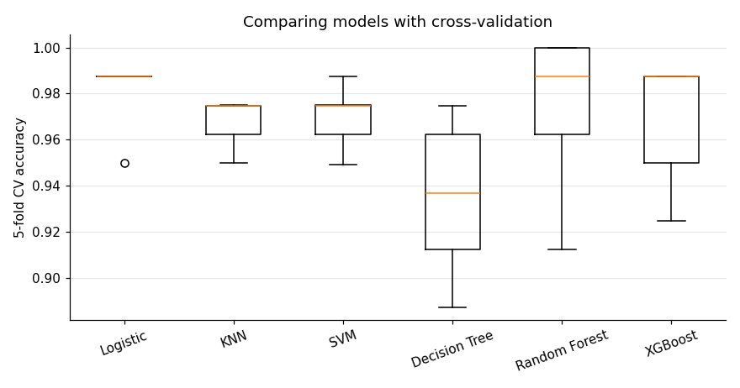
Each box shows how a model's score changes across the 5 folds. A simple, scaled logistic regression is at the top. A complicated model is not automatically a better model. This is why you should always build a simple baseline first.

Chapter 23: Feature Engineering and Pipelines
Definition: Feature engineering is the creation of new, more useful input columns from existing data. A feature is an input variable that a model uses to make predictions.

Feature engineering: the secret weapon

Syntax
df["new_feature"] = df["col1"] + df["col2"] # combine columns
df["month"] = pd.to_datetime(df["date"]).dt.month # parts of a date
df["group"] = pd.cut(df["age"], bins=[0, 18, 60, 100], labels=["child", "adult", "senior"])
df["log_col"] = np.log1p(df["col"]) # reduce skew
Feature engineering means creating new, more useful input columns from existing ones. A well-designed feature often improves a model more than a fancy algorithm.
Examples
# From a date
df["date"] = pd.to_datetime(df["date"])
df["month"] = df["date"].dt.month
df["day_of_week"] = df["date"].dt.dayofweek
df["is_weekend"] = df["day_of_week"].isin([5, 6]).astype(int)
# Combining columns
df["family_size"] = df["SibSp"] + df["Parch"] + 1
df["price_per_sqft"] = df["price"] / df["area"]
# Extracting from text
df["title"] = df["Name"].str.extract(r", (\w+)\.") # Mr, Mrs, Miss...
# Binning numbers into groups
df["age_group"] = pd.cut(df["Age"], bins=[0, 12, 18, 60, 100],
labels=["child", "teen", "adult", "senior"])
# Fix skewed data
import numpy as np
df["log_income"] = np.log1p(df["income"])

Feature selection
Definition: Feature selection means keeping only the most useful features and dropping irrelevant or duplicate ones, which makes models faster and often more accurate.

Syntax
from sklearn.feature_selection import SelectKBest, f_classif
selector = SelectKBest(score_func=f_classif, k=5) # keep the 5 best features
X_new = selector.fit_transform(X_train, y_train)
selector.get_support() # True for the features kept
More features is not always better. Irrelevant features add noise and slow training.
- Remove features with almost no variation.
- Remove one of two highly correlated features.
- Use feature importance from random forests.
- Use Lasso, which pushes useless weights to zero.

Pipelines: professional, leak-free workflows
Definition: A pipeline is a chain of steps (cleaning, encoding, scaling, model) packed into one object, so the same steps always run in the same order on both training and new data. This prevents data leakage.

Syntax
from sklearn.pipeline import Pipeline
from sklearn.compose import ColumnTransformer
pipe = Pipeline([
("step_name1", transformer1), # each step is (name, object)
("step_name2", transformer2),
("model", final_model) # the last step is the model
])
pipe.fit(X_train, y_train)
pipe.predict(X_test)
preprocess = ColumnTransformer([
("name", transformer, ["column1", "column2"]), # different columns, different treatment
])
A Pipeline chains preprocessing and the model into one object. Benefits: cleaner code, no data leakage, and one object to save and deploy.
from sklearn.pipeline import Pipeline
from sklearn.compose import ColumnTransformer
from sklearn.preprocessing import StandardScaler, OneHotEncoder
from sklearn.impute import SimpleImputer
from sklearn.ensemble import RandomForestClassifier
numeric_cols = ["Age", "Fare"]
categorical_cols = ["Sex", "Embarked"]
numeric_pipe = Pipeline([
("impute", SimpleImputer(strategy="median")),
("scale", StandardScaler())
])
categorical_pipe = Pipeline([
("impute", SimpleImputer(strategy="most_frequent")),
("onehot", OneHotEncoder(handle_unknown="ignore"))
])
preprocess = ColumnTransformer([
("num", numeric_pipe, numeric_cols),
("cat", categorical_pipe, categorical_cols)
])
clf = Pipeline([
("preprocess", preprocess),
("model", RandomForestClassifier(n_estimators=200, random_state=42))
])
clf.fit(X_train, y_train) # imputes, scales, encodes, then trains
print(clf.score(X_test, y_test)) # the same steps are applied to test data automatically

Saving your model
Definition: Serialization (saving a model) writes a trained model to a file so it can be loaded and used later without retraining. Deployment means making a model available for real users.

Syntax
import joblib
joblib.dump(object, "filename.pkl") # save
object = joblib.load("filename.pkl") # load

import joblib
joblib.dump(clf, "titanic_model.pkl")
loaded = joblib.load("titanic_model.pkl")
print(loaded.predict(X_test.head()))

Practice
- Build a pipeline for a dataset with both numeric and categorical columns.
- Engineer at least three new features and test whether they improve cross-validated scores.
- Save your trained pipeline and load it in a new notebook.

Output: feature engineering (real run)
df["date"] = pd.to_datetime(df["date"])
df["month"] = df["date"].dt.month
df["day_of_week"] = df["date"].dt.dayofweek
df["is_weekend"] = df["day_of_week"].isin([5, 6]).astype(int)
df["family_size"] = df["SibSp"] + df["Parch"] + 1
df["price_per_sqft"] = df["price"] / df["area"]
df["age_group"] = pd.cut(df["Age"], bins=[0, 12, 18, 60, 100], labels=["child", "teen", "adult", "senior"])
df["log_income"] = np.log1p(df["income"]).round(2)
On a small demo table with four rows, the new columns look like this:
date month day_of_week is_weekend family_size price_per_sqft age_group log_income
0 2026-10-16 10 4 0 2 300.000000 child 10.31
1 2026-10-17 10 5 1 1 300.000000 adult 10.71
2 2026-10-18 10 6 1 4 277.777778 adult 14.00
3 2026-10-19 10 0 0 3 400.000000 senior 10.86
How to read it: day 4 is a Friday and days 5 and 6 are Saturday and Sunday (Monday is 0), so is_weekend is 1 for those two rows. The log_income column shows why the log transform helps: incomes of 30,000 and 1,200,000 (a 40 times gap) become 10.31 and 14.00, which are much closer together. The huge value no longer dominates the model.

Output: a complete pipeline (real run)
This example builds its own 200-row dataset with missing values, so you can run it without any file.
rng = np.random.default_rng(42)
n = 200
df = pd.DataFrame({
"Age": rng.integers(1, 80, n).astype(float),
"Fare": rng.gamma(2, 20, n).round(2),
"Sex": rng.choice(["male", "female"], n),
"Embarked": rng.choice(["S", "C", "Q", None], n),
})
df.loc[rng.choice(n, 20, replace=False), "Age"] = np.nan
df["Survived"] = ((df["Sex"] == "female") | (df["Age"] < 10)).astype(int)
print("Missing ages:", df["Age"].isnull().sum(), "| missing Embarked:", df["Embarked"].isnull().sum())
X, y = df.drop("Survived", axis=1), df["Survived"]
X_train, X_test, y_train, y_test = train_test_split(X, y, test_size=0.2, random_state=42, stratify=y)
# ... the numeric_pipe, categorical_pipe, preprocess and clf from this chapter go here ...
clf.fit(X_train, y_train)
print("Test accuracy:", clf.score(X_test, y_test))
joblib.dump(clf, "titanic_model.pkl")
loaded = joblib.load("titanic_model.pkl")
print("Predictions from the saved model:", loaded.predict(X_test.head()))
print("Real answers :", y_test.head().to_numpy())

Missing ages: 20 | missing Embarked: 56
Test accuracy: 0.975
Predictions from the saved model: [0 1 1 1 0]
Real answers : [0 1 1 1 0]
How to read it: the pipeline filled the 20 missing ages and 56 missing ports by itself, scaled the numbers, encoded the text and trained the forest in one fit() call. It scored 97.5 percent on the test data. The reloaded model gives the same five predictions as before, and all five match the real answers, so the saved file works. This data follows a simple hidden rule (women and young children survive), which is why the score is so high. Real data is messier.

Part 8: Deep Learning and Your Career
The last part gives you a first look at deep learning, which is machine learning with large neural networks and is the technology behind image recognition, speech assistants and chatbots. It ends with portfolio projects and a roadmap that shows what to learn next to become job-ready.

Chapter 24: A Gentle Introduction to Deep Learning
Definition: Deep Learning is machine learning that uses neural networks with many layers. It is especially strong for images, audio and text.

What are neural networks?
Definition: A neural network is a model made of layers of small units called neurons. Each neuron multiplies its inputs by weights, adds them, and passes the result through an activation function. Backpropagation is the method that sends the error backwards to adjust the weights, and an epoch is one full pass through the training data.
A neural network is inspired (loosely) by the brain. It is made of layers of small units called neurons. Each neuron takes inputs, multiplies each by a weight, adds them up, and passes the result through an activation function.
- Input layer: receives the features.
- Hidden layers: learn increasingly abstract patterns.
- Output layer: produces the prediction.
Deep learning means networks with many hidden layers. It excels at images, speech and text.

Key ideas
Definition: An activation function is a small formula applied after each neuron that decides how strongly it "fires", like a gate that opens only when the signal is strong enough. An epoch is one complete pass through all the training data, like reading the whole textbook once.
Definition: Backpropagation is how a neural network learns: the error is sent backward through the layers and every weight is adjusted a little, like a teacher who marks an exam and tells you which steps went wrong.
- Activation functions: ReLU (max(0, x)) in hidden layers, sigmoid or softmax in the output for classification.
- Forward propagation: data flows through the network to make a prediction.
- Loss: measures how wrong the prediction is.
- Backpropagation: the error flows backward, and gradient descent updates every weight a little.
- Epoch: one full pass through the training data. Batch: a small group of samples processed together.

A first network with Keras
Definition: Keras is a high-level library (part of TensorFlow) for building neural networks with a few lines of code. A Dense layer connects every neuron to every neuron of the previous layer, and compile sets the loss function and optimizer before training.

Syntax
from tensorflow import keras
from tensorflow.keras import layers
model = keras.Sequential([
layers.Input(shape=(number_of_features,)),
layers.Dense(units, activation="relu"), # hidden layer
layers.Dense(1, activation="sigmoid") # output layer (binary classification)
])
model.compile(optimizer="adam", loss="binary_crossentropy", metrics=["accuracy"])
history = model.fit(X_train, y_train, epochs=30, batch_size=16, validation_split=0.2)
model.evaluate(X_test, y_test)
model.predict(X_new)
For regression use one output neuron with no activation and loss="mse". For more than two classes use Dense(n_classes, activation="softmax") with loss="sparse_categorical_crossentropy".
import tensorflow as tf
from tensorflow import keras
from tensorflow.keras import layers
from sklearn.datasets import load_breast_cancer
from sklearn.model_selection import train_test_split
from sklearn.preprocessing import StandardScaler
data = load_breast_cancer()
X_train, X_test, y_train, y_test = train_test_split(
data.data, data.target, test_size=0.2, random_state=42
)
scaler = StandardScaler()
X_train = scaler.fit_transform(X_train)
X_test = scaler.transform(X_test)
model = keras.Sequential([
layers.Input(shape=(X_train.shape[1],)),
layers.Dense(16, activation="relu"),
layers.Dense(8, activation="relu"),
layers.Dense(1, activation="sigmoid") # binary output
])
model.compile(optimizer="adam", loss="binary_crossentropy", metrics=["accuracy"])
history = model.fit(X_train, y_train, epochs=30, batch_size=16,
validation_split=0.2, verbose=0)
loss, acc = model.evaluate(X_test, y_test, verbose=0)
print("Test accuracy:", acc)
Install with pip install tensorflow, or just use Google Colab where it is already available.

Where to go next
- Computer Vision: Convolutional Neural Networks (CNNs) for images.
- NLP: text processing, embeddings, Transformers and large language models.
- Frameworks: PyTorch and TensorFlow.
Important: on tabular data (spreadsheet-style tables), random forests and gradient boosting often beat deep learning. Use deep learning mainly for images, audio and text.

Practice
- Change the number of neurons and epochs. What happens to accuracy?
- Plot history.history["loss"] and history.history["val_loss"]. Can you spot overfitting?

Output: a neural network that runs without TensorFlow (real run)
TensorFlow is a large download, so I could not run the Keras code above in this environment. The Keras code is correct, but I do not show output for it. Here is the same idea, the same two hidden layers (16 and 8 neurons) and the same data, using scikit-learn's MLPClassifier. You can run it right now, and the training works exactly as explained in this chapter.
from sklearn.neural_network import MLPClassifier
mlp = MLPClassifier(hidden_layer_sizes=(16, 8), activation="relu",
solver="adam", max_iter=300, random_state=42)
mlp.fit(X_train, y_train) # X_train is already scaled
print("MLP test accuracy:", round(mlp.score(X_test, y_test), 4))
print("epochs run:", mlp.n_iter_)
print("first loss:", round(mlp.loss_curve_[0], 4), "last loss:", round(mlp.loss_curve_[-1], 4))

MLP test accuracy: 0.9825
epochs run: 300
first loss: 1.0681 last loss: 0.0179
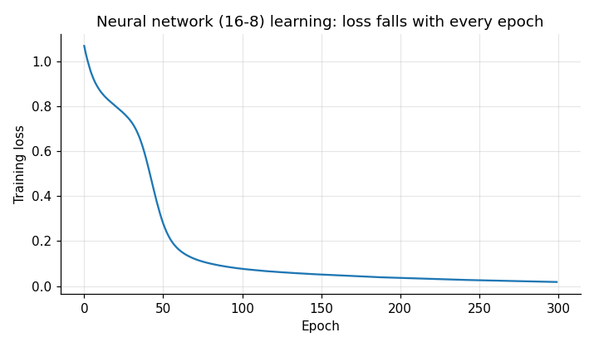
How to read it: the loss is the model's average mistake. It starts at 1.07 and falls to 0.018 after 300 epochs, which means the network is learning. The test accuracy is 98.25 percent. Python also prints a ConvergenceWarning because the model used all 300 allowed epochs. It was still improving slightly, so you could raise max_iter. A very low training loss together with a lower test score would be the sign of overfitting, so always check both.

Chapter 25: Portfolio Projects and Career Roadmap
Employers hire people who can show what they have built. Put your projects on GitHub with a clear README.

Project ladder: from beginner to advanced
Level 1: Beginner
- Student score predictor (linear regression). Predict marks from study hours.
- Titanic survival prediction (classification). Practice EDA and cleaning.
- Iris flower classifier. Compare KNN, SVM and decision tree.
Level 2: Intermediate
- House price prediction. Feature engineering, regularization, cross-validation.
- Customer segmentation with K-Means and PCA.
- Spam / SMS classifier with text features and Naive Bayes.
- Customer churn prediction with imbalanced data and a full pipeline.
Level 3: Advanced
- Image classifier (digits or cats vs dogs) with a CNN.
- Sentiment analysis of product reviews using NLP.
- Deploy a model as a web app (Streamlit or Flask) so people can try it.

What a good GitHub project contains
- A README: the problem, the dataset, your approach, results and how to run it.
- Clean notebooks with explanations between code cells.
- A requirements.txt file.
- Charts that tell the story.
- A short "what I learned and what I would improve" section.

Professional coding habits
- Use clear names and small functions with docstrings.
- Follow PEP 8 (Python's style guide).
- Use Git and commit often with clear messages.
- Keep data cleaning, training and evaluation in separate, reusable code.
- Set random_state for reproducibility.
- Never evaluate on training data, and never tune on the test set.

Learning roadmap
- Months 1 to 2: Python, NumPy, Pandas, Matplotlib, SQL basics.
- Months 3 to 4: Statistics, probability, linear algebra basics, core ML algorithms with scikit-learn.
- Months 5 to 6: 3 to 5 projects, Git/GitHub, Kaggle practice.
- Months 7 to 9: Deep learning (PyTorch or TensorFlow), NLP or computer vision.
- Months 10 to 12: MLOps basics (APIs, Docker, deployment), internships, LinkedIn portfolio, interview practice.

Key math to learn along the way
- Statistics: mean, median, variance, standard deviation, distributions, correlation.
- Probability: conditional probability and Bayes' theorem.
- Linear algebra: vectors and matrices (what NumPy does).
- Calculus: derivatives and gradients (how models learn).
Learn them in small pieces, exactly when a project needs them.

Final words
You now have a map: Python, then data tools, then machine learning, then projects. Nobody becomes an AI engineer by reading alone. Pick a dataset today, ask a question, and start building. Make mistakes, fix them, and share your work. Every expert was once a beginner who kept going.
Good luck on your AI journey!

Appendix A: Python and ML Cheat Sheet
Task | Code
Load CSV | pd.read_csv("file.csv")
Inspect data | df.head(), df.info(), df.describe()
Missing values | df.isnull().sum(), df.fillna(value)
Filter rows | df[df["col"] > 5]
Group and average | df.groupby("col")["x"].mean()
Split data | train_test_split(X, y, test_size=0.2, random_state=42)
Scale | StandardScaler().fit_transform(X)
Train | model.fit(X_train, y_train)
Predict | model.predict(X_test)
Evaluate | accuracy_score, r2_score, classification_report
Cross-validate | cross_val_score(model, X, y, cv=5)
Tune | GridSearchCV(model, params, cv=5)
Save model | joblib.dump(model, "model.pkl")

Appendix B: Glossary
- Algorithm: a step-by-step method for solving a problem.
- Feature: an input variable (column) used for prediction.
- Label / Target: the value we want to predict.
- Overfitting: learning noise in training data, failing on new data.
- Underfitting: model too simple to capture the pattern.
- Hyperparameter: a setting chosen before training.
- Epoch: one full pass through the training data.
- Gradient descent: repeatedly adjusting weights to reduce the loss.
- Pipeline: a chain of preprocessing and modeling steps.
- Data leakage: test information accidentally used during training.

Appendix C: More Important Libraries for AI, Data Science and Machine Learning
The libraries below are used every day by professional engineers. The ones marked (run) were executed while writing this book, and the output shown is real. The ones marked (code only) need a big installation or an internet connection, so run them yourself in Google Colab.
Library | What it is used for | Install
NumPy, Pandas, Matplotlib, Seaborn | Numbers, tables, charts (Chapters 11 to 13) | pip install numpy pandas matplotlib seaborn
scikit-learn | Classic machine learning (Parts 3 to 7) | pip install scikit-learn
SciPy (run) | Statistics and scientific maths | pip install scipy
statsmodels (run) | Statistical models with p-values | pip install statsmodels
XGBoost / LightGBM (run) | Fast, powerful boosted trees for tables | pip install xgboost lightgbm
OpenCV (run) | Images and computer vision | pip install opencv-python
Text processing with scikit-learn (run) | Turning text into numbers | included in scikit-learn
Plotly (code only) | Interactive charts | pip install plotly
TensorFlow / Keras (code only) | Deep learning | pip install tensorflow
PyTorch (code only) | Deep learning (popular in research) | pip install torch
NLTK, spaCy, Hugging Face Transformers (code only) | Natural language processing | pip install nltk spacy transformers

C.1 SciPy: statistics (run)
Definition: SciPy is a library of scientific and statistical tools built on NumPy. A t-test checks whether the difference between two groups is real or just luck, and the p-value is the chance of seeing such a difference by luck alone: the smaller it is, the more you can trust the difference.
Is Class B really better than Class A, or is it luck? A t-test answers this. It gives a p-value: the chance of seeing such a difference by luck alone. A small p-value (below 0.05) means the difference is probably real.
import numpy as np
from scipy import stats
rng = np.random.default_rng(42)
class_a = rng.normal(70, 8, 40) # 40 students, average about 70
class_b = rng.normal(76, 8, 40) # 40 students, average about 76
t, p = stats.ttest_ind(class_a, class_b)
print("mean A:", round(class_a.mean(), 2), "mean B:", round(class_b.mean(), 2))
print("t-statistic:", round(t, 3))
print("p-value:", round(p, 4))
r, p_r = stats.pearsonr([1,2,3,4,5,6,7,8,9,10], [35,42,50,55,62,68,74,80,85,93])
print("Pearson r:", round(r, 4))
print("P(score <= 80):", round(stats.norm.cdf(80, 70, 8), 4))

mean A: 70.31 mean B: 76.11
t-statistic: -4.16
p-value: 0.0001
Pearson r: 0.9991
P(score <= 80): 0.8944
How to read it: the p-value is 0.0001, much smaller than 0.05, so Class B's higher average is very unlikely to be luck. The Pearson correlation of 0.9991 says study hours and marks move almost perfectly together. stats.norm.cdf(80, 70, 8) says that about 89 percent of students score 80 or less if marks follow a normal curve with average 70 and spread 8.
[image: t-test histograms and the normal distribution]

C.2 statsmodels: regression with p-values (run)
Definition: statsmodels is a library for statistical modelling whose goal is to explain, not just predict. It shows how large each effect is and how sure you can be about it, like a report card with a margin of error for every number.
scikit-learn is made for prediction. statsmodels is made for understanding: it tells you how sure you can be about each number.
import statsmodels.api as sm
hours = np.arange(1, 11)
score = np.array([35, 42, 50, 55, 62, 68, 74, 80, 85, 93])
result = sm.OLS(score, sm.add_constant(hours)).fit()
print(result.params.round(3))
print("R-squared:", round(result.rsquared, 4))
print(result.conf_int().round(3))

[29.867 6.279]
R-squared: 0.9982
[[28.504 31.23 ]
[ 6.059 6.498]]
How to read it: the intercept is 29.9 and the slope is 6.28 marks per hour. The 95 percent confidence interval for the slope is 6.06 to 6.50, so we are fairly sure that an extra hour is worth between 6 and 6.5 marks. result.summary() prints a full report table with p-values.

C.3 XGBoost: the competition winner for tables (run)
Definition: XGBoost is a fast and powerful library for gradient boosting: it builds many small decision trees one after another, and each tree fixes the mistakes of the trees before it. It is like a team of students where each new student studies only the questions the others got wrong.
import xgboost as xgb
model = xgb.XGBClassifier(n_estimators=200, learning_rate=0.1, max_depth=3,
random_state=42, eval_metric="logloss")
model.fit(X_train, y_train)
print("XGBoost test accuracy:", round(model.score(X_test, y_test), 4))
importance = pd.Series(model.feature_importances_, index=X_train.columns)
print(importance.sort_values(ascending=False).head(5).round(3))

XGBoost test accuracy: 0.9474
worst radius 0.389
worst perimeter 0.262
worst concave points 0.066
mean concave points 0.058
texture error 0.042
[image: XGBoost top 5 important features]
How to read it: the model is right 94.7 percent of the time on the breast cancer test set. The size of the tumour (worst radius and worst perimeter) is what the model trusts most. Note that logistic regression scored higher on the same data in Chapter 22, so a more advanced library does not guarantee a better result.

C.4 OpenCV: computer vision (run)
Definition: Computer vision is the field of teaching computers to understand images and video. OpenCV is the most popular library for it. To a computer an image is not a picture but a grid of numbers, one number (or three, for colour) for every pixel.
An image is just a NumPy array of numbers. A colour image has 3 numbers (blue, green, red) per pixel, and a grayscale image has one number (0 is black and 255 is white).
import cv2
img = np.full((200, 300, 3), 255, np.uint8) # white canvas
cv2.rectangle(img, (30, 40), (130, 150), (255, 0, 0), -1) # blue rectangle
cv2.circle(img, (210, 100), 55, (0, 160, 0), -1) # green circle
cv2.putText(img, "AI", (120, 185), cv2.FONT_HERSHEY_SIMPLEX, 1.2, (0, 0, 0), 3)
gray = cv2.cvtColor(img, cv2.COLOR_BGR2GRAY)
blur = cv2.GaussianBlur(gray, (9, 9), 0)
edges = cv2.Canny(gray, 50, 150)
print("color image shape:", img.shape)
print("gray image shape :", gray.shape)
print("edge pixels found:", int((edges > 0).sum()))

color image shape: (200, 300, 3)
gray image shape : (200, 300)
edge pixels found: 954
[image: Original, grayscale, blurred and edge-detected image]
How to read it: the shape (200, 300, 3) means 200 rows, 300 columns and 3 colour channels. Blurring removes small noise. Canny edge detection keeps only the outlines of the shapes. Real image projects, such as face detection and number plate reading, start with exactly these steps. To load your own picture use cv2.imread("photo.jpg").

C.5 Text to numbers with TF-IDF (run)
Definition: TF-IDF (term frequency, inverse document frequency) is a way of turning text into numbers. A word gets a high score if it appears often in one text but is rare in the other texts. If the word "cricket" appears many times in one article and almost nowhere else, it is probably what that article is about.
Models cannot read words, so we convert text to numbers. TF-IDF gives a high number to words that are important in one sentence but rare in the others.
from sklearn.feature_extraction.text import TfidfVectorizer
docs = ["I love machine learning", "machine learning loves data", "I love pizza"]
vectorizer = TfidfVectorizer()
X = vectorizer.fit_transform(docs)
print(pd.DataFrame(X.toarray().round(2), columns=vectorizer.get_feature_names_out()))

data learning love loves machine pizza
0 0.00 0.58 0.58 0.00 0.58 0.0
1 0.56 0.43 0.00 0.56 0.43 0.0
2 0.00 0.00 0.61 0.00 0.00 0.8
How to read it: each row is one sentence and each column is one word. The word "pizza" gets 0.8 in the third sentence because it appears nowhere else, so it identifies that sentence. The single letter "I" is ignored by default. These rows can be fed directly into Naive Bayes or logistic regression for spam detection or sentiment analysis.

C.6 Plotly: interactive charts (code only)
Definition: Plotly is a library for interactive charts. Unlike a printed picture, an interactive chart lets you hover to see values, zoom in and click the legend to hide or show groups.
import plotly.express as px
fig = px.scatter(df, x="sepal_length", y="petal_length", color="species",
title="Hover, zoom and click the legend")
fig.show() # opens an interactive chart in Jupyter or Colab
In Plotly you can hover over points, zoom and hide groups. This is great for dashboards and presentations.

C.7 PyTorch: deep learning (code only)
Definition: PyTorch is a deep learning library that is very popular in research. It stores data in tensors (NumPy-like arrays that can run on a GPU) and lets you build and train neural networks step by step, like building with LEGO blocks.
import torch
import torch.nn as nn
model = nn.Sequential(nn.Linear(30, 16), nn.ReLU(), nn.Linear(16, 1), nn.Sigmoid())
loss_fn = nn.BCELoss()
optimizer = torch.optim.Adam(model.parameters(), lr=0.01)
X = torch.tensor(X_train, dtype=torch.float32) # scaled features
y = torch.tensor(y_train, dtype=torch.float32).view(-1, 1)
for epoch in range(50):
optimizer.zero_grad() # clear old gradients
loss = loss_fn(model(X), y) # forward pass + loss
loss.backward() # backpropagation
optimizer.step() # update the weights
if epoch % 10 == 0:
print(epoch, loss.item())
The printed loss should go down as training continues. If it does not, lower the learning rate. PyTorch makes the learning loop visible, which is why researchers like it. Keras (Chapter 24) hides the loop behind model.fit().

C.8 Natural language processing libraries (code only)
Definition: Natural language processing (NLP) is the field of teaching computers to understand human language, for example for chatbots, translation and sentiment analysis. Libraries such as Hugging Face Transformers and spaCy give ready-made tools for it.
# Hugging Face Transformers: use a ready-made model in 3 lines
from transformers import pipeline
classifier = pipeline("sentiment-analysis")
print(classifier("I love learning machine learning!"))
# spaCy: tokenization, part-of-speech tags, named entities
import spacy
nlp = spacy.load("en_core_web_sm") # first run: python -m spacy download en_core_web_sm
for token in nlp("Waseem studies AI in Islamabad"):
print(token.text, token.pos_)
These examples download models from the internet on the first run, so the exact output depends on the model version.

C.9 What to learn next
- Practise with Kaggle datasets and notebooks.
- Learn SQL, because most company data lives in databases.
- Move to PyTorch or TensorFlow for images and text.
- Learn to deploy models with Streamlit or FastAPI.
- Use Git and GitHub for every project.

Copyright © Waseem Abbas. All rights reserved.

